STATE OF WEST VIRGINIA
CDBG-DR POLICIES AND PROCEDURES
CLEARANCE AND DEMOLITION PROGRAM
October 21, 2021

WEST VIRGINIA DEVELOPMENT OFFICE | WEST VIRGINIA HOUSING DEVELOPMENT FUND

CHANGE CONTROL LOG
Version | Date | Description | Author
Dec. 1 2019 | July 5, 2020 | Added Exception Policy to mirror other policies in RISE WV Program | Hannah Trautwein
July 5 2020 | July 15, 2020 | Original signature requirement  Ineligibility for Mortgage and Liens  Referenced Federal DR definition of severe storms  Application ROE & Hold Harmless Covenant | Hannah Trautwein
July 15, 2020 | October 30, 2020 | Duplication of Benefits Update to include language on the Stafford Act | Hannah Trautwein
October 30, 2020 | November 18, 2020 | Final Inspection updated to Closeout Inspection | Hannah Trautwein
November 18, 2020 | November 30, 2020 | Updated Labor Standards to include specific language on Section 3 | Hannah Trautwein
November 30, 2020 | December 9, 2020 | Updates to application access to include website application or mailing option | Hannah Trautwein
November 30, 2020 | December 9, 2020 | Updated Appeals policies to reflect Administrative policies for RISE Program | Hannah Trautwein
December 9, 2020 | January 5, 2021 | Update closeout inspection to include: The demolition project manager will review the Tier II Environmental Review Report to determine the scope of work has been completed and verified with the closeout inspection. | Hannah Trautwein
January 5, 2021 | July 28, 2021 | Updated policies to reflect change in WVNG Implementation of Clearance and Demolition Program | Hannah Trautwein
July 28, 2021 | August 25, 2021 | Updated DOB process, added a new Subrogation Agreement, Damage Verification form and Letter of Imminent Threat to the appendices | Hannah Trautwein

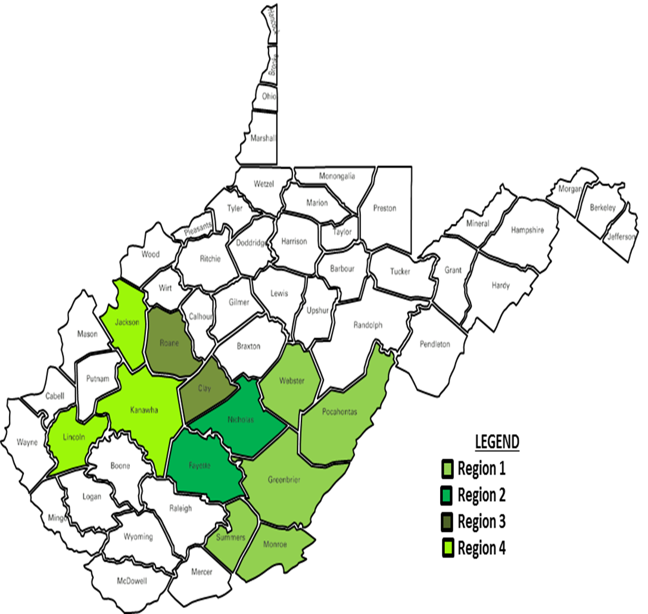

Most Impacted or Distressed (MID) Counties: Greenbrier, Kanawha, Nicholas, Clay

Non-Most Impacted or Distressed (NMID) Counties: Pocahontas, Monroe, Summers, Webster, Fayette, Roane, Jackson, Lincoln

INDEX

Change Log | Page 2
MID / NMID Map | Page 3
Program Background | Page 5
Program Eligibility | Page 5
Application Access | Page 6
Application / Intake Form | Page 7
Additional Requirements | Page 7
Withdrawal | Page 8
Process Overview | Page 8
Application Process | Page 9
Title Search and Covenants | Page 9
State Process | Page 10
Demolition Team Process | Page 11
Contractor Process | Page 12
File Storage | Page 13
Auditing / Compliance | Page 14
References: | Begin on Page 16
Appendix A | Demolition Process Checklist
Appendix B | Appeals Process
Appendix C | Exceptions Policy
Appendix D | Intake Packet
Appendix E | Withdrawal Authorization
Appendix F | Covenant
Appendix G | Damage Verification Form
Appendix H | Subrogation Agreement
Appendix I | Letter of Imminent Threat

SECTION 1: PROGRAM BACKGROUND

1.1: The RISE West Virginia Clearance and Demolition Program addresses the demolition of structures that were directly impacted by the severe storms* in June 2016. The program will eliminate specific conditions of slum and blight on a spot basis. The WVDED then entered into an Interagency Agreement with the West Virginia National Guard (WVNG) to assist with management of the Program in June 2018. WVNG was reassigned from this program April 6, 2021 and WVDED assumed all aspects of program implementation.

1.2: In 2017, the United States Department of Housing and Urban Development (HUD) provided the State of West Virginia with a series of three (3) separate Community Development Block Grant – Disaster Recovery (CDBG-DR) Grants, totaling over $149,000,000.⁰⁰. Of that funding, $5,875,000.⁰⁰ has been allocated for the Clearance and Demolition Program.

1.3: In July 2018, the West Virginia Development Office (WVDED) published four (4) Contract Requests for Quotation (RFQ), with identified potential properties that were submitted by the West Virginia National Guard (WVNG). Multiple Vendor Bids were reviewed, and in September 2018, these Contracts were awarded to two (2) Demolition Contractors, based on lowest responsible bids.

1.4: In compliance with HUD policies, the WVDED submitted the Official Request for the Release of Grant Funds in December 2018. HUD accepted the request and issued the Authority to Use Grant Funds in February 2019.

1.5: The objective of the Clearance and Demolition Program is to remove, on a spot basis, structures that were directly impacted by the severe storms in June 2016 and directly contribute to unsafe and unhealthy conditions which threaten public safety and meet the National Objective of Elimination of Slum and Blight as identified in 24 CFR 70.483(c).

SECTION 2: PROGRAM ELIGIBILITY

2.1: To meet the basic eligibility requirements, properties must be located within the following 12 counties: Kanawha, Nicholas, Greenbrier, Clay, Roane, Jackson, Pocahontas, Fayette, Monroe, Lincoln, Webster and Summers County. Each of these counties were designated in the Presidential Disaster Declaration 4273. 80% of program allocation must be spent in: Clay, Greenbrier, Kanawha, and Nicholas County.

2.2: This is a Voluntary Program, the property must have directly sustained damage by the June 2016 Storm, be vacant, and the applicant must currently own the property. Eligible properties include both residential and commercial structures. The applicant must currently own the property without any mortgage or liens.
*Federal Disaster WV Severe Storms, Flooding, Landslides associated with DR 4273

2.3: Once Eligibility or Ineligibility has been determined, the applicant will receive a letter from the Case Management Team informing them of eligibility. If the applicant is deemed ineligible, they have the option to contact the WVDED Program Management Team to request an appeal of that determination. The appeal request must be submitted either in electronic form or in writing and will be reviewed by a committee for final determination of eligibility. Sample appeal actions can be found in Appendix B.

SECTION 3: ACCESSING THE APPLICATION

3.1: The property must have directly sustained damage by the June 2016 Storm, be vacant, and currently own the property for inclusion the RISE WV Clearance and Demolition Program. Applications can be accessed by any of the options listed below:

3.1.A: Accessing the WV Flood Recovery website and downloading a copy of the application located at: www.wvfloodrecovery.com
Please fill out, or print and scan/email the completed application to: Disasterrecovery@wv.gov Subject: Clearance and Demolition Application

3.1.B. If you do not have access to PDF fillable form or a scanner, you can print the form from the website (same as above) and mail it directly to the West Virginia Development Office where we can process the paper copy.
West Virginia Development Office
Attn: RISE WV Clearance and Demo Program
1900 Kanawha Blvd. E
Building 3, Suite 700
Charleston, WV 25305

3.1.C: Contacting your County Office of Homeland Security and Emergency Services.
3.1.C.1: | Clay County | 304-587-2849
3.1.C.2: | Fayette County | 304-574-4951
3.1.C.3: | Greenbrier County | 304-645-5444
3.1.C.4: | Jackson County | 304-373-2208
3.1.C.5: | Kanawha County | 304-257-0991
3.1.C.6: | Lincoln County | 304-546-3443
3.1.C.7: | Monroe County | 304-772-3925
3.1.C.8: | Nicholas County | 304-872-7991
3.1.C.9: | Pocahontas County | 304-799-3985
3.1.C.10: | Roane County | 304-927-0918
3.1.C.11: | Summers County | 304-466-5613
3.1.C.12: | Webster County | 304-847-2122

SECTION 4: APPLICATION / INTAKE PACKET

4.1: The Application and Intake Packet includes forms necessary to comply with HUD and program requirements. These forms include: The Intake Form, Direct Benefit Data, PII Agreement, Right of Entry and Hold Harmless Agreement, and Personal and Property Specific Documentation.

4.2: Intake Form: This form requires the property owner to provide contact information, structure type(s), ownership information such as: titles, deeds, insurance, Small Business Administration (SBA), Federal or other assistance and/or repairs, utility disconnection, structure(s) to be removed, wells and septic systems to be removed or capped, voluntary participation statement, and original signatures.

4.3: Covenant: As noted in section 9.2, each property owner will be required to fill out and sign a Covenant for their property that prohibits them from selling the property for a period of three (3) years. If the property is sold during those three (3) years, the owner agrees to refund the Program for the full amount disbursed for the demolition of said structures. Owners must also stay current on all property taxes and must maintain their property and keep it clear of any debris.

4.4: Direct Benefit Data: This form requests information such as; name, address, county, income level, female headed household, own or rent, and demographics. This information is used solely by HUD for direct benefit tracking purposes and is not provided or sold to any outside agency or entity.

4.5: PII Agreement: The Letter of Agreement for the use of Personally Identifiable Information (PII) is a required document that assures the applicant that their PII is properly handled and secured, and only accessed by program staff and HUD.

4.6: Right of Entry and Hold Harmless Agreement: This document is required to allow any Program personnel, Contractor or Sub-contractor, and Building Inspectors access to the property requested for demolition and to ensure that all entities identified are legally protected from any potential recourse.

4.7: Personal and Property Specific Information: The last page of the application requires the Property Owner to provide the Case Management Team with copies of specific information such as: a valid Government photo identification card, title to a Manufactured Housing Unit (MHU) if applicable, and/or deed to the home/property.

SECTION 5: ADDITIONAL APPLICANT REQUIREMENTS

5.1: This section covers the additional information that the applicant is required to provide to the Case Manager but does not affect eligibility. It will, however, affect the timeliness of getting the applicants packet ready for the demolition stage. The subsequent paragraphs will specify those items needed.

5.2: Utility Disconnection: The applicant must provide documentation from their Utility Service Providers validating that those utilities have not only been paid in full but turned off and disconnected from the structure prior to demolition. These utilities include, but are not limited to the following: Water, Electric, Sewer, Gas, and Telephone.

5.3: Property Cleared: The applicant will be required to remove any and all personal items they wish to keep from the property, Vehicles, Boats, Tractors, or anything that has a Title must be removed from the property by the property owner. The Contractor will not be responsible for removing these types of items. Anything, outside of the aforementioned items remaining on the property at the time of demolition is thereby considered to be part of the demolition activity.

5.4: Maintaining Contact: The applicant is required to update the Case Management Team with any changes in their status or contact information. The applicant will also need to inform the Case Management Team of any changes in information submitted about their property prior to demolition. This includes but is not limited to having a grave located on the property or anything of sentimental significance.

SECTION 6: APPLICATION WITHDRAW

6.1: The applicant can at any time, up to the point of demolition, withdraw from this voluntary program. The applicant will need to complete sign and date the Withdraw Form and return it to the Case Management Team.
See Appendix E

7: PROCESS OVERVIEW

7.1: The process begins with application intake. The application will be considered complete upon receipt of all required documentation and original signature and dated. The ownership of the dwelling will be verified by a title search.
7.2 Duplication of Benefits
The Stafford Act established the requirements for Duplication of Benefits (DOB) analysis and more recently, the Clarification of Duplication of Benefits Requirements Under the Stafford Act for Community Development Block Grant (CDBG) Disaster Recovery Grantees provided additional guidance on how Grantees should determine duplication of benefits. The Stafford Act prohibits entities, including households, from receiving disaster recovery funding for a loss which has previously received financial assistance from any source. DOB verification and analysis ensures that program funds compensate applicants for damages and needs that have not been addressed by an alternate source, either through funding or assistance.
Duplication of Benefit will begin at intake with applicants’ self-certifying statement of funds received. The program will conduct a DOB analysis regarding all funds received for the purpose of Demolition. Disaster case management documents provided by Federal Emergency Management must be reviewed and a determination that no other funds have been received for demolition. Prior to notice to proceed, the program will conduct a quality control review to verify other sources of funding and execute a Subrogation Agreement with all eligible applicants regarding any duplicative funds. Notice to Proceed will not be issued without the DOB analysis completed and the Subrogation Agreement signed.
8: APPLICATION PROCESS

8.1: Owners will apply directly to the WVDED for household and property eligibility determinations including the County verifying storm related damage. All owners must be included in the applicant process.

8.2: Program recipient must provide the rationale behind the request to demolish the structure and why the program recipient does not consider rehabilitation a viable option. Applications must include a storm verification letter signed by a city or county official with expertise and authority to make this determination.

8.3: The program requires a letter from local law enforcement describing any illegal activity reported on the property.

9: TITLE SEARCH AND COVENANTS

9.1: The Demolition Management Team will work with a licensed and certified Real Estate Law Firm to conduct Title Searches on each property. This will be used to determine actual ownership of the property and the structures located thereon. Any project identified with a lien / mortgage on the property will be ineligible. A copy of this report will be placed in the property file. No additional federal funds will be expended to resolve any lien issue.

9.2: Each property owner will be required to fill out and sign a Covenant for their property that prohibits them from selling the property for a period of three (3) years. If the property is sold during those three (3) years, the owner agrees to refund the Program for the full amount disbursed for the demolition of said structures. Owners must also stay current on all property taxes and must maintain their property and keep it clear of any debris.

9.2.1: Owners with multiple properties and businesses/LLCs are limited to only submitting three (3) properties for inclusion into the Program.
See Appendix F for an example of a CDBG-DR Clearance and Demolition Program Covenant.

10: Process

10.1: Process the application intake form.

10.2: Confirm eligibility of property.

10.3: Confirm ownership of property and process a Covenant with the property owner.

10.4: The WVDED will request an inspection of the property with the property owner.

10.5: The WVDED will coordinate with the local building inspector to perform an inspection of the property.

10.6: A qualified site inspector will conduct a damage verification

10.7 Gather documentation for the environmental review. Conduct and complete the environmental review process.

10.8: Coordinate the asbestos testing and abatement if applicable.

10.9: Document the property meets the Clearance and Demolition documentation.

10.10: Confirm disconnection of utilities.

10.11: Perform progress and inspect for closeout.

10.12: Process invoice payments.

11: WV DEMOLITION TEAM RESPONSIBILITIES

11.1: Site Inspection Team: During the demolition, a minimum one team member could be present at all demolition worksite locations. This service member, along with the appointed supervision, will conduct site inspections as part of the oversight process. These inspections will follow the checklist developed by the WVDED. This team will also be responsible for oversight and documentation demolition.

11.2: Field Supervisor/Assistant Field Supervisor: These individuals are responsible for the leadership and management of the Site Inspections Teams. They also act as liaison between the County, State, and other Government agencies to ensure efficiency in the process to remediate the blighted properties. This management team will also act as Quality Assurance/ Quality Control of the collections, recording, and submission of all required paperwork that pertains to the demolition Any issues regarding supplies, equipment, personnel, contractors, accidents, or injuries, will be routed through these individuals.

11.3: Program Manager: This individual is responsible for the execution of the entire Clearance and Demolition Program.

11.3.1: Maintain record of all demolition at the approved demolition locations.

11.3.2: Ensure that contractor is following all Federal, State and Local Laws.

11.3.3: Provide training and equip service members that will perform inspections.

11.3.4: Contractor ensures that all debris removed from the demolition sight is properly sorted and all hazardous materials are disposed of properly and in accordance to Federal, State and Local Laws.

11.3.5: Responsible for the Initial Site Visit along with the contractor for the environmental testing of the structures that will be demolition and assist in the measurement of the said structure.

11.3.6: Progress Inspections: After notice to proceed, the Site Inspection Team is responsible for periodic site visits to ensure that all work conducted is performed in the manner as described in the written specifications used to procure demolition contractors. It should be noted that the Site Inspection Teams may not always schedule progress inspections with the contractor or the Program Recipient, ensuring that the Contractors are always correctly performing their required duties.

11.3.7: Perform the Environmental Site Inspection worksheet on the individual properties in the assigned counties and ensure that this document gets processed and recorded.

11.3.8: Photographs will be documented prior to, during and after the demolition process and report those up the designated chain of command.

12: CONTRACTOR PROCESS

12.1: Once the Notification to Proceed is provided, the demolition process may begin. The demolition process checklist can be found in Appendix A of this document.

12.2: Contractors must post with Notice of Demolition and obtain permits from the applicable jurisdiction. The contractor performing the demolition should contact the respective County representatives in order to obtain the permits for that County.

12.3 Submit properties to asbestos contractor and abate asbestos if applicable.

12.3.1: Contractors are required to provide their inspection reports from each property to the Department of Environmental Protection and Bureau for Public Health prior to asbestos removal or demolition.

12.4: Closeout Inspection: Closeout inspections are conducted before final payment to confirm completion of demolition. These inspections are conducted by the Site Inspection Team and will include 4 pictures documenting the appearance and completion of the demolition for that property. The demolition project manager will review the Tier II Environmental Review Report to determine the scope of work has been completed and verified with the closeout inspection.

13. LABOR STANDARDS
When Clearance/Demolition work is funded in whole or in part with CDBG-DR funds, adherence to certain Federal labor standard requirements applies. The Subrecipient (WVNG) will be responsible for full compliance and adherence to these applicable requirements.

Labor Laws and Requirements
The following labor laws may apply to CDBG-funded clearance and demolition work:
Davis-Bacon Act – applicable when work exceeding $2000 is funded in whole or in part using CDBG funds. It requires that workers do not receive wages less than those being paid for similar work in the same area. Davis-Bacon does not apply to the rehabilitation of residential structures containing less than eight units. See 40 USC, Chapter 3, Section 276A-276a-5 and CFR Parts 1, 3, 5, 6 and 7 for more information
Copeland Anti-Kickback Act – requires that workers be paid weekly, that deductions from workers’ pay be permissible and that contractors maintain and submit weekly payrolls. See 40 USC, Chapter 3, Section 276c; 18 USC, Part 1, Chapter 41, Section 874; and 29 CFR Part 3 for more information
Contract Work Hours and Safety Standards Act – applicable to construction contracts over $100,000 and requires that workers receive overtime compensation for hours worked over 40 hours in one week. See 40 USC, Chapter 5, Sections 326-332; 29 CFR Part 4, 5, 6, and 8; and 29 CFR Part 70-240 for more information
Section 3 of the Housing and Urban Development Act of 1968 – requires that HUD-financed projects provide opportunities for training and employment to lower-income residents of the project area as well as the awarding of contracts to businesses that provide economic opportunities for low and very low-income persons residing in the project area.
The Program must include all applicable labor standards language and the appropriate wage decision in the construction bid and contract documents. During construction, the Program is responsible for enforcing any applicable requirements outlined above. Once construction is underway, the General Contractor should complete weekly payroll for its employees and sign the Statement of Compliance. The contractor is responsible for housing the records. Compliance is monitored and ensured by the Program continuously throughout the construction process, prior to any progress or final payments being made.

14: FILE STORAGE AND CLOSEOUT PROCESS

14.1: Personally Identifiable Information
The files containing the information on each individual property and property owner will be controlled in the regards that the information contained is in fact Personally Identifiable Information (PII). It. The counties and other organizations utilizing these records should take the necessary steps in the management and protection of these documents. This is essential for good governance and accountability of all PII used during the CDBG DR process. The WV National Guard will ensure that all PII or sensitive data will be locked in a cabinet behind two locks and at no time be left out and will at all times be in positive control while be utilized.

14.2: Once the demolition has been completed of the structure on the approved property the field inspector should have the ability to assess the completion of the demolition. The contractor once all demolition has been completed is responsible for bringing the property back to its natural state and to level green space. The property should be properly filled with fill dirt, with the area leveled to reflect the surrounding natural lay of the property and both grass seed and straw laid to cover all barren areas of the property. Upon completion the property will be evaluated by the field inspector and a finished photo will be taken from all four corners of the work sight. An inspection must also be completed by the local jurisdiction. The photos taken will be reported up the chain of command and entered into the packet. The individual packet will go thru a QC process and at this time, if all documents and photos are present, be closed out and a copy given to that county EOS Director. An electronic copy will be made for historical record and the original paper copy will be filled away and considered completed.

15: AUDITING/ COMPLIANCE (STATE AND FEDERAL)

15.1: Complete and accurate records should be kept, both paper and electronic copies of individual packets, as to have quick orderly access for the dissemination of information. A habit should be formed to periodically review as in the QC process internally to ensure that all individual case files are in order and completed. This control procedure will allow for full compliance and accuracy in the audit process.

15.2: The WVNG along with the WVDED will follow the above procedures to meet Applicable Federal regulations and the Federal Register guidance. This can be found in the 24 CFR 200.

15.3: As per CDBG regulation, 24 CFR 570.501(b), grantees of CDBG-DR funds are responsible for carrying out their programs to meet compliance with CDBG Program, statutory and regulatory requirements, including monitoring their project administrators, contractors and subcontractors. As such, throughout the application, eligibility, and construction phase of the program, the WVDED will conduct internal monitoring of processes, procedures, applications and construction phases. Monitoring is designed to make sure that program funds are operating efficiently and effectively and that Disaster Recovery CDBG funds are being used appropriately. Effective internal monitoring evaluates a program’s compliance against the program requirements and procedures; and, it also identifies areas of strong performance and areas that need improvement.

15.4: WVDED utilizes a Monitoring Plan that details the reasons monitoring reviews occur, timelines, specific approach to monitoring, documentation requirements and corrective actions necessary to resolve issues or concerns discovered through a review. This plan details monitoring procedures, scheduling, and standards, to provide HUD-funded activity compliance and performance reviews for all funding recipients, including internal WVDED program operations. WVDED performs monitoring and compliance reviews based on risk assessments and predetermined scheduling, as well as monitoring related to an acute or chronic matter uncovered by an external audit or necessitated by the possibility of fraud, waste, or mismanagement. The monitoring process reviews consist of entrance meetings, analysis of documentation, interviews, exit meetings, development and issuance of compliance review reports, corrective action plans, and if necessary, follow up reviews and letters.

15.5: The monitoring process has three primary objectives:

15.5.1: Gauge the overall program progress and effectiveness of the contractors, State Grantees, Local Grantees and/or Subrecipients, as applicable, in meeting the program objectives, goals and requirements set forth under the Binding Agreement(s)

15.5.2: Serve as a management tool to identify issues that may compromise program integrity, funding, and service delivery for corrective action and resolution

15.5.3: Serve as a technical assistance tool to identify areas in which to strengthen program capacity and quality of service delivery

15.6: Monitoring Priority and Frequency

15.6.1: All applications are thoroughly reviewed by Program staff during the intake and verification of benefit processing levels to ensure consistency with program documentation and data requirements. Additional monitoring is then completed at regular scheduled intervals using sample populations. WVDED’s monitoring strategy includes the use of desk reviews by the WVDED program staff and onsite monitoring by the WVDED compliance staff.

15.7: The complete West Virginia Monitoring Plan / Policies and Procedures (Monitoring Plan) were included in the Certification Documentation submitted to HUD. As demonstrated herein, WVDED already possesses the necessary policies, systems and procedures which formally establish the critical monitoring strategies for all cross-cutting regulatory requirements. These well-established systems include HUD program rules and regulations, civil rights, environmental, labor standards, fair housing, Section 3, citizen participation, reporting and recordkeeping requirements. Not only do the systems exist, but they have proven to be successful approaches in the oversight of projects supported with CDBG and previously allocated CDBG-DR funds. The current CDBG-DR award leverages these existing resources and adapt them to the requirements of Public Law 114-223/254 and any subsequent related guidance. Monitoring functions ensure funding recipients, developers, contract service providers, and all contracted agencies adhere to state and federal regulations and requirements when operating, facilitating, or developing WVDED administered programs and activities.

Appendix A-Demolition Process Checklist

ORDER |  | STEPS | ACCOUNTABLE
1 |  | Authority to Use Grant Funds from HUD | WVDED
2 |  | Application Intake Form: (which includes) | WVDED
 | a | Case Number
 | b | Applicant Name(s)
 | c | Structure Address
 | d | Applicant Contact Information
 | e | Insurance information
 | f | Structure Type(s) and property information
 | g | DOB Previous Assistance Received
 | h | Repairs Completed
 | i | Voluntary, Unoccupied, No Rebuild Statement
 | j | Utility information
 | k | Signatures (need original signatures in file)
3 |  | Direct Benefits Data form | WVDED
4 |  | Use of Personally Identifiable Information (PII) Agreement | WVDED
5 |  | Right of Entry and Hold Harmless Agreement  (need original signatures in file) | WVDED
6 |  | Property Owner(s) Photo ID | WVDED
7 |  | Title / Deed from Owner | WVDED
8 |  | Copy of Previous Tax Year Paid Property Taxes | WVDED
9 |  | Covenant (Original signature with Notary Stamp) | WVDED
10 |  | 2016 Storm Damage Verification Letter | Local Jurisdiction

Appendix A continued:

ORDER |  | STEPS | ACCOUNTABLE
12 |  | WV Flood Tool Parcel Map | WVDED
13 |  | Letter of Imminent Threat (meets definition of Slum and Blight per WV State code) | Local Jurisdiction
 | a | Must document local/state code or ordinances that the structure is in violation of, and must be signed by person with authority and training to make the determination
14 |  | Illegal Activity Letter | WVDED
15 |  | Duplication of Benefits Review | WVDED
16 |  | Title Search Report (Lawyers) | Law Firm
17 |  | Environmental Record Review (ERR) (must have signatures) | WVDED
18 |  | Program executes Subrogation Agreement and final DOB analysis | WVDED
19 |  | Issue Notification to Proceed Letter | WVDED
20 |  | Initial Site Inspection | Contractor
21 | a | Square Footage | Contractor
 | b | Debris Totals
 | c | Septic Tanks / Fuel Oil Tanks
 | d | Other Structures
22 |  | Documented disconnection of Public Utilities | Contractor
23 |  | Post property with demolition notice if required by local county unit of government | Contractor

Appendix A continued:

ORDER |  | STEPS | ACCOUNTABLE
24 |  | Asbestos abatement if applicable | Contractor
25 |  | Obtain Demolition Permit (if required) | Contractor
26 |  | Debris and landfill report | Contractor
27 |  | Inspection report from jurisdiction | Local jurisdiction
28 |  | Take Before, During, and After Photos | WVDED
29 |  | Fill, level and reseed property | Contractor
30 |  | A Review Tier II Scope of Work with Closeout Inspection | WVDED
31 |  | Submit Invoice to WVDED | Contractor
32 |  | Submit Invoice Supporting Documentation to WVDED | WVDED
33 |  | Place Close out Documents in Case File | WVDED
34 |  | Close Case Management File | WVDED

APPENDIX B – APPEALS:
During the program's operations, decisions will be made on applications and/or Program Eligibility. These decisions are made based on applicable statutes, codes of federal regulation, state and local codes and ordinances, local guidelines, and program operational procedures, as each is interpreted by the State of West Virginia.

Ineligible Decisions
All applications are thoroughly reviewed during the intake and eligibility process to ensure applicants are eligible for the Program prior to construction. If at any point during this process it is determined that the applicant is ineligible for the Program, they are notified via a Program Ineligible Letter by the Case Management team. This letter outlines the eligibility determination made and next steps, if applicable. Applicants have sixty days from the receipt of a Program Ineligible Letter to file an Appeal if they believe the Program’s eligibility determination to be inaccurate.

Appeals
If an applicant wishes to appeal their Ineligible Letter, the following steps should be followed:
- Applicant sends a written appeal to
West Virginia Development Office,
Attn. RISE West Virginia Program Appeals Team
Capitol Complex,
1900 Kanawha Boulevard, E., Building 3, Suite 700
Charleston, WV 25305.

- Appeal Letter should include date of appeal, client name, client’s current mailing address, street address of the property or residence listed on application, client application identification number, copies of all supporting documentation the program should consider with your appeal, and a specific, written explanation of the reasons for the client’s disagreement with the decision. This must be done within 60 days of a case closure letter being received by the client.

- The Appeals Coordinator will record the applicants request for Appeal via an email to Case Management as well as the Program Manager, and schedule an appeal meeting with the Appeals Review Team.

- The Appeal Review Team is made up of a representative from:
  - West Virginia Development Office: CDBG-DR Program Manager,
  - West Virginia Development Office: CDBG-DR Clearance and Demolition Project Manager

- If the decision is made by the Appeal Review Team to reopen the client’s case, the client will receive an Appeal Approved Letter (See Attachment A) and the case will be reopened in Case Management.

- If the decision is made by the Appeal Review Team that the client does not meet eligibility requirements set forth under the RISE West Virginia Flood Recovery Program, then they will inform Case Management that the case will be closed, and the client will receive an Appeal Denied Letter (See Attachment B) informing them of the result of their appeal.

ATTACHMENT A TO APPENDIX B – Appeal Approved Letter

[Month Date, Year]

[WV-FL16-0####]
[Applicant Name]
[Applicant Mailing Address Line 1]
[Applicant Mailing Address Line 2]

RE: Appeal Submitted [Month Day, Year]

Dear [Mr./Mrs./Ms./Miss] [Insert Applicant Name]:

This letter is to inform you the RISE West Virginia Program Appeals Team has reached a final decision regarding your eligibility for assistance through the program.

After careful consideration of your written appeal and review of supporting information the Appeals team has approved the reopening of your case and your application for assistance will be reinstated into Case Management.

The WVDED Program will reach out to you promptly to review the next steps necessary to continue moving your case through recovery.

While this decision returns your case to Active Status, there are additional federal guidelines that govern program eligibility and you must remain in compliance with these guidelines in order to receive assistance.

We appreciate your patience throughout our review of your appeal. If you have any additional questions or concerns, you may contact the RISE WV Service Center at 304-561-6201.

Sincerely,

Jennifer Ferrell
Director
Community Advancement and Development

ATTACHMENT B TO APPENDIX B – Appeal Denied Letter

[Month Date, Year]

[WV-FL16-0####]
[Applicant Name]
[Applicant Mailing Address Line 1]
[Applicant Mailing Address Line 2]

RE: Appeal Submitted [Month Day, Year]

Dear [Mr./Mrs./Ms./Miss] [Insert Applicant Name]:

This letter is to inform you that the RISE West Virginia Program Appeals Team has reached a final decision on your appeal request.

The RISE WV Program Appeals Team consists of representatives from the West Virginia Department of Economic Development, A Division of the West Virginia Development Office. This team met in-person to consider your appeal and review all supporting documentation.

After thorough review and consideration, your case has been deemed ineligible according to the federal guidelines governing the program and your appeal has been denied. This decision is final.

Sincerely,

Jennifer Ferrell
Director
Community Advancement and Development

Appendix C – Exceptions
During the program's implementation and delivery of grant services, decisions will be made based on established policies and procedures for each program and the grants approved Action Plan. These decisions are made based on applicable statutes, codes of federal regulation, state and local codes and ordinances, local guidelines, and program operational procedures, as each is interpreted by the State of West Virginia.

The West Virginia Development Office, Department of Economic Development (Grantee) will strive to deliver equal and fair opportunity to each individual applicant based on the guidance of established policies and procedures, at the time of grant delivery. However, the Grantee reserves the right to make exceptions from the policies and procedures in order to best serve applicants in their recovery efforts. The Grantee will follow the governing Federal Registers for the RISE West Virginia program but will allow for exceptions.

Purpose
To assist an applicant who is not eligible in accordance to the West Virginia, CDBG-DR policy, an exception may be granted if it does not alter local, State or Federal regulations. A policy exception is different from an appeal. An appeal is based on a disagreement with an award or eligibility decision. A policy exception occurs when an applicant is not eligible in accordance to policy but may still be determined eligible based on other types of documentation or circumstances not anticipated by the current policy. For example, an applicant may not have had a water bill in their name but has a good justification for that bill being in another person’s name and other bills or documents are in the applicants name such as the cable bill, voter’s registration, or driver’s license. This would be an exception to the current policy related to occupancy but may still achieve the purpose of verifying occupancy.

Request
A request for an exception to the Action Plan and the program policies and procedures will be initiated by the case manager or CDBG-DR program specialist.

The Case Manager/CDBG-DR Program Specialist
- Needs to obtain any supporting documentation demonstrating that the applicant is eligible.
- Will collect the documentation to support the exception and complete the policy exception form.
Case Management Supervisor/CDBG-DR Program Manager
- The forms and documents for justification will be presented to the Case Management Supervisor (CMS)/CDBG-DR Program Manager.
- The CMS/PM will request additional documents from the case manager assigned to the file if needed.
- The CMS/PM will review the request and recommend accepting or denying the exception.
- The case manager/program specialist may be required to answer any questions pertaining to the case.
- After review, the CMS/PM agree to the exception, both will sign the exception form as approved. The applicant will then proceed through the process as any other eligible applicant.
- If the applicant is deemed ineligible, the CMS/PM will sign and mark the exception as disapproved.
- The determination will be sent back to the requestor.

Each Subrecipient or Contractor will maintain a spreadsheet of all their exception files with the outcomes; the approval or disapproval determination form will also be saved in the applicant’s file.

Appendix D Intake Packet
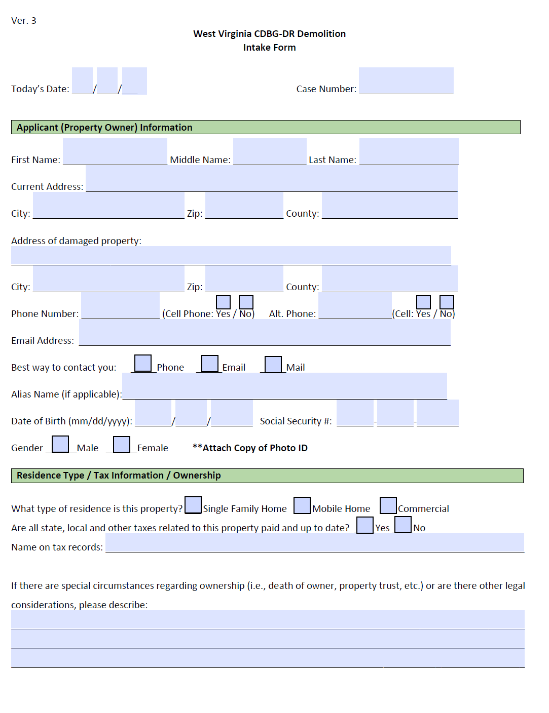
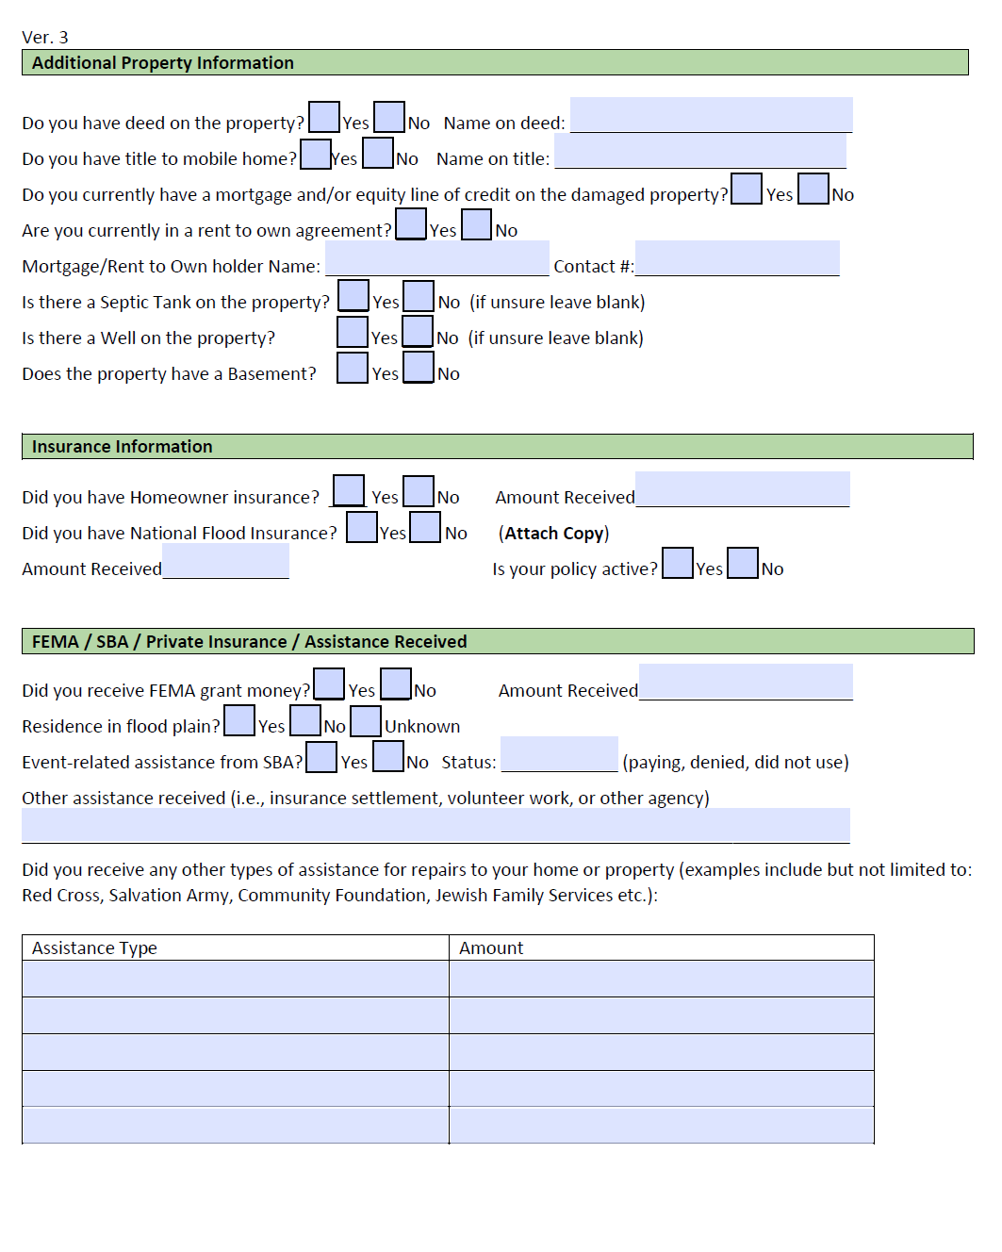

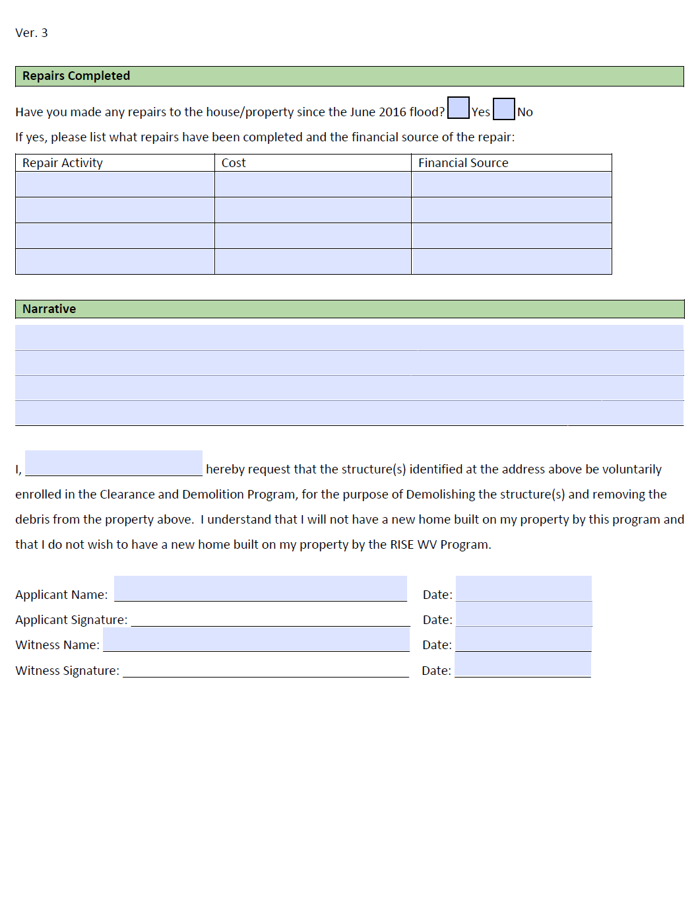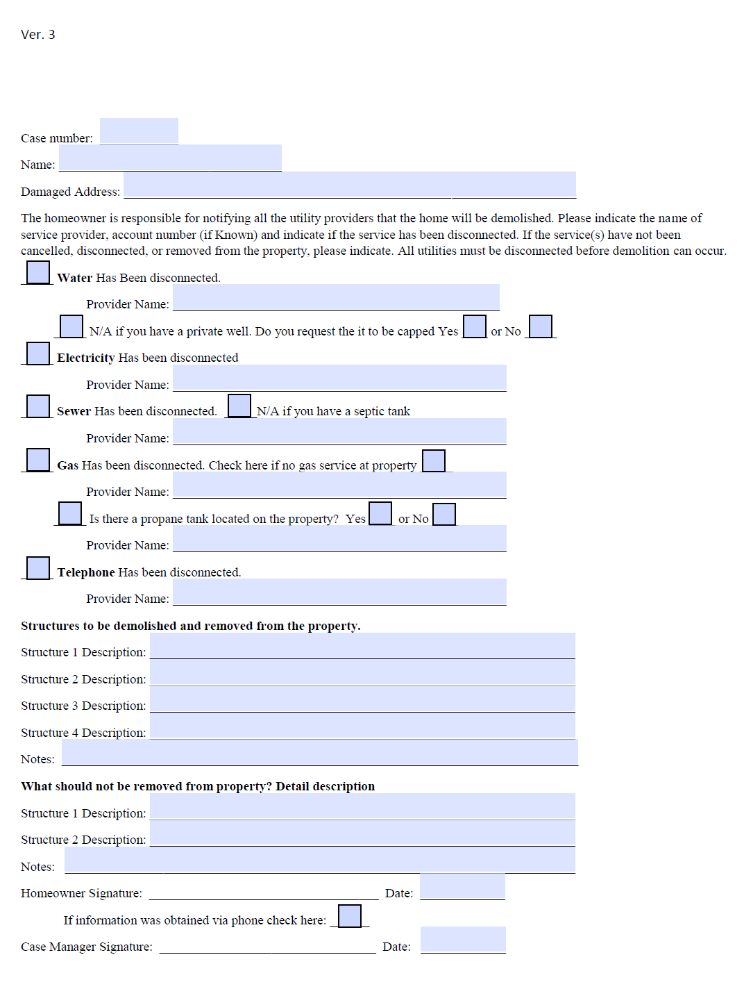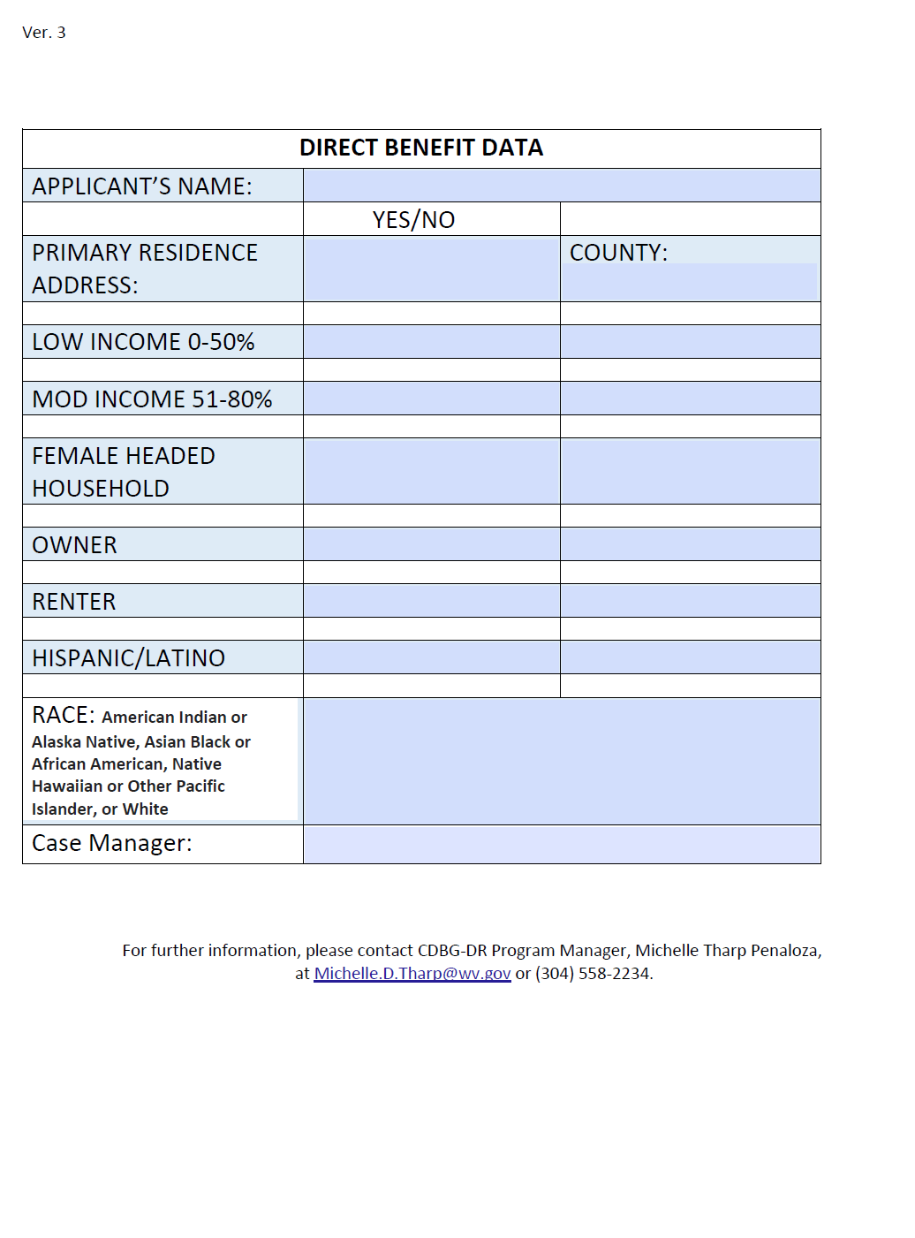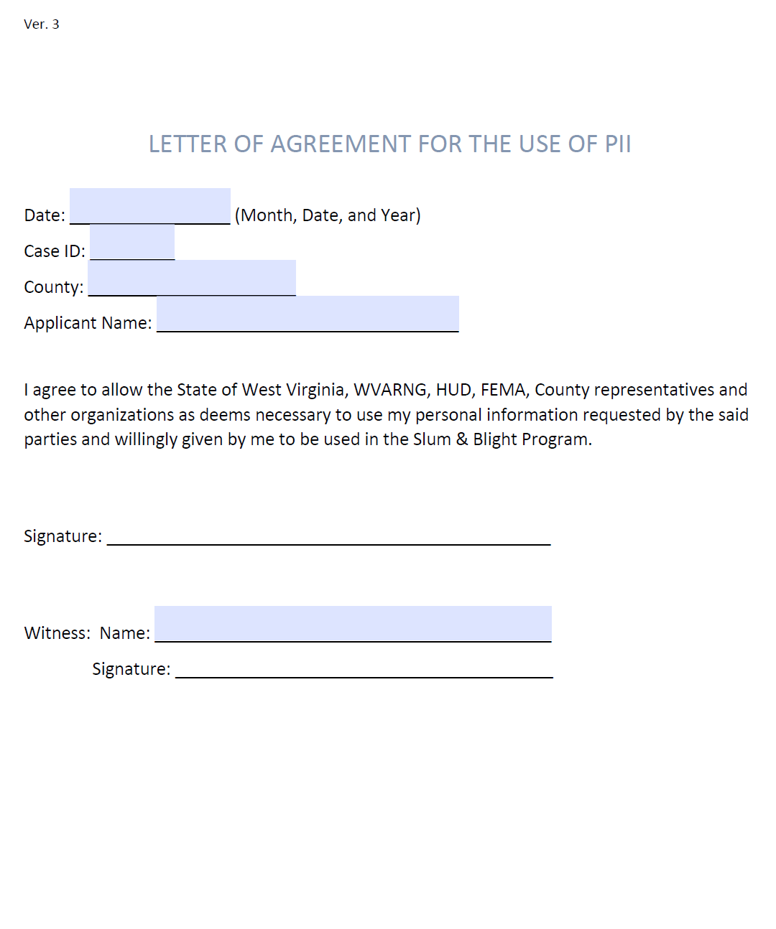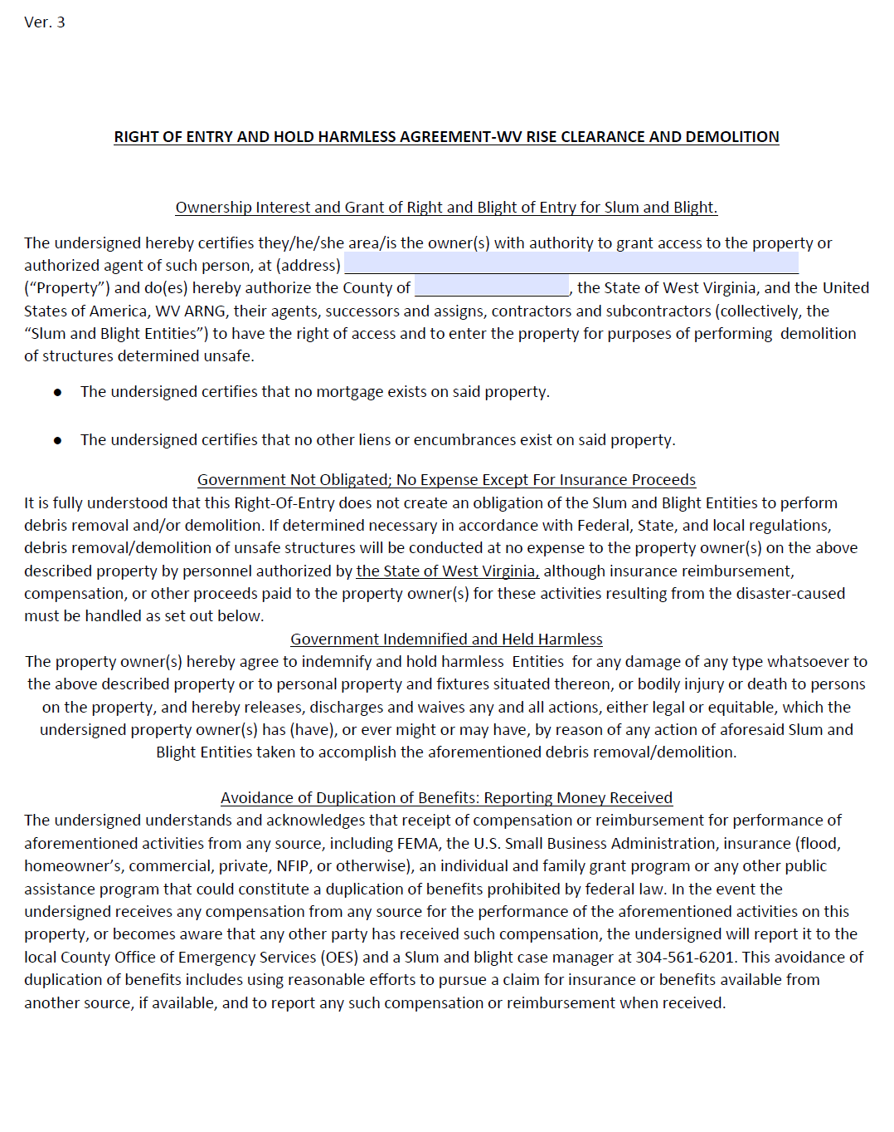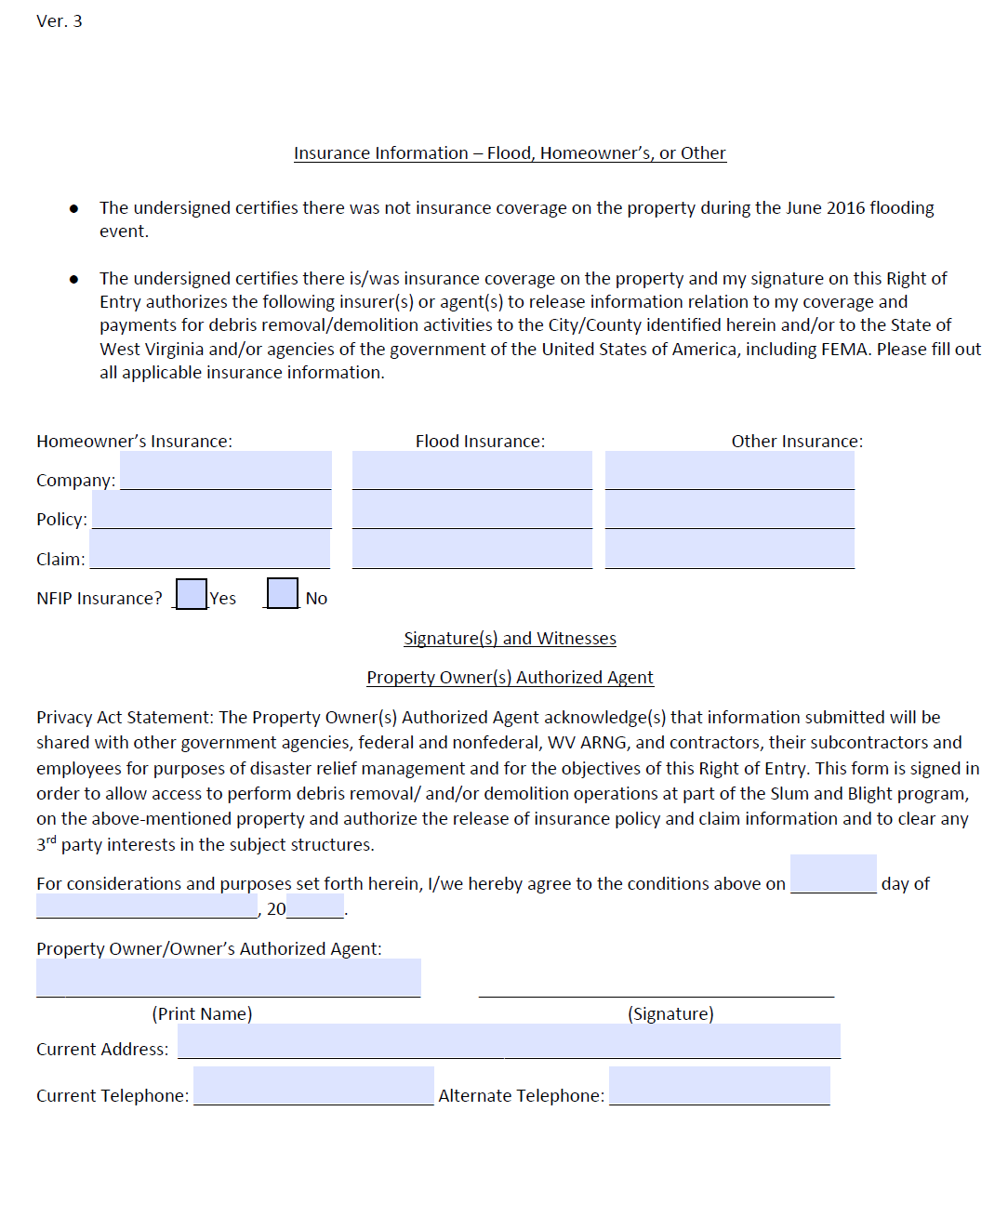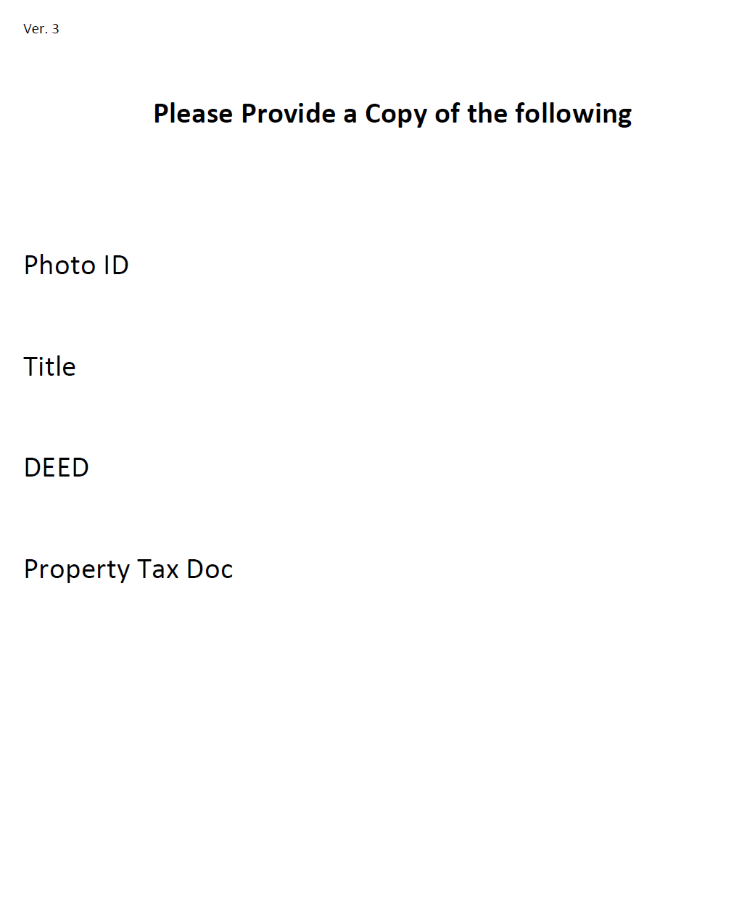

APPENDIX E:
CLEARANCE AND DEMOLITION PROGRAM
WITHDRAWAL AUTHORIZATION

Date: ____________________________ (Month, Date, and Year)
Case ID: _________
Applicant Name: _____________________________________
Damaged address ________________________________
________________________________
Current Mailing Address ________________________________
________________________________

I request my application to participate in the Clearance and Demolition Program be withdrawn. I no longer want to have my property on this list.

Signature: __________________________________________________

Witness Name: ________________________________________________________
Witness Signature: _____________________________________________________

APPENDIX F

THREE-YEAR DECLARATION OF COVENANTS AND RESTRICTIONS

West Virginia Development Office – Community Advancement and Development
U.S Department of Housing and Urban Development Community Development Block Grant—Disaster Recovery
Disaster Recovery Clearance and Demolition Program
Date: (Complete)
Owner: (Name)
Property Address: (Complete)
Expiration/Anniversary Date: Three years from demolition closeout inspection date
WHEREAS, the undersigned (insert name of owner(s) here) ________________________________ (“OWNER(S)”), of subject property at (insert full damaged property address here)____________________________________ (“PROPERTY”) is the owner of certain real property located in the City/Township/Town of (insert name of municipality here)__________________, County of (insert name of county here)___________________, State of West Virginia, and

WHEREAS, OWNER has signed a Grant Award with the WV Development Office (WVDED), which provides for a Demolition Grant Award funded by Community Development Block Grant Disaster Recovery (“CDBG-DR”) monies; and
WHEREAS, OWNER has agreed to the imposition of certain covenants and restrictions as required in order to receive the Grant Award.
NOW, THEREFORE, for and in consideration of the Grant Award with the WV Development Office the receipt and sufficiency of which is hereby acknowledged, OWNER does hereby make, declare and publish the following covenants and restrictions, all of which shall be covenants running with the Property, and the Property shall be held, transferred, sold, conveyed and occupied subject to the covenants and restrictions hereinafter set forth until released as set forth herein:
- The Term of this Agreement is Three Years from the Demolition Closeout Inspection.

- Clearance and demolition activities undertake through the Program meet HUD national objective slum and blight as set forth under the State’s HUD-approved Action Plan. The intent of the policies and procedures supporting these activities are to achieve the national objective by providing non-discriminatory race-neutral relief, while causing no disparate impact to the beneficiaries of the program.

- Owner agrees to Program requirement for the repayment of the Demolition Grant Award in the total amount whenever the Property is sold or transferred within three years of the date of the Closeout inspection.

- Building any structure on subject property identified in the Floodway is prohibited. Subject property must be maintained greenspace and clean of any debris.

- Subject property outside or inside of the identified 100-year or 500-year floodplain, may be utilized within the three-year restriction as greenspace or any purposeful space that provides public access for all following NEPA requirements. Examples of permissible usages include a community park, community outside markets to support local goods, kayak launching site, or other recreational uses. Subject property may not be used for general conduct of government affairs/business.

- Upon the third anniversary date, and if all conditions of the Program rules and regulations have been satisfactorily followed, the Covenants and Restrictions will be released. In addition to the above, in the event of noncompliance with the terms and conditions herein, the WV Development Office may avail itself of any and all legal remedies to enforce the within terms and conditions.

- The Program will file and record this Declaration in the County Recorder’s office for the County in which the Property is located for all applicants.

- This Declaration imposes no other obligations or restrictions upon the OWNER, their successors, assigns, licensees, and any party claiming under OWNER from utilizing the Property in such lawful manner as they may deem desirable with the exception of the terms and conditions contained herein.
This Declaration shall be binding upon OWNER.
IN WITNESS WHEREOF, OWNER has duly executed this Declaration as of the date first above written.
WITNESS: __________________________

_______________________________________ ___________________________________________________
AUTHORIZED SIGNATURE for OWNER WV DEVELOPMENT OFFICE AUTHORIZED SIGNATURE

_______________________________________ ___________________________________________________
NAME and TITLE NAME and TITLE

_______________________________________ ___________________________________________________
DATE DATE

STATE OF WEST VIRGINIA )
) ss:
COUNTY OF __________ )
I CERTIFY that on the _______ day of _________________, 20__, __(insert names of all owners here) ________________________________________ , personally came before me, and this person(s) acknowledged under oath, to my satisfaction, that: he/she is named in and personally signed this document; and he/she signed, sealed, and delivered this document as his/her act and deed.

Appendix G:
RISE WV Clearance and Demolition Program:
Damage Verification Form
Case ID: ________________________________________

County: ________________________________________

Address: ________________________________________

City: ___________________________ Zip: ________
The purpose of this form is to provide verification that the proposed structure(s) on the address listed above was damaged beyond rehabilitation by the severe weather disaster in June of 2016. This form must be completed by a Floodplain Manager or an individual who possesses expert knowledge in the field, and whose jurisdiction extends to the county in which the identified property is located. This form may not be completed by an elected official such as a mayor or county commissioner. In order to be eligible to receive demolition assistance through the RISE WV Clearance and Demolition Program, the proposed structure must:

- Be located in a Federal Disaster Declared County;
- Have sustained damage during the June 2016 severe weather disaster that worsened the structure beyond its pre-event use;
- Be damaged beyond rehabilitation;
- Be vacant from the time of application;
- Have documentable evidence of storm related damage from the June 2016 disaster; and
- Present a significant risk of contributing to slum or blight conditions

Completion of the Damage Verification form does not guarantee eligibility. In addition to these damage verification requirements, the proposed structure must also meet all other eligibility criteria listed in the program Policies and Procedures document before demolition can be approved by the program. A copy of this document can be accessed at https://wvfloodrecovery.com/program-details/. Funding for the RISE WV Clearance and Demolition program is provided by the U.S. Department of Housing and Urban Development (HUD). Program guidelines, policies, and procedures have been approved by HUD and must follow Federal CDBG-DR regulations. Eligible applicants will be mailed a letter confirming their eligibility.

The address listed above is located in one of the Federal Disaster YES □ / NO □
Declared counties resulting from the June 2016 severe storms.

The structure on the address listed above sustained damage during the YES □ / NO □
2016 disaster that worsened it beyond its pre-event use.

To the best of my knowledge, the structure on the address listed above YES □ / NO □
is damaged beyond rehabilitation.

The structure on the address listed above is vacant. YES □ / NO □

The structure on the address listed above has documentable evidence YES □ / NO □
of disaster-related damage.

The structure on the address listed above presents a significant risk of YES □ / NO □
contributing to slum and blight conditions per WV State Code.
By signing below, under penalties of perjury, I certify that the information presented in this document is true and accurate to the best of my knowledge and belief. I further understand that providing false representations herein constitutes an act of fraud. False, misleading or incomplete information may result in ineligibility to participate in this or other Federal programs. This document is subject to HUD review at any time, and any person who knowingly makes a false claim or statement to HUD may be subject to civil or criminal penalties under 18 U.S.C. 287, 1001 and 31 U.S.C. 3729.

Printed Name: ___________________________________

Title: ___________________________________________

Signature: _______________________________________

Inspection Date: __________________________________
Appendix H
RISE Clearance and Demolition Program: Subrogation Agreement

I grant the State, or its designees, subrogation rights to recover, from any person or entity, funds to which I may be entitled for property damage incurred by the June 2016 severe weather disaster. I understand that if I receive future assistance intended for the same purpose as the CDBG Disaster Recovery services provided through the RISE WV Clearance and Demolition Program, any funds (or the cost of equivalent benefits) received through RISE WV must be returned to the State according to program guidelines, which can be accessed at: https://wvfloodrecovery.com/.

Examples of duplicated funds include, but are not limited to:
- Insurance payouts as a result of a settlement
- Non-profit funding or funding through other local sources
- Financial assistance from other Federal programs (e.g. FEMA, SBA, Covid Relief, etc.)
- Funding from other State programs (e.g. WVDEP)
- Funding from County programs (e.g. DHHR)

I also understand that the State or its designees may recover other funds awarded to me, up to the total cost of assistance provided by the RISE WV Clearance and Demolition Program. I agree that if I receive duplicated funds intended for the same purpose of rehabilitating, repairing, or demolishing the same structure(s) identified in my application, I will notify the State or its designee within five (5) days of receipt of the funds. I will send the notice to:

West Virginia Department of Economic Development
ATTN: Jacob Wolfe
1900 Kanawha Blvd., E
Building 3, Suite 700
Charleston, WV 25305

By signing below, I agree that I have read and understand this document or have had someone explain it to my satisfaction.

___________________________________ ____________ ____________
Property Address Case ID Date

Applicant Signature Applicant Name (Printed)
Co-Applicant Signature Co-Applicant Name (Printed)
Appendix I:
RISE WV Clearance and Demolition Program:
Verification of Imminent Threat / Slum and Blight

Case ID: _____________________ Date of Inspection : ______________________

City: ________________________ Zip: ________ County: _________________

Property Address: _______________________________________________________________

Inspected By: __________________________ Title: __________________________________

The purpose of this form is to provide verification that the proposed structure(s) on the address listed above meets the definition of Slum and Blight conditions per WV Code Chapter 16, Article 18. This document, alone, does not serve to determine eligibility for the RISE WV Clearance and Demolition Program. Eligible applicants will be mailed a letter confirming their eligibility after all application criteria has been reviewed. A copy of program Policies and Procedures detailing eligibility criteria can be accessed online at https://wvfloodrecovery.com/program-details/. Funding for the RISE WV Clearance and Demolition program is provided by the U.S. Department of Housing and Urban Development (HUD). Program guidelines, policies, and procedures have been approved by HUD and must follow Federal CDBG-DR regulations.

Based upon the inspection completed on the above-referenced date, it has been determined by the County Building Inspector and/or County Commission authorized representative(s) that the referenced structure(s) meets the criteria for Slum and Blight conditions per WV Code Chapter 16, Article 18. This property poses an immediate threat to life, health, and/or public safety. In addition, this determination meets the following applicable criteria documented below, as defined by the Federal Register guidelines which govern the program:

Please check all conditions that apply to the structure on the property listed above:

□ The structure is unsafe and poses an immediate threat to life, health, and/or public safety
□ The structure poses an immediate threat of damage to public or private property
□ The structure poses an immediate threat to economic recovery in its community
□ The structure is abandoned
□ The structure is home to known or suspected criminal activities

By signing below, under penalties of perjury, I certify that the information presented in this document is true and accurate to the best of my knowledge and belief. I further understand that providing false representations herein constitutes an act of fraud. False, misleading or incomplete information may result in ineligibility to participate in this or other Federal programs. This document is subject to HUD review at any time, and any person who knowingly makes a false claim or statement to HUD may be subject to civil or criminal penalties under 18 U.S.C. 287, 1001 and 31 U.S.C. 3729.

______________________________________
Inspector Name (Printed)

_______________________________________ ________________________
Signature Date

