West Virginia

Community Development Block Grant

Amendment 11 to Disaster Recovery Action Plan

For the use of CDBG-DR Funds in response to the floods and severe storms of June 2016

Date posted to website: March 10, 2026

Table of Content

Summary of Changes | Page 3
Amendment 11 to CDBG-DR Action Plan | Page 3
Executive Summary | Page 6
- Introduction | Page 9
- Overall Storm Impact | Page 20
- Impact & Unmet Needs | Page 33
- Sources of Funding to be Leveraged & CDBG-DR Award | Page 78
- Method of Distribution & Connection to Unmet Need | Page 83
- Programs  - Housing  - WV Housing Restoration Program  - WV Rental Assistance Program  - RISE WV Multifamily Rental Housing  - RISE WV Clearance and Demolition  - Bridge Home Program  - WVHMGP / CDBG-DR Match  - Restore Riverview Project  - RISE WV Economic Development  - Planning  - Administration | Page 87  Page 87  Page 91  Page 94  Page 99  Page 100  Page 101  Page 103  Page 105  Page 107  Page 110  Page 111
- Long-Term Recovery | Page 112
- Effort to Minimize or Address Displacement | Page 115
- Flood insurance and Elevation Standards | Page 116
- Protection of People and Property; Construction Methods | Page 117
- Program Income | Page 119
- Monitoring Procedures | Page 120
- Broadband Infrastructure | Page 121
- Citizen Participation Plan | Page 121
- Certification | Page 125
- Appendices | Page 127

Summary of Changes
This Eleventh Amendment to the West Virginia Community Development Block Grant – Disaster Recovery (CDBG-DR) Action Plan…..
Amendment Changes to the Action Plan

11th SUBSTANTIAL AMENDMENT TO THE CDBG-DR ACTION PLAN
Previous Page | New Page | Section | Change/Addition/Deletion
91  94  101  105  106  99  107  110 | 91  94  101  105  106  99  107  110 | VI. Programs | RISE WV Housing Restoration Program: Decrease activity budget by $3,624,108.23 in order to close the project.  RISE WV Rental Assistance: Decrease activity budget by $238,363.53 in order to close the project  Bridge Home Program: Decrease activity budget by $860,704.24 in order to close the project.  Restore Riverview Onsite: Decrease activity budget by $5,191.56 in order to close the project.  Restore Riverview Offsite: Decrease activity budget by $3,032.38 in order to close the project  RISE Multifamily - Increase activity budget by $5,522,691.51 for additional Multi-Family project  WV Economic Development - Increase activity budget by $700,000 for Infrastructure project  Planning: - Decrease activity budget by $1,491,291.58

CDBG-DR Award Allocation
The following table illustrates where all funds are derived from and what activities they are allocated to.
West Virginia CDBG-DR Award

Program | Substantial Amendment 10 | Substantial Amendment 11
RISE WV Housing Restoration Program | $78,870,409.97 | $3,624,108.23  $75,246,301.74
RISE WV Rental Assistance | $8,248,270.83 | $238,363.53  $8,009,907.30
WV Coordinated Match Program (HMGP/CDBG-DR Match) | $0.00 | $0.00
Bridge Home Program | $7,360,816.11 | $860,704.24  $6,500,111.87
Restore Riverview Onsite | $7,586,783.00 | $5,191.56  $7,581,591.44
Restore Riverview Offsite | $11,284,135 | $3,032.38  $11,281,102.62
RISE Clearance and Demo | $5,661,110.43 | $5,661,110.43
RISE Multifamily | $8,875,000.00 | $5,522,691.51  $14,397,691.51
RISE Economic Development | $6,442,216.41 | $700,000.00  7,142,216.41
Planning | $8,240,508.25 | $1,491,291.58  $6,749,216.67
State Administration | $7,305,750.00 | $7,305,750.00
West Virginia CDBG-DR Award | $149,875,000 | $149,875,000

*Red text shows a change in the allocation
*Black text reflects the change and shows the new budget

Citizen Participation
This Action Plan Amendment is considered substantial as it changes program benefits and eliminates language previously in the original action plan and tenth substantial amendment. The formal public comment period for the plan begins March 9, 2926 and commences at 5:00 pm on March 23, 2026.
This Eleventh Amendment to the Disaster Recovery Action Plan was posted on http://wvfloodrecovery.com for a minimum of 14 days.
Citizens and organization were offered multiple opportunities to comment on this Amendment via:
- Email: disasterrecovery@wv.gov
- Mail:
West Virginia Development Office
1900 Kanawha Boulevard East, Building 3, Suite 700
Charleston, WV 25305
- Phone: 304-558-2234

Executive Summary
In June 2016, the State of West Virginia suffered record breaking amounts of rainfall causing catastrophic flooding across 17 counties. As profiled in West Virginia Public Broadcasting’s coverage of the flood aftermath entitled “Inside Appalachia: West Virginia’s 1,000-year flood,”¹ the flooding caused widespread damage to housing, businesses, and infrastructure in an event that the National Weather Service has deemed “historic” and “extremely rare.” Based on data now available it is referred to as “the thousand-year flood.”² Between 8 to 10 inches of rain fell in a narrow window of 12 hours. Small towns like White Sulphur Springs and Clendenin were damaged beyond recognition. Then-Governor, Earl Ray Tomblin, declared a state of emergency in 44 of West Virginia’s 55 counties. Excessive rainfall caused swelling of creeks and rivers to extreme levels, widespread power outages, structural damage to homes and businesses, and made thousands of West Virginians homeless. The American Red Cross opened 13 shelters which resulted in 2,300 overnight stays, 198,300 meals and snacks served, 133,000 relief items distributed, and 1,700 cases opened to help individuals and families in need.³ A total of 23 lives were lost as a result of the devastating flood.
Many of the flood impacted areas throughout the State were outside the flood plain and thus, were not required to carry flooding insurance. An estimated 90% of the almost 9,000 FEMA applicants did not have flood insurance.⁴ Additionally, these areas have some of the State’s poorest and oldest citizens with neither adequate funds nor the ability to obtain substantial funding for recovery. Of the almost 5,000 approved applicants for FEMA funding, only 1,776 applicants were referred to SBA for a disaster home loan and only 720 were ultimately approved.

Image 1: An excavator rebuilds where a private bridge once stood while containers from a flooded kitchen are laid out to dry
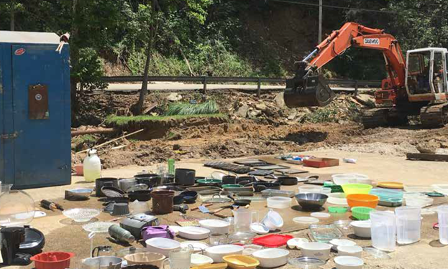
- https://youtube.com/watch?v=V8ehFEtJsGo
- https://weather.com/safety/floods/news/1-in-1000-year-flood-events
- http://www.redcross.org/local/west-virginia/flood-information
- FEMA Individuals and households program application dataset
Additionally, only 431 of the loans have actually been disbursed.⁵ The low SBA approval and disbursement rate supports the fact that the impacted population throughout the State is already over leveraged to a point where additional debt is simply unmanageable.
With approximately 75% of homes approved for FEMA assistance being deemed unsafe after inspection it is apparent that the State is facing a housing recovery crisis. Housing repairs and replacement could easily exceed $300 million per the State’s calculation of unmet need as outlined in this Action Plan. In addition, damage to West Virginia’s public infrastructure is estimated to top $500 million per the State’s emergency management officials. Adding to the cost of recovery is the number of aging local water and wastewater collection systems across the declared counties which were inundated with water. Hundreds of West Virginians continue to be displaced without sufficient accommodations, with many living in tents and campers outside of their damaged homes.⁶
- SBA Home Loan application dataset
- http://www.wvgazettemail.com/news-education/20161119/vocational-students-build-tiny-houses-for-wv-flood-survivors
The State intends to utilize $88,889,250 of the $149 million CDBG-DR award to design and implement a housing program which will grant funds to homeowners and owners of rental property who have unmet needs as a result of the flood and require additional assistance for returning their properties to their pre-flood state. The focus will be to repair and habilitate single family homes and mobile homes, although whole replacement will also be considered in situations where properties were deemed to have substantial damage. The State estimates there are approximately 1,000 units throughout the areas of the declared counties with the highest social vulnerability which still have an unmet housing need after accounting for other sources of funds. Because of the limited award funds available, the State will prioritize and target outreach efforts and application processing in the most vulnerable areas first by utilizing the SoVI® index method which is discussed in detail in the Action Plan. Additional prioritization factors include those properties that were primary residences and did not have flood insurance. If after serving the most vulnerable population there are funds remaining, the State will move to serve populations with a lower vulnerability.
In addition to the repair and rehabilitation of homes, the State will use $48 million of the funds to implement a home access bridge repair program, a mixed-use rehabilitation project, a clearance and demo program, an Economic Development Program and provide the State’s required non-federal local match for FEMA’s Hazard Mitigation Grant Program. This approach will ensure that housing recovery is holistic and addresses additional unmet needs specific to West Virginia’s landscape that are outside of traditional repair and rehabilitation of housing structures. The State will leverage its relationships with other federal, state, and local jurisdictions to ensure that these activities are not duplicative of other programs but instead, are blended with additional sources of funds to realize maximum investments in its recovery.
The remaining funding will be spent on the State’s planning and administration activities. The State intends to use these funds for the following activities: planning, the development of a disaster recovery and response plan, community outreach and implementation of program activities; geographic, demographic and legal support; and planning to increase resilience. These activities have already included and will include in the future:
- Support the State Resiliency Office;
- Preparation of CDBG-DR Action Plans;
- Ensuring citizen participation (including publication of public notices);
- Development of a disaster recovery and response plan;
- Preparation of the required CDBG-DR quarterly reports;
- Maintenance of the CDBG-DR website;
- Preparation and oversight of environmental reviews;
- Monitoring of the expenditures for CDBG-DR programs;
- Delineation of population groups served by CDBG-DR programs;
- Liaison function with HUD, FEMA, and other federal departments; and
- Certification and maintenance of the necessary records that demonstrate that federal requirements for environmental review, fair housing, relocation, labor standards, equal opportunity, and citizen participation are met.

Program Budget
Housing | West Virginia Housing Restoration Program | $75,246,301.74
Housing | West Virginia Rental Assistance Program | $8,009,907.30,
Housing | Hazard Mitigation Grant Program Match | 0
Housing | Bridge Home Program | $6,500,111.87
Housing | Restore Riverview Project-Onsite | $7,581,591.44
Housing | RISE Clearance and Demo | $5,661,110.43
Housing | Riverview Offsite | $11,281,102.62
Housing | RISE Multifamily Rental Housing Program | $14,397,691.51
Housing | RISE Economic Development | $7,142,216.41
Housing | State Planning | $6,749,216.67
Housing | State Administration | $7,305,750.00
 | Total Budget | $149,875,000

Under its CDBG-DR Action Plan, West Virginia has outlined the programs to be administered during the next several years based on an unmet needs assessment performed with available post-flood data. Federal, state, and local partners provided input on all funds awarded thus far and the needs that remain for which CDBG-DR funding may be used. It is the intention of the State to focus primarily on housing as directed by HUD and given this is the affected sector which has the highest remaining unmet need per the analysis the State performed. The State believes that the first priority after any disaster of this magnitude is to ensure that citizens, particularly the most vulnerable, have safe and sanitary housing to return to and begin the process for rebuilding their lives. Without adequate housing, devastated communities will not return to their pre-storm state, populations will decrease, and local economies will suffer.
The State recognizes that West Virginia has unique characteristics, such as a challenging topography, that must be taken into account when designing and implementing a holistic recovery focused on housing. With limited land for development the State will take care to ensure that mitigation efforts such as elevation are considered when restoring property. As discussed in detail within the Needs Assessment of the State’s Action Plan, mitigation and resiliency is especially important in West Virginia considering the history of flooding in the state. Accordingly, mitigating against future disasters will be an integral part of the State’s approach to minimize loss of life and property in the future.

Introduction
West Virginia’s initial settlers developed communities with easy access to natural resources, ease of transportation, and availability of flat stream or river bottom land for growth of communities and development of local industries. West Virginia’s landscape of mountains and narrow valleys coupled with environmental factors only exacerbates the state’s flooding problem. During the June 2016 severe storms, water drained from steep mountain tops into valleys, where roads and homes became inundated with water at a record pace. Entire communities were under water in a matter of minutes. Small towns such as Rainelle, with a rich history rooted in lumber and coal mining but whose local economies have suffered in recent years, were some of the hardest hit in the historic flood. These already economically disadvantaged small towns were unprepared for the record-breaking flooding and as a result, now face an overwhelming task of recovery. They simply do not have the capacity to recover without assistance from the state and federal government. Using the best available data, the West Virginia Department of Commerce (WVDOC) identified the unmet need amounts shown in the table below.
Table 2: Unmet Needs
Unmet Needs by Sector
Housing | Infrastructure | Economic
$295,500,000 | $41,300,000 | $132,800,000

In October and December of 2016, West Virginia was awarded a total of $104.28 million in Community Development Block Grant – Disaster Recovery funds from the U.S. Department of Housing and Urban Development (HUD) to address unmet needs as a result of the floods. As part of the $104.28 million appropriated from Congress, Federal Register Notices were then published by HUD which outlined the requirements and stipulations for the use of the grant. Along with the requirements set forth by the Federal Register, WVDOC will prioritize the use of funds accordingly to benefit the most vulnerable populations and address the most significant unmet needs. The requirements and priorities are as follows:
- Overall Requirements:
  - 80% of the total grant amount ($83,424,000) must benefit the Most Impacted and Distressed (MID) areas determined by HUD to be Kanawha, Greenbrier, Clay and Nicholas Counties. The remaining 20% of funds ($20,856,000) will be available to benefit other declared counties determined by the State to be MID areas.
  - 70% of the total funds must benefit low- to moderate-income (LMI) persons (approximately $73 million)
  - All funded activities must meet 1 of 3 national objectives
    - Benefit persons of low- to moderate-income, or
    - Aid in the prevention or elimination of slums or blight, or
    - Meet other urgent community development needs
  - Programs must stern from an unmet recovery need not already addressed by other federal, state/local, nonprofit funds, or private insurance. Grantees will be required to document a connection to the disaster.
- The State submitted, and HUD approved, a waiver which will include the counties of Clay and Nicholas in the MID areas.
- The Priorities of the State shall be to:
  - Address needs of the most vulnerable LMI populations
    - Four of the five programs implemented will satisfy the national objective of benefiting low- to moderate- income persons, which includes total funding of approximately $83 million (detailed below)
    - Aid the most substantial needs of the State’s most vulnerable populations identified by the needs assessment
    - Mitigate risk and hazards due potentially related to future natural disasters
Table 3: CDBG-DR Funded Activities
CDBG-DR Funded Activities
Funded Activity | HUD Eligibility Criteria | National Objective
West Virginia Housing Restoration Program | Rehabilitation / Reconstruction of Residential Structures | Activities benefiting Low-to moderate income (LMI) persons
West Virginia Rental Assistance Program | Rehabilitation / Reconstruction of Residential Structures | Activities benefiting LMI persons
HMGP Match | Non-Federal Match | Shall satisfy any 1 of the 3 national objectives
Bridge Home Program | Code Enforcement and Architectural Barrier Removal | Activities benefiting LMI persons and/or Urgent Need
Restore Riverview Project | Code Enforcement, Clearance and Demo, Provision of Assistance to Public and Private Organizations | Activities benefiting low- and moderate- income persons
State Planning and Administration | Planning and Administrative Activities

West Virginia was declared a major disaster area by President Obama on June 25, 2016. As a result of the intense flooding, 1,200 homes were destroyed, thousands were left without power and shelter, critical public and private infrastructure was affected, and many residents were left vulnerable with limited access to housing, healthcare, and other critical needs.² During the aftermath of the flood the dedication of local and state volunteers, public employees, and officials provided the pathway for a swift short-term recovery. The U.S. Housing and Urban Development’s (HUD) Community Development Block Grant Disaster Recovery (CDBG-DR) program will now provide critical resources to address remaining unmet need and the long-term recovery needs in West Virginia communities devastated by the severe storms.
Programs outlined in this Action Plan described how West Virginia will utilize its two allocations of CDBG-DR funding. Resilience measures to protect against future flooding will be a key factor in program design. Projects will promote best practices in land use, such as managing floodplain development, addressing dilapidated buildings, acquiring or flood proofing and/or elevating at-risk structures, and providing safe housing outside of the floodplain. Best practices in land use will be key to West Virginia’s recovery because of the limited sites available for development due to the mountainous terrain. The programs in this Action Plan include activities to primarily address housing.

Appropriations Act
The Continuing Appropriations Act of 2017 (Pub.L. 114-223 and Pub.L. 114-254) (collectively, Appropriations Act) was enacted to appropriate federal funds for disaster relief. The Appropriations Act gives monies to states for disaster recovery efforts in the affected areas. The federal government appropriated a total of $2.3 billion in Community Development Block Grant – Disaster Recovery (CDBG-DR) funds through two separate allocations, the requirements of which are set forth under Federal Register Notices, 81 FR 83254, 82 FR 5591. These funds were allocated to the various states that were declared to have suffered a major disaster by the President of the United States in 2016. The appropriating laws and implementing regulations require the funds to be used to satisfy a portion of unmet need that remains after other federal assistance such as Federal Emergency Management Agency (FEMA) grants, Small Business Administration (SBA) loans, or private insurance has been received.
The Department of Housing and Urban Development (HUD) uses the “best available” data to identify and calculate unmet needs for disaster relief, long-term recovery, restoration of infrastructure, and housing and economic revitalization. Based on this assessment, HUD notified the State of West Virginia that it will receive three allocations totaling $149,875,000 in Community Development Block Grant – Disaster Recovery (CDBG-DR) funding for recovery programs stemming from Federal Disaster 4273, West Virginia Severe Storms, Flooding, Landslides, and Mudslides.
The Appropriations Act requires that the State must expend the funds within six years of the signed agreement between HUD and the State unless HUD grants an extension. All allocation funds will be used for eligible disaster-related activities only. To ensure that fraud, waste, and misuse of funds does not occur, effective controls are in place to continuously monitored for compliance. Additionally, the West Virginia Action Plan describes how the State will utilize and leverage other funding sources to address unmet needs.
2 http://www.cnn.com/2016/06/28/us/west-virginia-flooding-weather/
West Virginia Recovery Coalition
West Virginia rapidly began short-term planning and recovery after the waters receded. The State, with help from local communities and volunteer organizations, was dedicated in its service to restore basic needs and ensure immediate threats were alleviated. Multiple faith-based organizations, non-profits, and other stakeholders around the state and nation aided in community clean-up, short-term home repairs, and provided shelter for displaced residents. Most of the counties included in the presidentially declared disaster established Long Term Recovery Committees (LTRC) in the aftermath of the flood. The purpose of the LTRCs is to aid in long-term recovery efforts once initial emergency partners, both federal and state, complete their work in the area. These committees have worked tirelessly throughout the recovery process to organize volunteers and distribute assistance to local citizens with many of the members being affiliated with organizations such as The Red Cross and Mountain Mission. Additionally, the West Virginia Chapter of Voluntary Organizations Active in Disasters (WVVOAD) has been instrumental in organizing volunteers and collaborating with local, regional, and national partners to expedite recovery to residents who still have unmet needs. The State of West Virginia has been intentional in its efforts to include all stakeholders in the recovery process by forming a Recovery Coalition that captures input on the unmet needs in the declared counties from all affected entities and streamlines recovery operations across the state. The State will continue to coordinate planning efforts with federal, state, regional, and local partners to ensure consistency in delivery of the programs undertaken as outlined in this action plan.

Image 3: A woman stands outside her home in Clendenin where water levels reached the top of the home’s roof
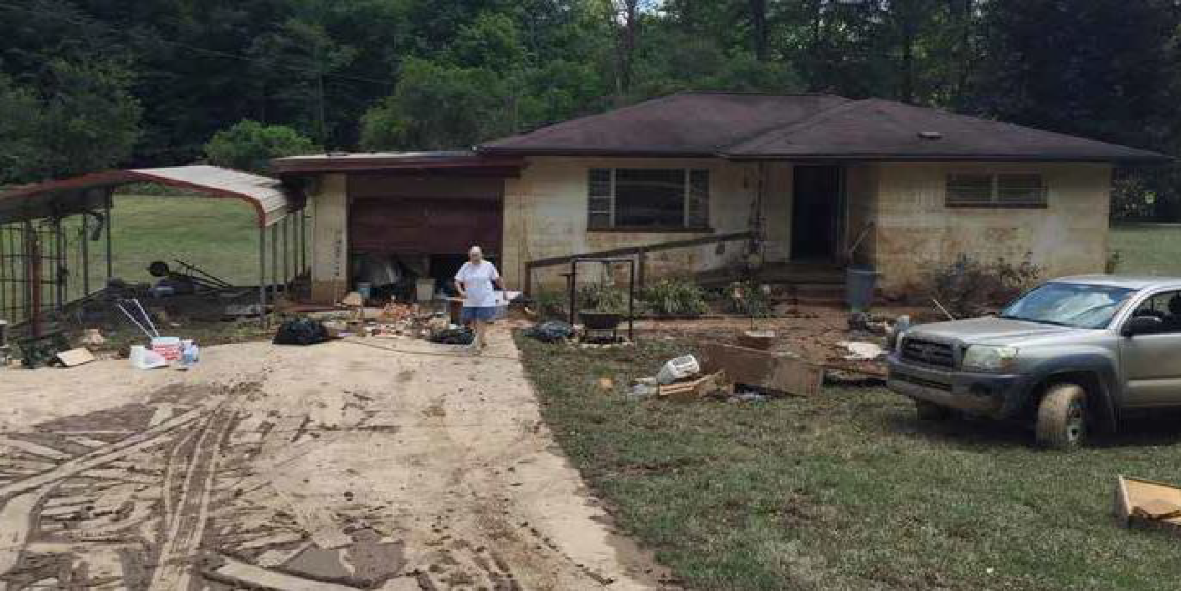

 | West Virginia Army National Guard  One of the multiple unsung heroes of West Virginia’s flood recovery has been the West Virginia Army National Guard. The Guard is led by Major General James A. Hoyer, who was appointed Chief Recovery Coordinator by former Governor Earl Ray Tomblin to oversee flood recovery operations across the state. The National Guard was an integral part of the immediate response efforts of the state with 570 troops deployed in the field. Dubbed “Operation Summer Rain,” several hundred rescue missions were carried out including swift water and rooftop rescues. The Guard worked diligently as a part of the Interagency Task Operation and although 23 lives were ultimately lost, many more were saved by the Guards quick action and unrelenting service to the citizens of West Virginia.  Led by General Hoyer, the Guard has been a vital partner to the WVDOC since the award of CDBG-DR dollars was made, offering input and assistance to the State to ensure long-term recovery is accomplished expeditiously. Joint meetings have been held and will continue under the direction of General Hoyer while long-term recovery efforts are further defined, and activities begin.

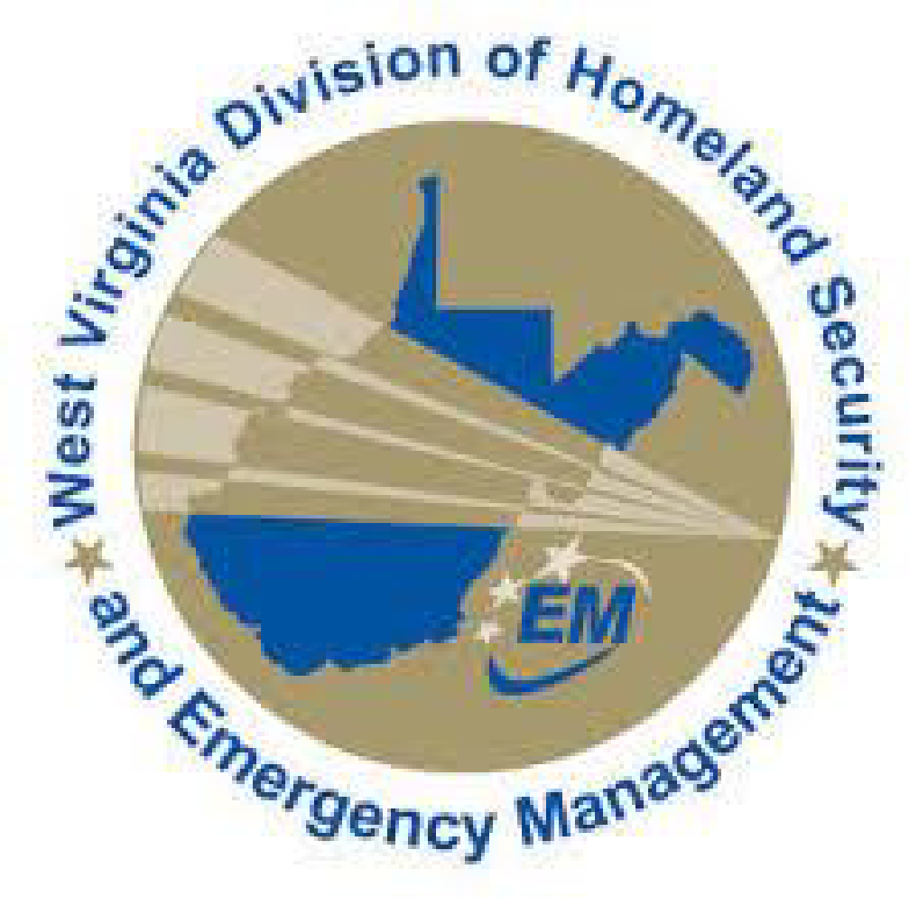  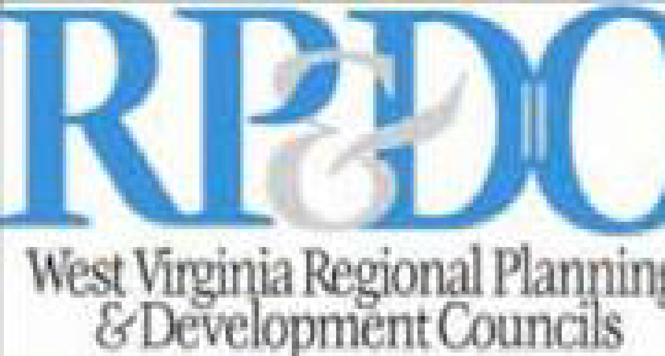      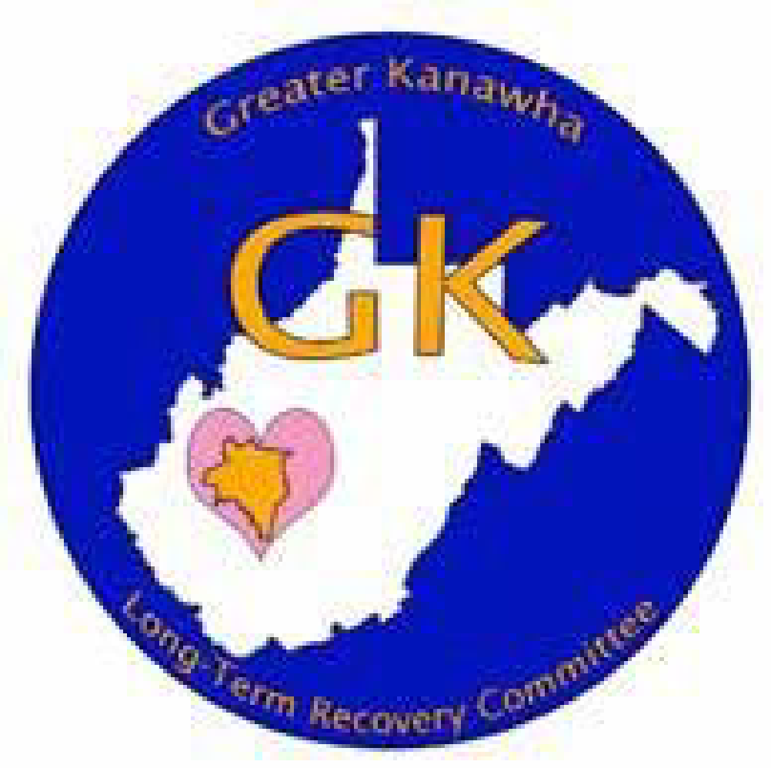    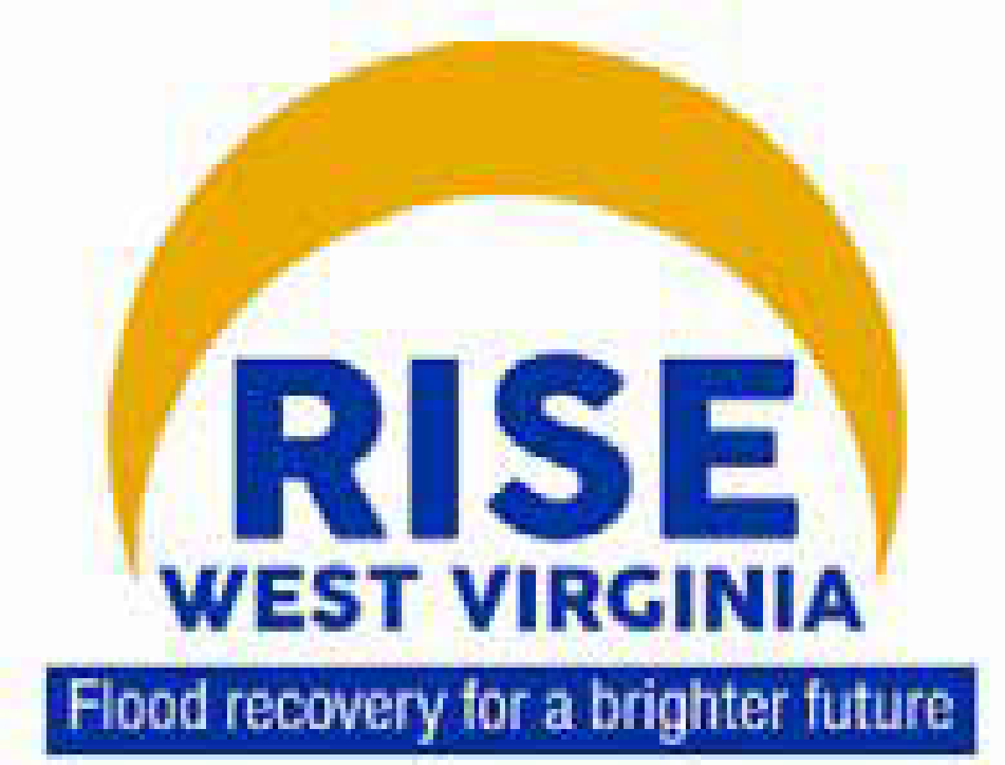  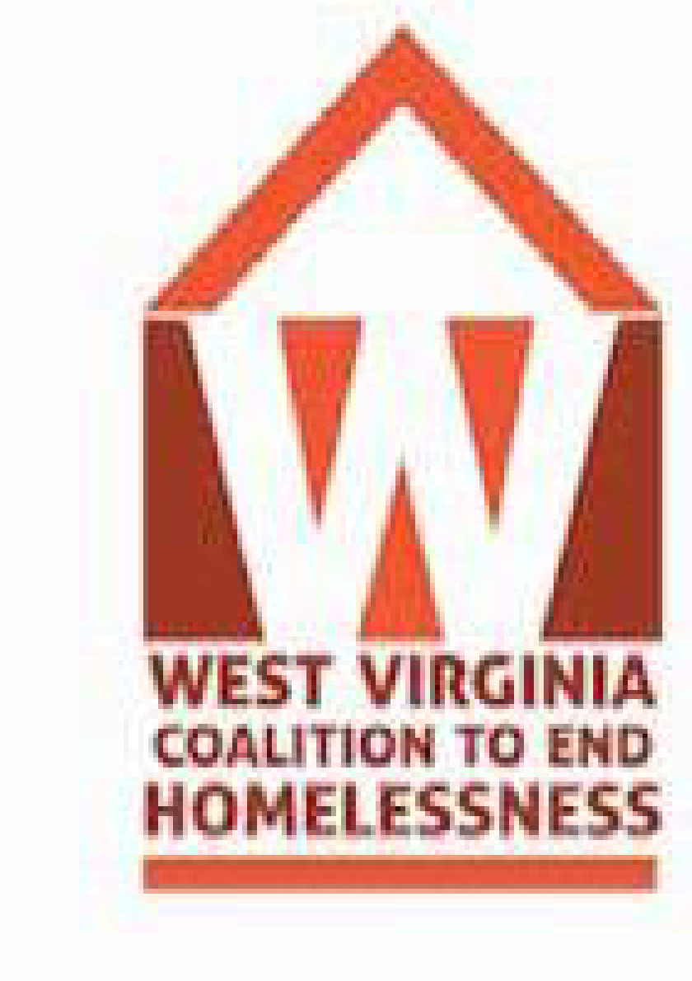  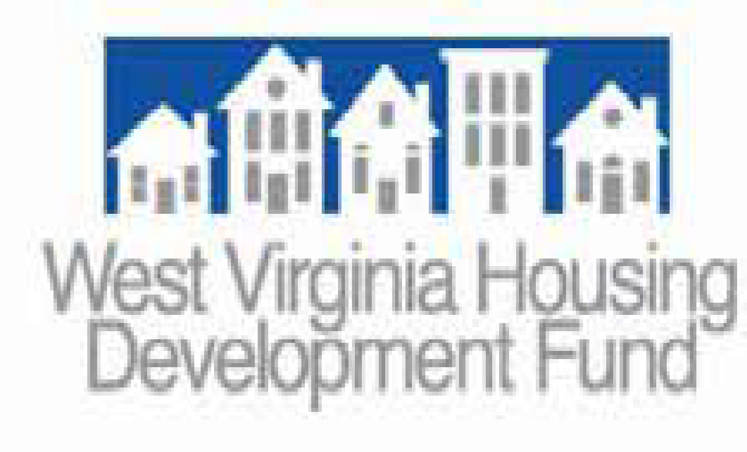  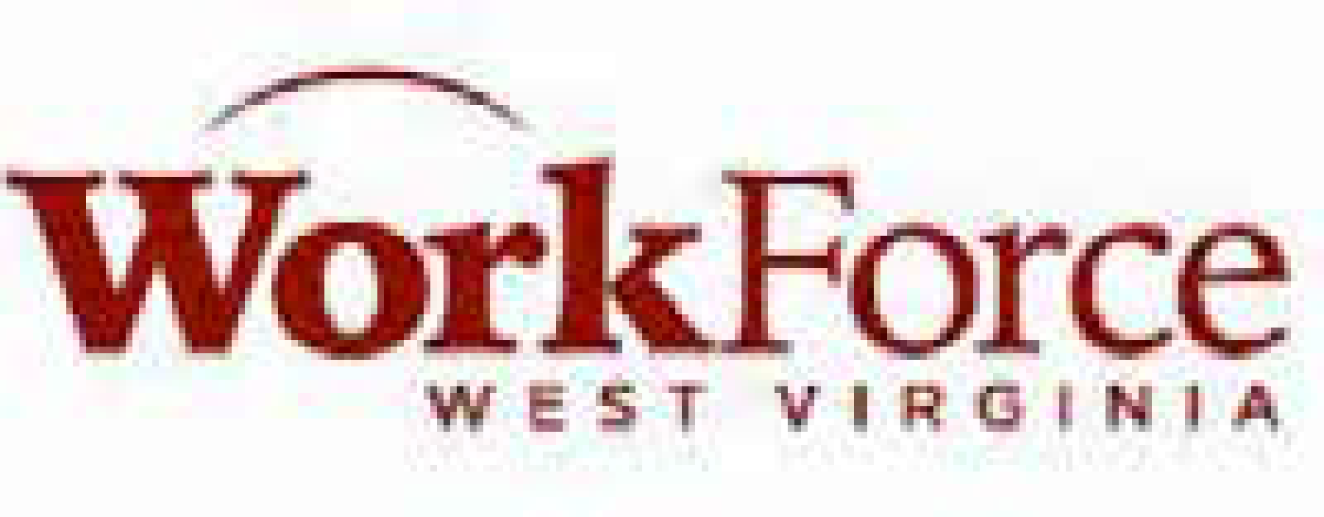  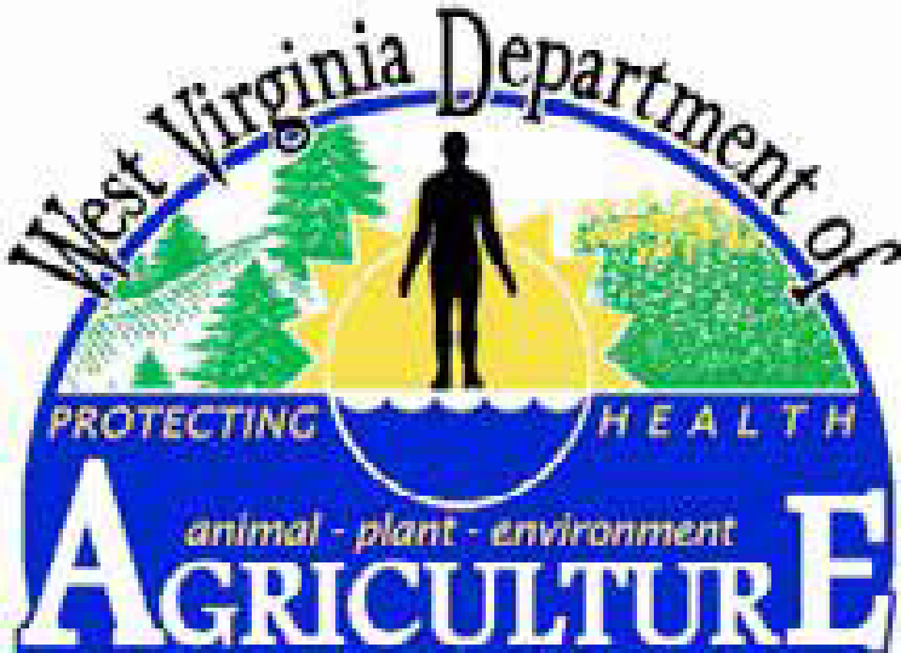  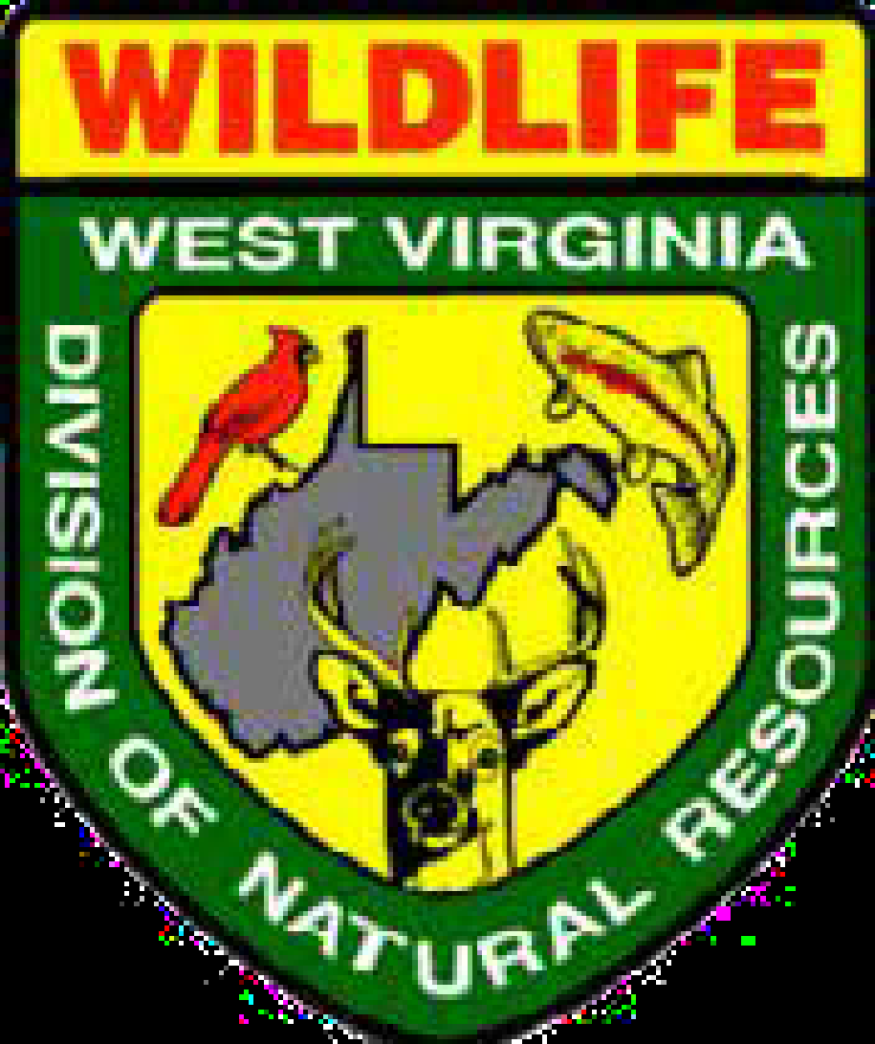   | West Virginia Division of Homeland Security and Emergency Management  West Virginia Division of Homeland Security and Emergency Management has been a key part of defining the State’s unmet housing and infrastructure need by utilizing the data received from FEMA damage assessments in its estimates. The DHSEM has worked alongside FEMA to assess damage in the declared counties and offer support to local jurisdictions for defining project worksheet scopes. Director Jimmy Gianato has offered unwavering support to the WVDOC and will continue to be a partner in the State’s long-term recovery efforts, particularly with the Hazard Mitigation Grant Program. The WVDOC intends to provide a match for the program.  West Virginia Regional Planning & Development Councils  The West Virginia Regional Planning & Development Act of 1971 established 11 regions across the state to serve as “development districts” to more effectively use the state’s resources and maximize small community’s chances of attracting federal dollars. The mission of these Regional Planning & Development Councils involves the conversion of community and economic development needs into proactive strategies and plans, which then become realistic opportunities, and finally actual projects or programs. The Councils operate as low-key facilitators in a systematic and synergistic process. The Councils are structured as locally oriented, public corporations. They are directed by elected officials from the elected appointees from a cross-section of a region’s social and economic institutions. Each Council retains a professional staff adept in public administration, regional/community planning and economic development. Given the vast experience for the RPDC staff with grant administration and community coordination, WVDOC will partner with the Councils to implement the disaster recovery programs.  West Virginia Volunteer Organizations Active in Disaster (WVVOAD)  The West Virginia Organizations Active in Disaster (WVVOAD) is the state chapter of the National VOAD. It is a humanitarian association of independent organizations that are active in all phases of disaster. Its mission is to identify unmet needs and facilitate efficient, streamlined service delivery to those imperiled or impacted by disaster while eliminating duplication of effort through cooperation in the four phases of disaster: preparedness, response, recovery and mitigation.  After the flood the WVVOAD began immediately organizing volunteer organizations from inside and outside the state to respond to the critical needs of citizens. They have worked since day one to overcome challenges by maintaining effective channels for sharing information across volunteer groups. They have identified common goals and created shared solutions by utilizing all resources to help communities prepare and recover. Past recovery efforts have resulted in WVVOAD being awarded the 2013 State VOAD of the Year Award, 2015 Governor’s Service Award, and the 2016 National VOAD innovative Program of the Year Award.⁴  WVVOAD has effectively coordinated their long-term efforts alongside the WVDOC by holding joint meetings and offering input on the design of the CDBG-DR programs, most notably the Bridge Home Program which will provide assistance for rebuilding private bridges that were washed away, preventing full access to homes. WVVOAD has experience rebuilding private bridges for citizens throughout the state of West Virginia as a result of disasters that hit the state in 2015. Therefore, the State intends to leverage their experience by rebuilding up to 100 private bridges through the Bridge Home Program. Additionally, WVVOAD will provide case managers in Greenbrier and Kanawha counties to assist with the CDBG-DR housing programs.  Greater Greenbrier Long-Term Recovery Committee  The mission of the Greater Greenbrier Long-Term Recovery Committee is to ensure the safety and well-being of Greenbrier Valley citizens in all phases of disaster. Since the flood the Greater Greenbrier LTRC has coordinated leadership to assess and meet the present and future needs of disaster survivors and provided financial assistance and service-related assistance to residents and businesses whose needs are unmet by existing relief systems. They have worked to connect those impacted by disaster to physical, emotional, and spiritual resources, without discrimination and advocated to secure grants, funding, and ongoing recovery efforts for all disaster-affected communities in Greenbrier County. They are headquartered in Lewisburg with case managers stations in White Sulphur Springs and Rainelle, two of the hardest hit areas. The WVDOC will utilize these case managers in the delivery of the housing recovery program.  Greater Kanawha Long-Term Recovery Committee  The Greater Kanawha Long-Term Recovery Committee provides long-term flood recovery services to individuals, families and local businesses to ensure the safety and well-being of Kanawha County citizens in all phases of disaster. The committee is a collaborative team of community leaders, representatives from affected areas, non-profits, local, state, and federal officials and others. This team is designed to strategically align all available resources, including volunteers, material donations and support into a one-stop shop for residents. They are headquartered in one of the most devastated towns in the state, Clendenin. The WVDOC has attended community meetings held by the Greater Kanawha LTRC to gather input from citizens on their unmet needs and will continue to utilize their partnership to administer programs that meet those needs. The WVDOC will utilize their case managers in the delivery of the housing recovery programs.  Neighbors Loving Neighbors  Neighbors Loving Neighbors is a 501(c)(3) organization that was formed by The Greenbrier Classic to provide donated items to West Virginia’s most vulnerable residents. The campaign began to collect food and cash to help flood victims with immediate needs following the flood in June 2016. Initially, 10,000 cans of food were stored in the Greenbrier’s Upper Lobby and distributed to local food banks across the state.⁵ The project is now focused on providing resources to those without basic needs. Notable PGA Golf professionals have offered assistance as well as members of The Greenbrier Sporting Club and friends of The Greenbrier. The WVDOC will coordinate housing recovery activities to those individuals that are referred by Neighbors Loving Neighbors and still have an unmet housing need.  5 http://www.greenbrier.com/neighbors  Image 5: Cars inundated with mud sit outside a damaged home in Clendenin  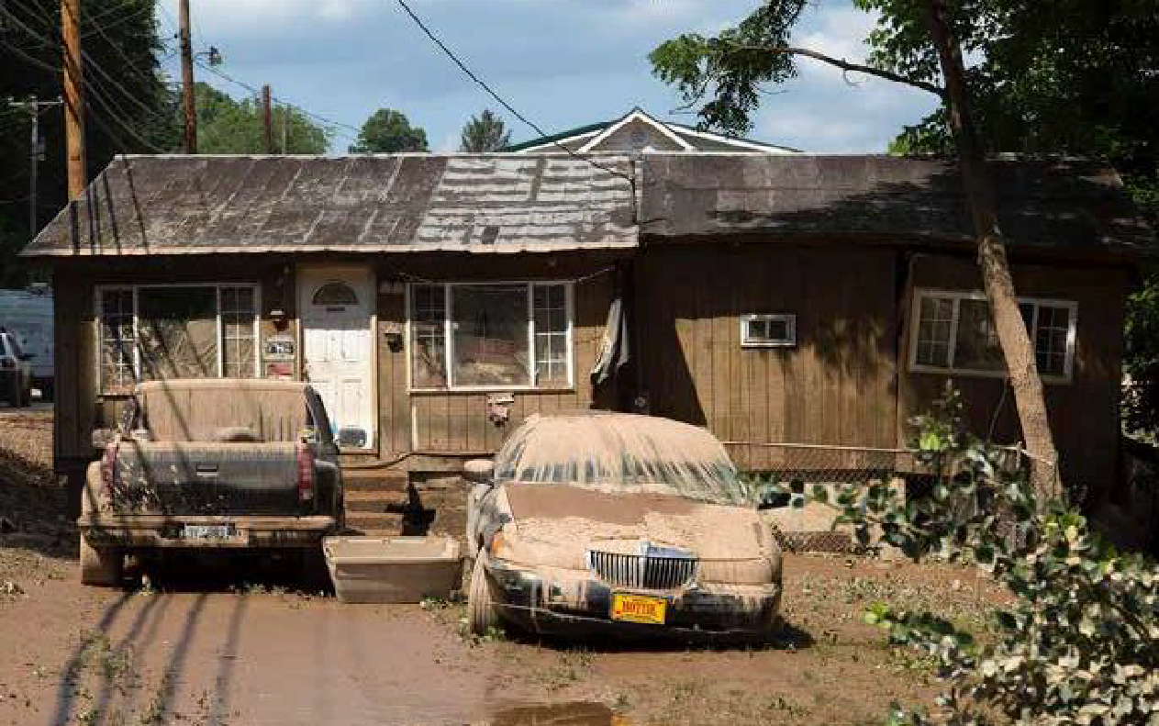  Statewide Unmet Needs Committee  A new statewide unmet needs committee was formed at the beginning of 2017 that consists of representatives from numerous organizations to coordinate relief to those citizens who still have unmet needs as a result of the flood. The committee meets every other week and allows individuals the opportunity to present their case of unmet needs and be potentially awarded additional funds from an inventory of donated sources available within the committee. The committee seeks to consolidate the recovery process for West Virginians to streamline recovery throughout the affected areas. The WVDOC will be represented at all committee meetings in an effort to coordinate with the Statewide Unmet Needs Committee to most effectively serve affective populations who may require housing assistance.  RISE West Virginia  RISE West Virginia is a small business program created by former Governor Earl Ray Tomblin in response to critical needs in the small business community resulting from the floods. This public-private grant program provides assistance for small businesses that were operational before the flooding and are working to reopen while struggling with existing debt and limited resources. The program is co-sponsored by West Virginia native and Intuit CEO and Chairman Brad Smith. The West Virginia Development Office oversees the program in partnership with the West Virginia Chamber of Commerce and will continue to work together to assist small business owners with their unmet needs by referring them to grant making organizations and the Small Business Administration’s Disaster Loan Program.  West Virginia Coalition to End Homelessness  The mission of the West Virginia Coalition to End Homelessness (WVCEH) is to create partnerships and collaborations at the local, state, and national levels to develop and implement long-term solutions to homelessness and poverty. The WVCEH advocates for public policies that will address the needs of homeless individuals and contribute systematically to the prevention and elimination of homelessness in West Virginia, and works with representatives from federal, state, and local governments. The WVCEH has worked with the WVDOC to provide data on the pre-flood and post-flood homeless population. The WVDOC has used this data to account for the changes in homelessness due to the flood and to formulate housing programs which will benefit this vulnerable population. The State will continue to coordinate with the WVCEH to ensure the homeless population is prioritized for assistance through any of its CDBG-DR programs which could meet the needs of this population.  West Virginia Housing Development Fund  The West Virginia Housing Development Fund (WVHDF) is a public body corporate and governmental instrumentality of the State of West Virginia established to increase the supply of residential housing for persons and families of low- and moderate- income, and to provide construction and permanent mortgage financing to public and private sponsors of such housing. To date, the Housing Development Fund has issued more than $4.3 billion in bonds and has financed more than 120,000 housing units since it began operation in 1969.⁶  ^{6 http://wvhdf.com/about-wvhdf}  WVHDF has provided input to the WVDOC on housing program design and the unmet needs of the populations they have served thus far with their Rebuild West Virginia program. This program provides loans and grants to victims of the flood whose owner-occupied residences were damaged or destroyed. WVDOC will continue to coordinate with WVHDF in order to leverage its housing recovery programs with Rebuild West Virginia. WVHDF will be a partner-agency with WVDOC to ensure the successful implementation of the disaster recovery housing programs.  WorkForce West Virginia  WorkForce West Virginia is a state government agency funded through the U.S. Department of Labor that oversees the state unemployment insurance program as well as a network of workforce development services designed to provide West Virginia’s citizens and employers the opportunity to compete in today’s competitive global economy. WorkForce West Virginia has provided data on disaster unemployment compensation claims to the WVDOC to account for the loss in jobs following the flood. WorkForce West Virginia will act as partner to the WVDOC in operations for programs to ensure that any jobs retained or created are properly accounted for under the appropriate national objective.  West Virginia Department of Agriculture  The West Virginia Department of Agriculture (WVDA) has worked in partnership with the United States Department of Agriculture to account for all flood damage to the state’s agriculture. Eleven counties have requested Emergency Conservation Program implementation for approximately $2 million in estimated clean-up costs of agriculture land. Additionally, multiple notices of loss related to mechanically harvested feed and purchased feed stuffs have been accepted through the Emergency Livestock Assistance Program (ELAP.)⁷ The WVDA has provided data on agriculture losses to the WVDOC to include in this action plan and will continue to be a partner for designing housing programs to address the rural housing shortage experienced in the affected counties.  7 Data provided by Richard Snuffer II, State Executive Director of USDA.  West Virginia Division of Natural Resources  The West Virginia Division of Natural Resources (WVDNR) under the Department of Commerce is responsible for wildlife management, hunting and fishing regulations, and all state parks and recreation areas throughout West Virginia. Flooding closed a portion of the famed Greenbrier River Trail, a 78-mile long rail trail that mirrors the Greenbrier River. The WVDNR provided data on damage to the state parks and recreation areas and is working in coordination with the WVDOC to design and implement long-term recovery programs that will protect the state’s natural resources.  West Virginia Division of Tourism  The West Virginia Division of Tourism, in partnership with the private sector tourism industry, works to cultivate a world-class travel and tourism industry through the creation of jobs, stimulation of investment, expansion of current tourism businesses, and promotion of a positive state image, thereby improving the way of life for West Virginians. After the floods, the Division of Tourism worked to quantify the disaster’s effect on the tourism industry. Industry members from nine counties shared completed surveys showing losses of tourism revenue from the flooding of nearly $22 million.⁸ The most notable tourist attraction affected was the famed Greenbrier Classic, which had to be canceled because of damage sustained to The Greenbrier resort. The Greenbrier was, in turn, offered as shelter to newly homeless individuals seeking short-term housing. The Division of Tourism continues to interface with the WVDOC to effectively offer input on programs that will revive the tourism industry to improve local economies struggling in the aftermath of the flood.  8 http://www.tristateupdate.com/story/33104084/back-in-business-greenbrier-county-business-owners-continue-to-salvage-their-livelihoods-while-hoping-to-welcome-tourists-again-soon

Overall Storm Impact
The damage left by the June 2016 flooding was unprecedented. Overall, more than 20% or West Virginia’s 55 counties experienced flooding and were declared federal disaster areas, with two of those counties hit especially hard. The HUD-identified most impacted declared counties were Kanawha and Greenbrier. The flood waters caused destruction to highways, schools, businesses, and agriculture and resulted in 23 lost lives. The flood was so destructive that it made the National Oceanic and Atmospheric Administration’s Billion-Dollar Weather and Climate Disasters list for 2016.
Figure 1: U.S. Billion-Dollar Weather and Climate Disasters
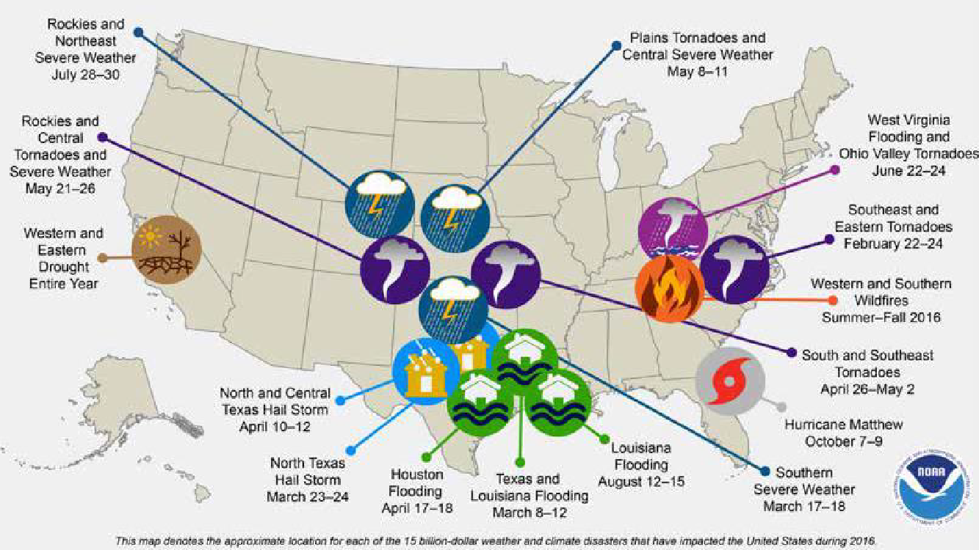

Pre-Disaster Conditions
People
The total population of the 12 counties contained in the disaster declaration makes up 22% of the statewide population of West Virginia, according to the 2015 U.S. Census estimates. Recently West Virginia residents have been hit hard by issues such as the state budget crisis, loss of well-paying coal jobs, aging of the populations, and the opioid epidemic. The percent of persons holding advanced education degrees past high school is half the national average throughout the affected counties, namely because physical labor jobs such as coal production and lumber have historically been the state’s largest industry. With the decline in those industries in recent years, it has been challenging for the state to balance a budget while reprioritizing core services to the recently unemployed, redefining desired education outcomes of new generations, and attracting new industries to derelict areas that have suffered as a result of the decline in coal. It is one of the most elderly and most disabled states in the nation as a result of the phase out of coal and other labor-intensive industries. Younger generations are not waiting for better conditions to emerge and are instead choosing to relocate outside of the state in search of higher education and jobs. As a result, the state’s population has declined every year since 2013.¹ Additionally, a high poverty rate and other socioeconomic factors throughout the state make it
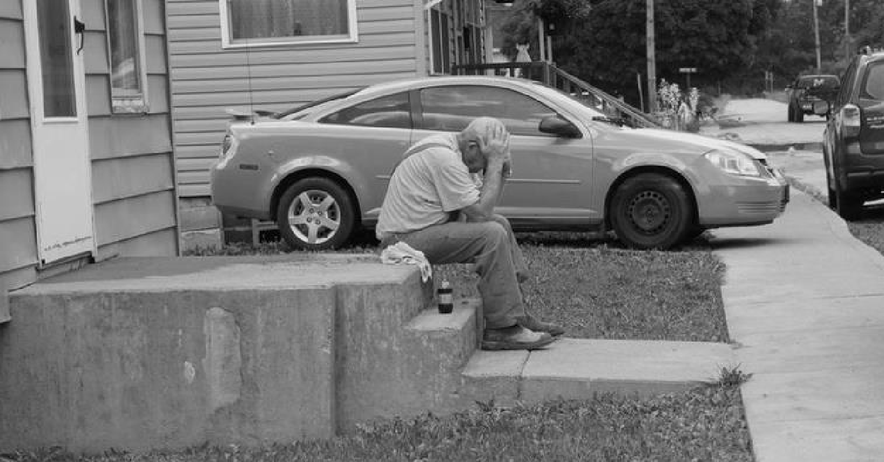
Image 6: An elderly man lost all of his possessions in his house where he’s lived since the 50’s
Especially tough for the average West Virginian to recover after a disaster. Because of these factors it will be critically important for the State to define recovery programs and services that will benefit these high-risk populations.
1 http://www.theintelligencer.net/news/top-headlines/2016/12/west-virginia-population-decline-continues/
Elderly
The state’s elderly population is significantly older than the nation as a whole. Per the 2015 U.S. Census estimates, the elderly population in West Virginia is 18.2% which is 22% higher than the national average of 14.9%. Within the 12 declared counties the elderly population is even higher at 20.5%. The following map illustrates the areas of the declared counties where the over 65 population is highest.

Figure 2: Elderly Population
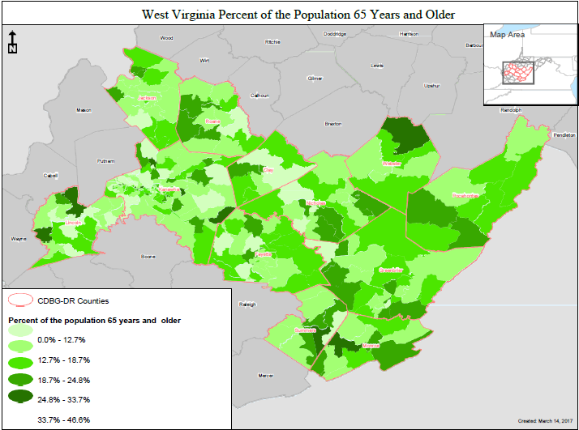
The percent of West Virginians 65+ years old is expected to increase from approximately 16% to over 24% in the next two decades.² Demographic trends show that older adults are generally inclined to remain in their communities while younger individuals tend to move away in search of employment. Therefore, it is imperative that West Virginia target the socially vulnerable elderly population for assistance through its housing programs. Accordingly, the State will do so through the Social Vulnerability Index SoVI tool which identifies this population in West Virginia. Following is a SoVI map that illustrates this affected population throughout the declared counties.
2 Christiadi, The Shrinking of the West Virginia Working-Age Population, 2011
Figure 3: Social Vulnerability percentages for under age 5 and over age 65
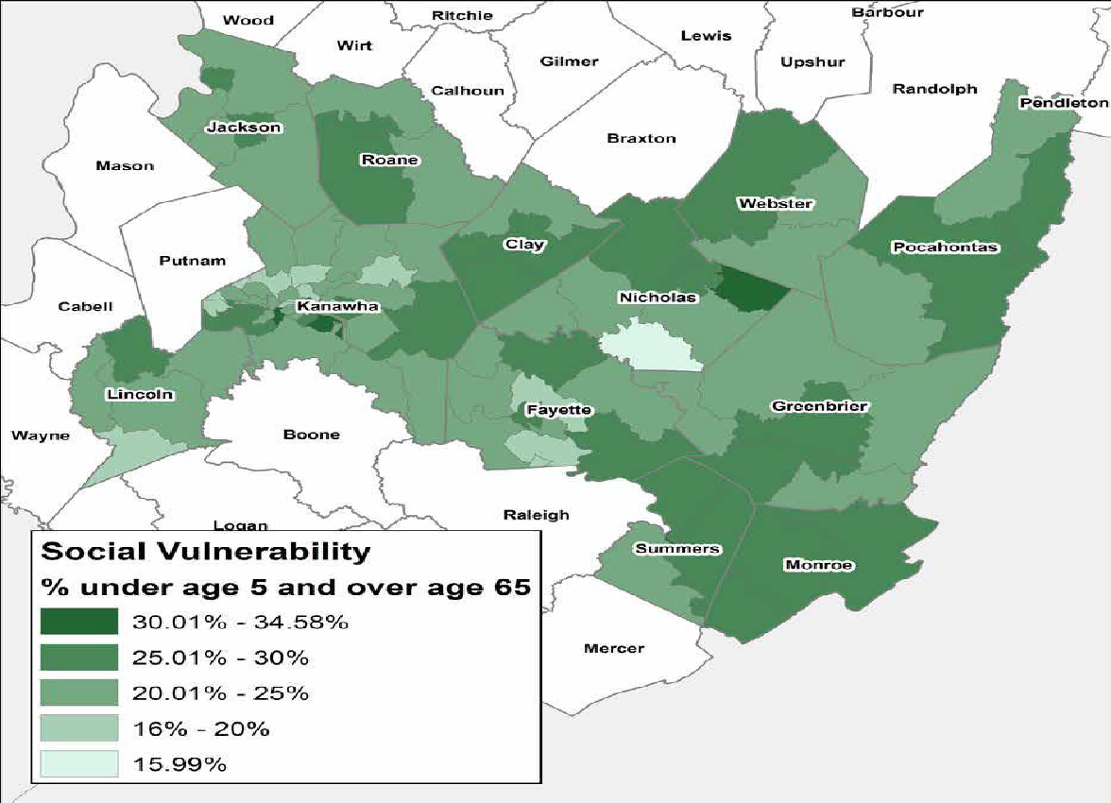
Disabled
The disabled population in the state is double the national average. Persons living with a disability below the age of 65 in the declared counties averages 17%, which doubles the national average of 8.6%. The map below shows the areas within the declared counties where the highest percent of disabled people.
One of the most pressing issues in the state is disability tied to employment, particularly with the highest incidence of black lung disease amount former coal miners. Residents in West Virginia with black lung disease received almost $40 million in Part C Black Lung Claims and Disbursement in FY 2016 from the U.S. Department of Labor (DOL), the highest amount among all 50 states.³ The Division of Coal Mine Workers’ Compensation to coal miners who are totally disabled by pneumoconiosis arising out of coal mine employment, and to survivors of coal miners whose deaths are attributable to the disease. The Act also provides eligible miners with medical coverage for the treatment of lung diseases related to pneumoconiosis.
3 http://www.dol.gov/owcp/dcmwc/statistics/bls2016/DistributionOfClaimsByState2016.htm

Figure 4: Disabled Population
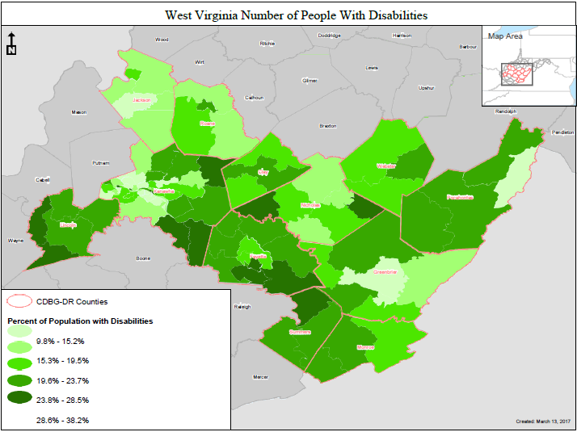

Figure 5: U.S. Black Lung Claims
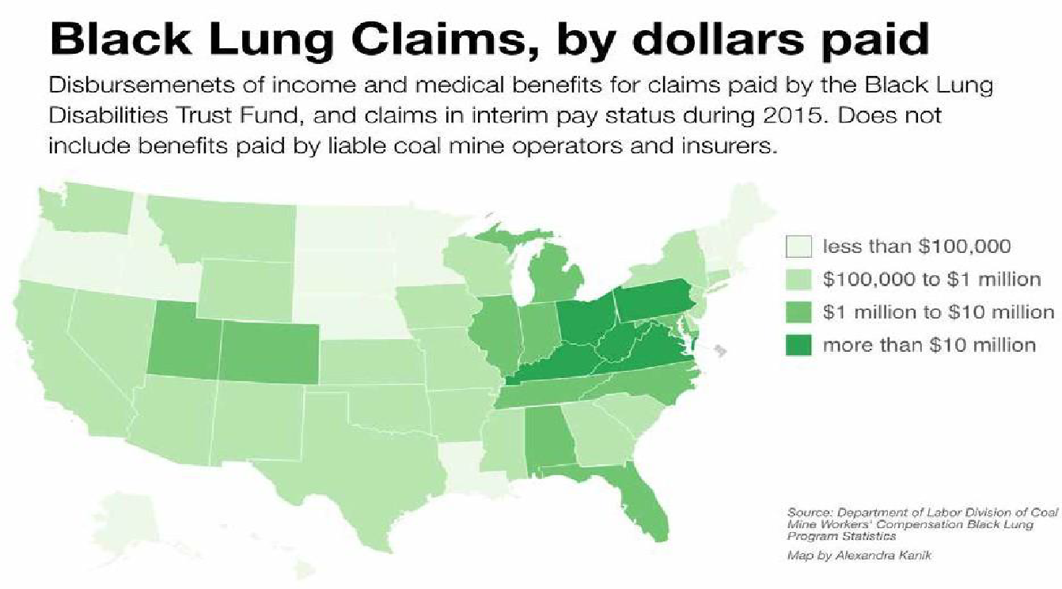

Poverty
West Virginia has a larger percentage of persons in poverty (17.9%) when compared to persons nationwide (13.5%). Specifically, one in four children in West Virginia is living in poverty. Further, of the 12 declared counties many are considered severely impoverished, including Clay, Lincoln, Summers, and Webster, with nearly all doubling the national poverty percentage. Because most of West Virginia’s landscape is rugged and rural, many of the residents living in poverty are isolated with limited access to public transportation or jobs that pay above minimum wage. The following SoVI map shows the areas within the declared counties where the highest percent of people living in poverty are located.
Figure 6: Social Vulnerability percentage living below poverty 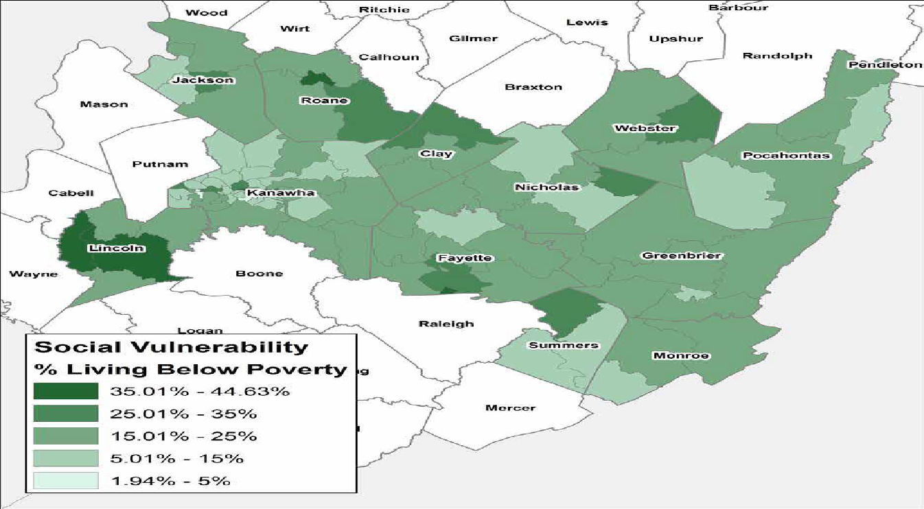
Unemployment
West Virginia currently has the fifth highest rate of unemployment in the continental U.S., mostly due to the decrease in coal production experienced in the past few years.⁴ In 2013, West Virginia ranked last in the nation with an employment-to-population ratio of 50%, compared to the national average of 59%.⁵ According to WorkForce West Virginia, the state lost 5,600 jobs in its labor force in four critical economic sectors: construction (1,900), manufacturing (1,100), retail (1,800), and education (800), while gaining just 400 in mining and logging. The state’s Civilian Labor Force dropped by 15,100. As jobs have disappeared or moved elsewhere, the state’s workforce has essentially shrunk. Additionally, because West Virginia has the oldest population in the nation many residents are simply aging out of the workforce while younger residents are moving out of state in search of opportunities available outside of the traditional mining and logging industries. The following SoVI map shows the areas within the declared counties experiencing the highest rates of unemployment.
4 Current Unemployment Rates for States, Bureau of Labor Statistics, February 2017
5 Regional and State Unemployment – 2013 Annual Averages, U.S. Bureau of Labor

Figure 7: Unemployment Rates
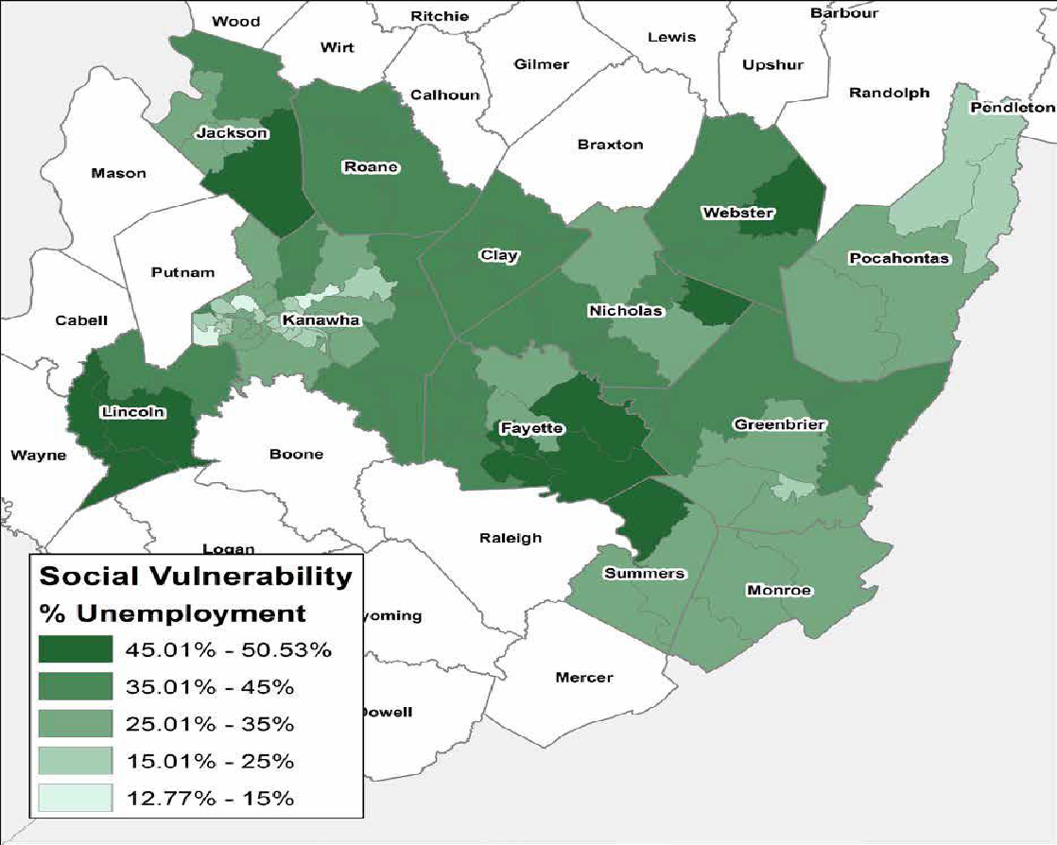

Homelessness
The West Virginia Coalition to End Homelessness (WVCEH) is the state advocacy body for issues of homelessness in West Virginia. They are the lead agency responsible for the balance of the state’s Continuum of Care as well as the SSI/SSDI Outreach Access and Recovery (SOAR) state lead. They maintain a client-level HMIS database which provides data on the state’s homeless population in an effort to provide an unduplicated count of homeless individuals, related demographics, and their needs over time. The following services are provided to homeless individuals by WVCEH:
- Emergency Shelter: These shelters are meant to act as a temporary, emergency triage until the next step in more permanent housing is available. In 2014, a total of 1,545 beds in emergency shelters were available in West Virginia.
- Transitional Housing: Consists of the placement of homeless individuals and families into project-based, or leased rental housing with case management, with a goal of exit to permanent housing. In 2014, a total of 589 beds in transitional housing were available in West Virginia.
- Rapid Re-Housing: A model that concentrates on moving a family or individual experiencing homelessness into permanent housing as quickly as possible. A total of $594,000 in ESG and $3,296,500 in SSVF funding was spent in 2014 to rapidly rehouse the homeless in West Virginia.
- Permanent Supportive Housing: A long-term housing subsidy with intensive case management designed specifically for those who are defined as chronically homeless. A total of 1,401 beds were available in West Virginia in 2014.⁶
HUD’s 2015 Annual Homeless Assessment Report to Congress found an overall 11 percent decline in the number of persons experiencing homelessness since 2010, including a 26 percent drop in the number of persons living on the streets. In West Virginia, local communities reported a total of 1,835 people experienced homelessness, representing an 18.9 percent decline since 2010, the year President Obama launched Opening Doors – the nation’s first-ever comprehensive strategy to prevent and end homelessness. Between 2014 and January 2015, veteran homelessness declined 8.4 percent in the state; family homelessness decreased 25.4 percent; and chronic homelessness fell 17 percent. On a single night in January 2015, state and local planning agencies in West Virginia reported the following estimates of homelessness:
- Overall, homelessness declined by 178 persons or 8.8 percent between 2014 and January 2015. In January 2015, an estimated 1,835 people were homeless on a given night. Most (76.5 percent) were staying in residential programs for homeless people, and 23.5 percent of those were on the street.
Homelessness among Veterans fell by 8.4 percent between 2014 and January 2015. On a single night in
- January 2015, 305 Veterans were homeless and 25.6 percent of those were on the street.
- Chronic homelessness among individuals continues to decline. Since 2010, chronic homelessness declined 31.8 percent. Nearly 400 people experiencing homelessness in January 2015 were reported as chronically homeless.
- Local communities reported a 25.4 percent reduction in families experiencing homelessness between 2014 and January 2015. Since 2010, family homelessness declined by 47.3 percent.⁷
6 http://www.endhomelessness.org/page/-files/2016-05010%2013.03%20Transforming%20Homeless%20Services%20in%20West%20Virginia%20Slides.pdf
7 http://www.wvva.com/story/30564681/2015/11/Thursday/homelessness-in-west-virginia-fell-88-percent-in-2015

Table 4: U.S. Census Comparison
People | Declared Counties | West Virginia | United States
Population
Population estimates, July 1, 2015, (V2015) | 412,543 | 1,844,128 | 321,418,820
Age and Sex
Persons under 5 years, percent, July 1, 2015, (V2015) | 5.6 | 5.6 | 6.2
Persons 65 years and over, percent, July 1, 2015, (V2015) | 20.5 | 18.2 | 14.9
Female persons, percent, July 1, 2015, (V2015) | 50.7 | 50.6 | 50.8
Race and Hispanic Origin
Black or African American alone, percent, July 1, 2015, (V2015) (a) | 2.0 | 3.6 | 13.3
American Indian and Alaska Native alone, percent, July 1, 2015, (V2015) (a) | 0.3 | 0.2 | 1.2
Asian alone, percent, July 1, 2015, (V2015) (a) | 0.7 | 0.8 | 5.6
Two or More Races, percent, July 1, 2015, (V2015) | 1.3 | 1.6 | 2.6
Hispanic or Latino, percent, July 1, 2015, (V2015) (b) | 1.1 | 1.5 | 17.6
Population Characteristics
Veterans 2011-2015 | 34,328 | 150,021 | 20,108,332
Foreign born persons, percent, 2011-2015 | 0.7 | 1.5 | 13.2
Housing
Housing units, July 1, 2015, (V2015) | 210,585 | 885,475 | 134,789,944
Owner-occupied housing rate, 2011-2015 | 77.2 | 72.5 | 63.9
Median value of owner-occupied housing units, 2011-2015 | $91,600 | $103,800 | $178,600
Median gross rent, 2011-2015 | $555 | $643 | $928
Building permits, 2015 | 393 | 2,814 | 1,182,82
Families and Living Arrangements
Households, 2011-2015 | 173,519 | 740,890 | 116,926,305
Persons per household, 2011-2015 | 2.4 | 2.43 | 2.64
Living in same house 1 year ag, percent of persons age 1+, 2011-2015 | 90.2 | 88.2 | 85.1
Language other than English spoken at home, percent of persons age 5 years+, 2011-2015 | 1.8 | 2.5 | 21.0

Table 5: FEMA Applicants by County
People | Declared Counties | West Virginia | United States
Education
High school graduate or higher, percent of persons age 25 years+, 2011-2015 | 81.1 | 85.0 | 86.7
Bachelor’s degree or higher, percent of persons age 25+, 2011-2015 | 14.2 | 19.2 | 29.8
Health
With a disability, under age 65 years, percent, 2011-2015 | 17.0 | 14.4 | 8.6
Persons without health insurance, under age 65 years, percent | 11.7 | 7.2 | 10.5
Economy
In civilian labor force, total, percent of population age 16 years+, 2011-2015 | 49.6 | 53.9 | 63.3
In civilian labor force, female, percent of population age 16 years+, 2011-2015 | 44.5 | 49.2 | 58.5
Total health care and social assistance receipts/revenue, 2012 ($1,000) (c) | $2,817,271 | $12,259,395 | $2,040,441,203
Total retail sales, 2012 ($1,000) (c) | $5,390,580 | $22,637,923 | $4,219,821,871
Total retail sales per capita, 2012 (c) | $8,936 | $12,201 | $13,443
Transportation
Mean travel time to work (minutes), workers age 16 years+, 2011-2015 | 29.6 | 25.6 | 25.9
Income and Poverty
Median household income (in 2015 dollars), 2011-2015 | $36,736 | $41,751 | $53,889
Per capita income in the past 12 months (in 2015 dollars), 2011-2015 | $20,945 | $23,450 | $28,930
Persons in poverty, percent | 21.7 | 17.9 | 13.5
Businesses
Total employer establishments, 2014 | 9,046 | 37,354 | 7,563,085
Total employment, 2014 | 133,226 | 575,228 | 121,079,879
Total annual payroll, 2014 ($1,000) | $5,208,571 | $22,100,477 | $5,940,442,637

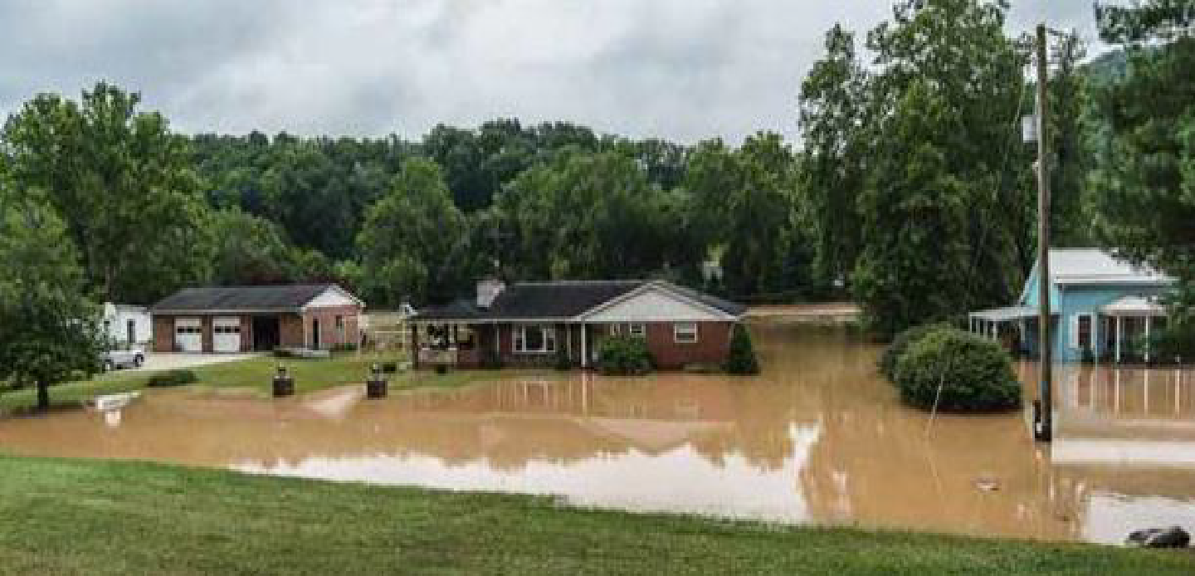
Image 7: Flooded homes along the Elk River
Housing
Due to the region’s economy, topography and population, much of the rural areas of West Virginia have historically experienced difficulties providing and maintaining an adequate supply of modern, quality, affordable housing for very low- to moderate-income households. In addition, it has been a challenge for the region to attract developers given the relatively low population densities, topography and lack of incentives to develop smaller properties.⁸ As a result, West Virginia consists of mostly single-family homes with a sizable share of manufactured housing. The median value of owner-occupied housing units in the affected counties is one of the lowest in the nation at $91,600. The national average is $178,600. Comparatively, the median gross rent is $555 compared to the national average of $928. Additionally, the owner-occupied housing rate of 77% is significantly higher than the national average of 63% and highlights how West Virginia must respond to this flood. Typically, after a flood, families are forced to relocate for extended periods of time to shelters and other forms of temporary housing. In West Virginia, there has been a high incidence of residents who have refused to relocate temporarily and have instead chosen to remain on their property in tents, automobiles, and campers next to their damaged homes while they await assistance. Some residents have chosen to shelter in place by removing disaster debris and mud from inside their damaged homes to make it habitable to some degree. West Virginia understands that the solution for these families is to create a housing repair program to rapidly repair the housing stock and get residents back into their homes.

Economy
West Virginia fell into a recession in 2015 with six counties experiencing Depression-era level unemployment. A total of 17,000 jobs have been lost over the last four years, many of which can be traced to the downturn in the coal industry. With the loss in jobs, West Virginia has seen a sizable decline in population as residents move out of the state for work (about 12,000 over the past three years). Only 53% of West Virginians are labor force participants which places the state last in workforce participation among all 50 states. The state’s unemployment rate of 6% is expected to remain steady for the remainder of this decade.⁴ The State accepts that job programs and economic development activities are vital to the recovery of the state’s residents. However, with such a large gap in housing unmet needs and limited recovery funds available, the State is limited in its ability to administer its own economic development programs with CDBG-DR funding. Because of this reality, the State has deliberately built relationships among other federal and state agencies with additional funding sources to leverage for economic development, such as the U.S. Economic Development Agency and Workforce West Virginia. It will work alongside these agencies and others in the coming months to design and implement programs to alleviate stresses on disaster affected local economies.
8 West Virginia Statewide Housing Needs Assessment, West Virginia Housing Development Fund
4 West Virginia Economic Outlook 2017-2021
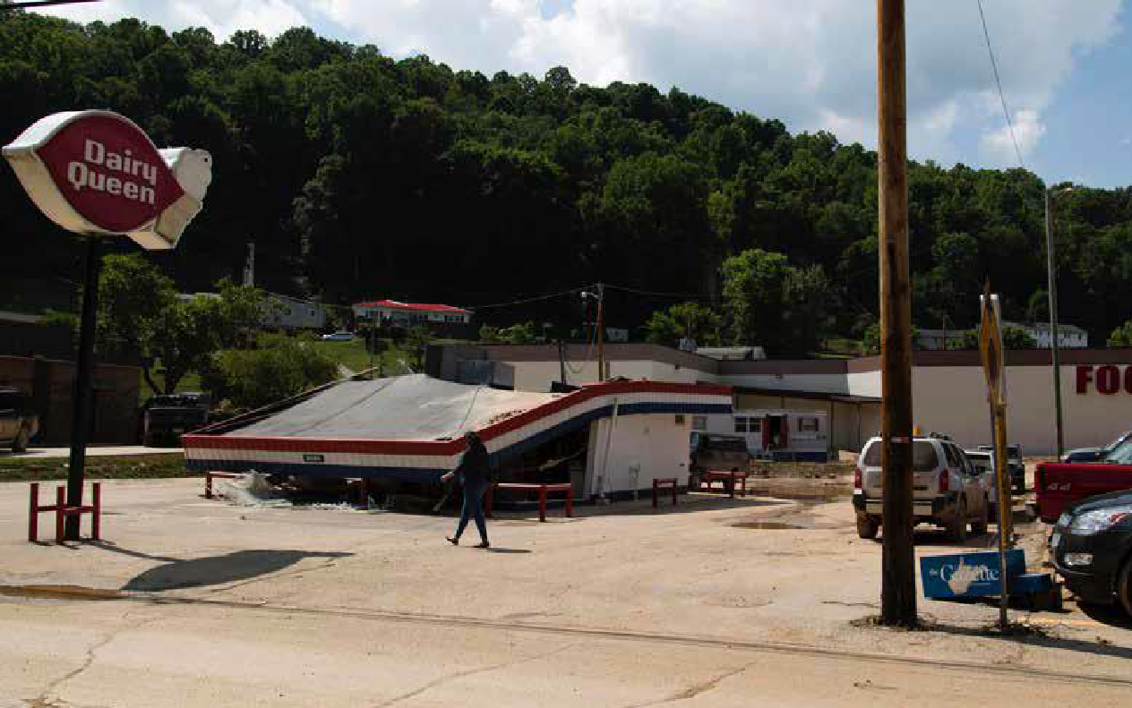
Image 8: A collapsed Dairy Queen as a result of flood damage
Infrastructure
Historically, West Virginians settled in areas that allowed for easy access to natural resources, ease of transportation and availability of flat stream or river bottom land for the growth of communities and development of local industries. Communities across the state were located near rivers in order to take advantage of all three. Previously robust communities in the southern portion of the state are now suffering declining local economies and populations due to macro-economic factors beyond their ability to control or influence. Additionally, local infrastructure damage has been exacerbated by decreased tax revenues that resulted in negative effects from postponed maintenance and flood associated repairs. Repeated damage from flooding has affected the infrastructure of several communities, resulting in systems that are now in need of major repairs, and upgrades that require relocation of major components of the systems. Before the flood, it was estimated in the 2013 Report Card for America’s Infrastructure published by the American Society of Civil Engineers that West Virginia would need nearly $6 billion in public infrastructure investment over the next 20 years.⁵ With a looming state budget crisis and limited recovery dollars available, the State intends to implement housing programs to further the most urgent need of returning people to their communities. The State will guide local jurisdictions through the FEMA PA process to ensure that all public series are restored and in turn, contribute to the full recovery of housing in the disaster affected counties. Specifically, the State will work with FEMA and local jurisdictions affected by the floods to prepare project worksheets for infrastructure costs eligible under the Public Assistance Program.
5 http://www.infrastructurereportcard.org/west_virginia/west-virginia-overview/
Disaster Declaration
Figure 9: West Virginia Disaster Declaration
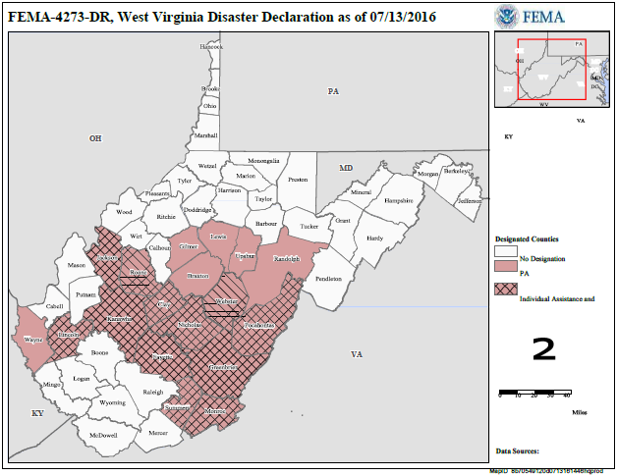
Leveraging Funds to Improve Conditions in Disaster Affected Counties
The State’s ability to adequately leverage all sources of funding available will be an imperative part of realizing a successful holistic recovery for the people of West Virginia. The State intends to improve the quality of life of the affected areas, particularly the areas consisting of the most vulnerable populations, by coordinating with other programs and funding streams available from federal, state, and local sources to ensure that available funds are disbursed in a prioritized manner to the neediest populations. The WVDOC has formed strong alliances with stakeholders who are delivering series throughout the declared counties in an effort to streamline delivery of funds and guarantee non-duplicative services are offered. Continued coordination will be vital throughout the life of the CDBG-DR program and the WVDOC will rely heavily on the lessons learned from other programs offered in the State.

Impact and Unmet Needs Assessment
Impact
Housing Impact
Pre-Existing Condition of the State’s Housing Stock-
Central Appalachia, with its substantial rural population, has a dispersed housing stock largely comprised of homes in smaller towns and isolated mountain valleys far away from major interstate highways and metropolitan areas. The overwhelming majority of residents are homeowners living on land that has been owned by their families for years. In fact, West Virginia’s homeownership rate is the highest in the nation at 74.6%.¹ A common sign along many rural Central Appalachian roadways is a forested hillside with the occasional small home or aging manufactured home. Their isolated locations, combined with the limited economic resources available to their owners, too often mean that these modest dwellings are in substandard condition. Problems such as inadequate plumbing and sewage treatment systems have long plagued the region’s residents.²

Image 9: A battered trailer and ice chest sit beside the river in Richwood
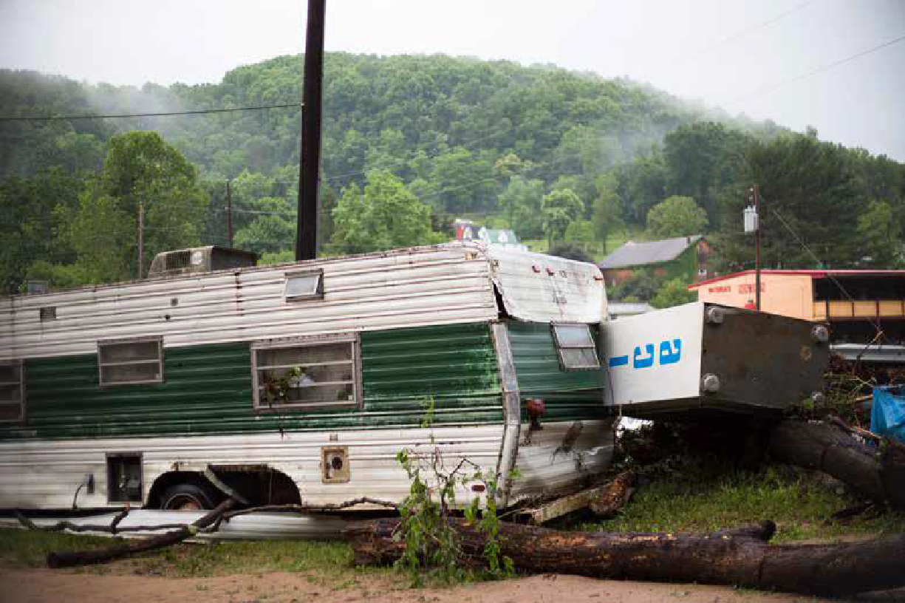
1 http://www.worldatlas.com/articles/the-most-homeowners-in-the-united-states-html
2 http://www.ruralhome.org/storage/documents/ts2010/ts_full_report.pdf
Manufactured housing is an important part of the housing stock in West Virginia and is particularly important in the supply of affordable housing for low-income residents. Of the more than 131,000 mobile homes and manufactured homes in West Virginia, 28% are pre-HUD Code homes. Many residents of pre-HUD Code homes experience severe financial burden because they have low incomes and face relatively high housing costs. Household financial burden is exacerbated by the often-poor conditions of these homes, which can pose health and safety hazards in addition to driving high energy costs. When flooding strikes an already substandard home the effects can be catastrophic. With the flooding in June 2016 many manufactured homes were swept away by flood water, carried downstream and ripped apart.
In White Sulphur Springs, images and video were captured of a burning home being carried down the river as a result of the flood.³ In many cases, a new, more energy efficient home would offer these households the opportunity for financial stability and, in turn, the opportunity to provide for their children, build wealth for the future and age in place.⁴ Additionally, mitigating homes against future flooding that has plagued the region for decades will ensure that residents are protected in times of disaster and will increase their ability to rebound after a flood.
3 http://insider.foxnews.com/2016/06/24/watch-house-fire-gets-carried-away-wv-flood
4 http://cfed.org/assets/pdfs/State_of_Appalachian_Mobile_Homes_WEST_VIRGINIA.pdf
Image 10: A home destroyed by flood damage.
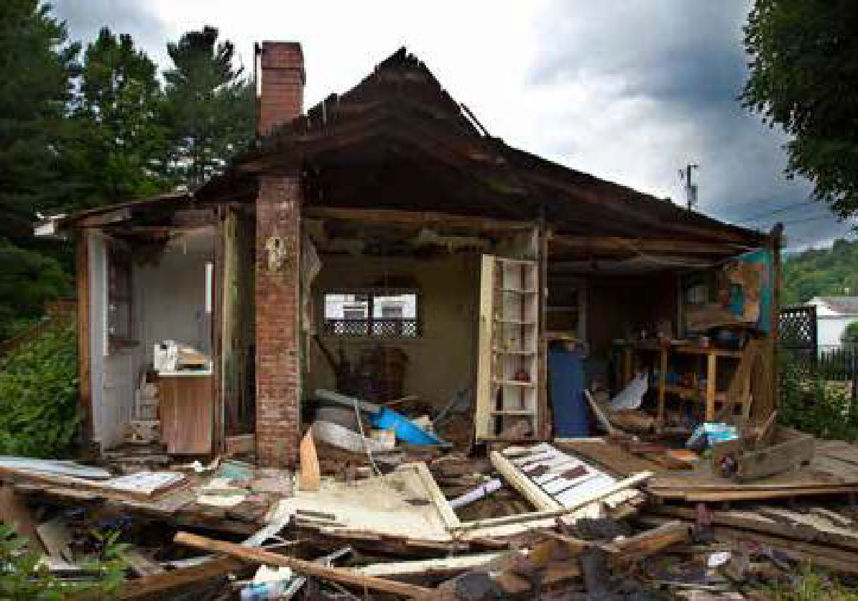

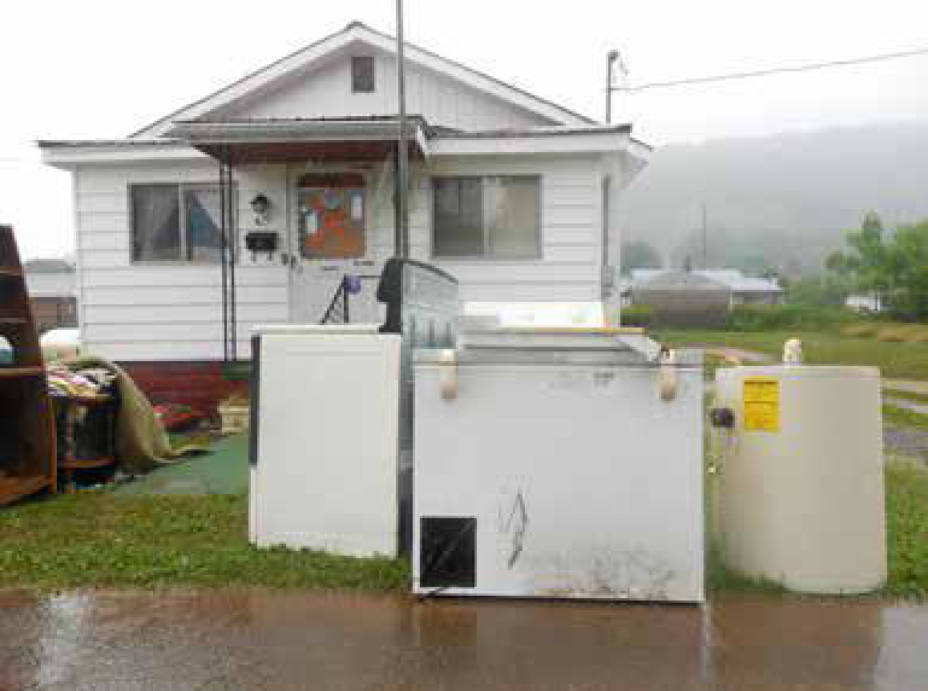
Impact to the State’s Housing Stock
West Virginia residents are especially susceptible to flooding given the expansive rural housing located all around the state situated in valleys, bordering rivers and streams. With a high incidence of substandard housing due to the economic depression felt with the decline in coal production, any disaster only exacerbates the housing problem faced by many West Virginians. The floods of June 2016 were no different. Homes were swept off foundations and carried downstream, taking with them personal artifacts and memories that reflect entire lives spent in rural Central Appalachia. Nearly 3,500 homes, many of which have been owned by generations of West Virginians for decades, were
Image 11: Home in Rainelle deemed structurally damaged by FEMA and received funding for repair and replacement costs. Additionally, nearly 800 renters, including those who rented mobile homes, received rental assistance from FEMA to assist with temporary housing costs and personal property replacement.
Single Family Owner-Occupied Housing
At least 1,500 homes were completely destroyed and another 4,000 damaged in the flood.⁵ Additionally, over 2,300 properties were recorded as having an average high-water mark of two feet or more in their homes throughout basements, first floors, and over roofs. Because of the inundation of water, 98% of these homes were deemed unsafe by FEMA with most lacking flood insurance. Over 3,400 applicants were approved for home repair amounts, with the average repair amount awarded being $8,200.⁶ Numerous single-family homes were inundated with mud spilling down from mountains with the rain. Further, mudslides and rain carried many mobile homes down river. The map on the following page shows the FEMA applicant ratio to housing units in the
declared counties. The map shows the areas within the declared counties that had a high number of applicants in relation to available housing units.
Although some areas in the state experienced lighter damage compared to others, the demographic characteristics of the counties highlight the fact that any amount of destruction in an area with vulnerable residents is particularly distressing because of their lack of adequate personal resources to properly recover. Examples provided by local officials in these areas include elderly residents without working appliances to cook a hot meal or do laundry, an impoverished child without food and clothing, and an unemployed former coal miner with black lung disease whose home hasn’t been remediated for mold. In hard hit places like White Sulphur Springs where the poverty rate exceeds 25% of the total population of the town, it is a particularly devastating time for socially vulnerable residents. Adequate recovery will not happen for them without intentional, direct outreach to these areas on the part of the State.
⁵
https://www.wsws.org/en/articles/2016/07/05/wvir-j05.html
6 FEMA Individuals and Households application dataset

Figure 10: FEMA applicants and impact assessment
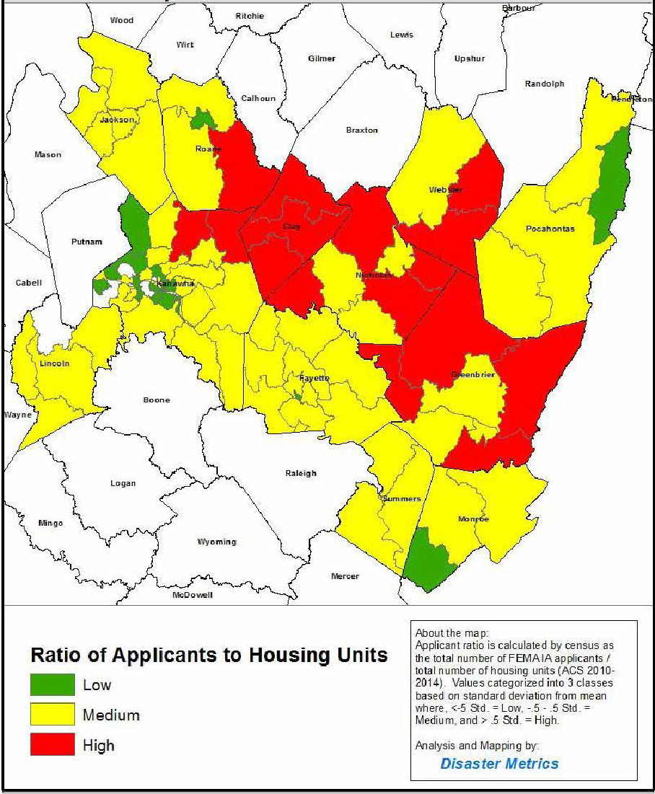

Figure 11: Repair funds to recipient ratio map
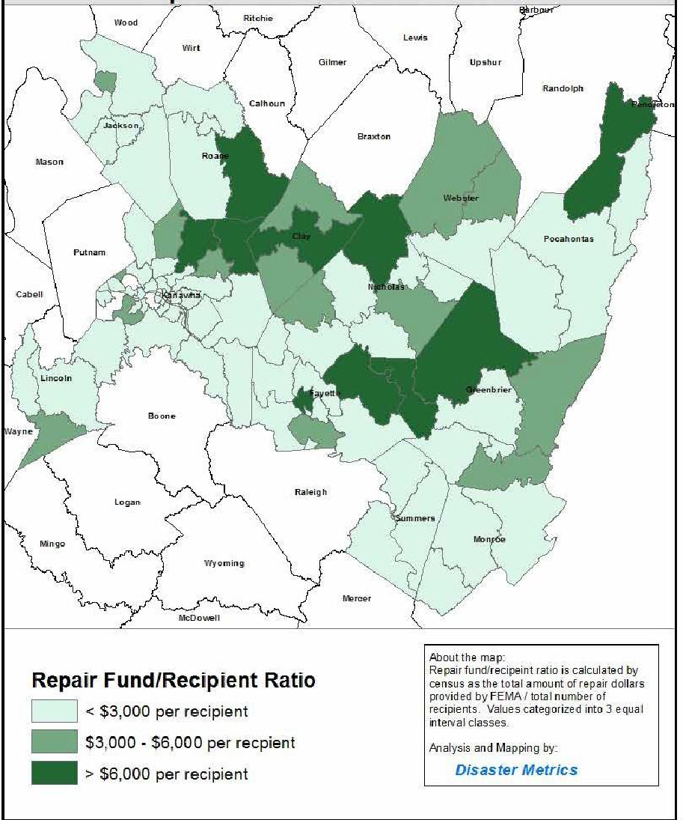

The above map shows the ratio of the amount of FEMA funds provided to recipients in the declared counties. It specifically highlights the areas within the declared counties were the highest average destructive flooding occurred among FEMA applicants. Below is a summary of the towns with the highest FEMA repair fund/recipient ratios in the declared counties.

Table 5: FEMA Applicants by County
County | Town | Total Approved FEMA Applicants for Home Repair Funding | Average Home Repair Amount
Kanawha | Clendenin  Elkview | 434  378  290 | $12,376  $10,126
Greenbrier | Rainelle  White Sulphur Springs | 257 | $14,530  $7,876
Clay | Procious | 109 | $8,400
Nicholas | Richwood | 108 | $6,135

Tenant-Occupied Rental Housing
Over 1,400 renters applied for FEMA assistance with 780 approved for funding. The average award for renters was approximately $3,500. Over half of the renters approved for FEMA funding resided in four towns: Clendenin and Elkview along the Elk River in Kanawha County, and Rainelle and White Sulphur Springs in Greenbrier County. Although many renters from these impacted towns were approved for FEMA assistance, only 59 lessors of residential rental property, or landlords, applied for SBA loans, with a mere 29 ultimately approved for funding. Considering the high percentage of uninsured properties throughout the declared counties, it is presumed that there is a substantial share of landlords whose properties have gone unassisted since they are not eligible for FEMA repair funds and applications for SBA disaster loans has been low. Although $1.8 million in assistance to landlords has been approved through SBA business loans, only $200,000 has actually been disbursed thus far. When taking into account the economic conditions in the state and the fact that many rental properties are “mom and pop” operations it is evident that many of these landlords are already overleveraged and hesitant to take on more debt.

Image 12: The Elk River
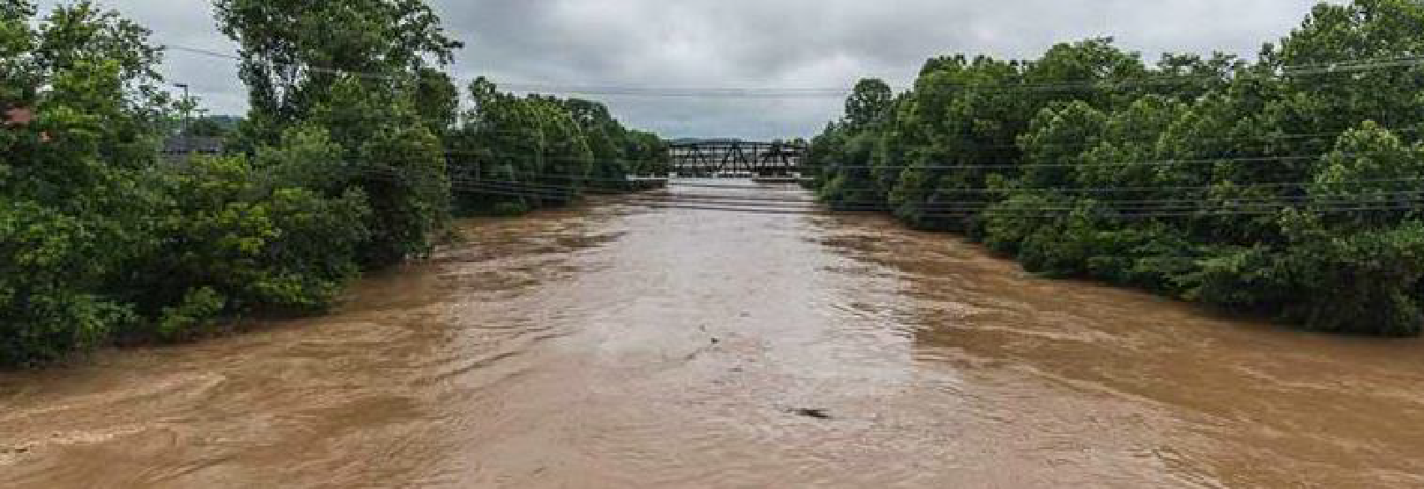
Affordable Housing and Public Housing
The WVDOC utilized HUD’s Resource Locator to find HUD-financed housing units that may have been damaged as a result of the floods. The HUD Resource Locator and website is an enterprise GIS service that allows users to identify where housing resources are located in their area and the contact information for each. The resource locator uses housing data from HUD and the U.S. Department of Agriculture to map the affordable housing units available in an area.
Below is a snapshot of the HUD Resource locator which has identified the affordable housing options in the town of Rainelle, West Virginia, a hard-hit community in Greenbrier County. The two icons shown pinpoint the Sewell Landing Apartments, which is a low-income housing tax credit property that is also included in the USDA’s Rural Housing program. It serves elderly and disabled tenants with ADA accessible one and two-bedroom units.

Figure 12: Snapshot of HUD Resource Locator
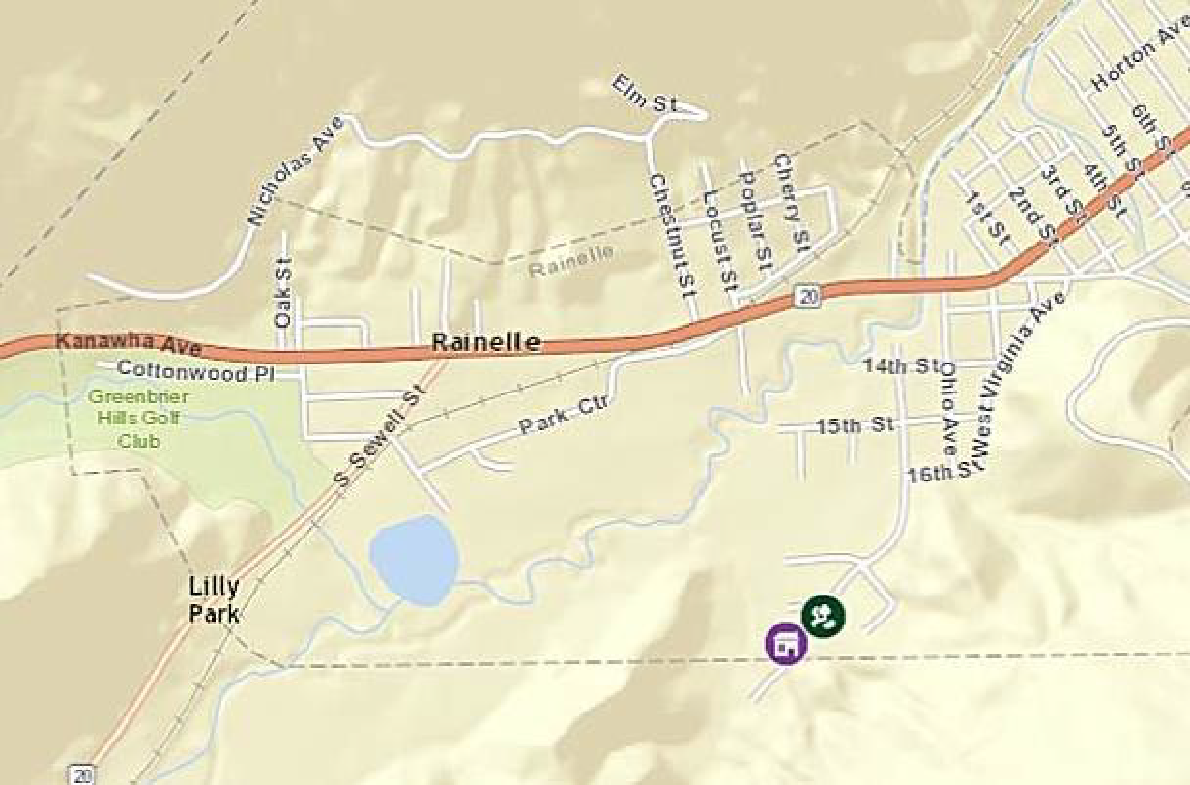
West Virginia utilized the Resource Locator and contacted all 78 affordable housing properties located in Greenbrier and Kanawha and confirmed that three sustained damage – Elk Village and Elk Crossing in Elkview and North Bend Apartments in Harrisville. The reported damage consisted of impact to roofing, gutters, flooring, and landscaping. No insurance monies or other assistance was received for the damage. None of the tenants living in the properties had to be relocated because of the damage and all of the repairs to the buildings were made using available funds in reserve accounts. As set forth in the description of the State’s programs to be funded with this CDBG-DR Award, should these properties have unmet needs remaining, the HUD-financed properties will be prioritized to receive assistance. Refer to Appendix C for the record of contact made to HUD-assisted properties.
Additionally, the State of West Virginia contacted Public Housing Authorities (PHAs) throughout all affected counties to confirm if damages were sustained to their properties and whether there remains an unmet need. Although no PHAs reported damage to their owned developments across the State, there were reports of damage to Section 8 rental properties. Specifically, in Kanawha County, mostly in the Clendenin area, a total of 71 Section 8 units were damaged by the flood but have since been repaired. Addressing any remaining unmet needs of these properties will also be prioritized as set forth in the descriptions of the State’s programs to be funded with CDBG-DR program funds.
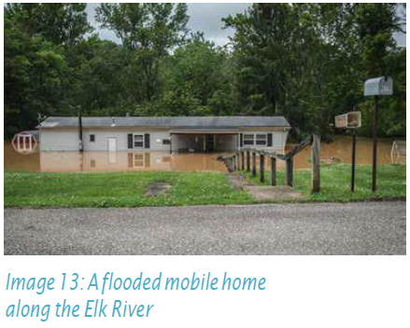
In Greenbrier County rental subsidy needs were high even before the flood. The Greenbrier County Housing Authority, Housing Choice Voucher Program is fully utilized with a waiting list of over 200 families.⁷ There simply are not enough vouchers in circulation to alleviate the shortage of affordable housing for those citizens who qualify.
Repairing and rebuilding affordable and more resilient rental housing and prioritizing assistance to Section 8 landlords as well as those properties which are occupied by low to moderate income tenants will bring these communities back stronger providing refuge for the most vulnerable populations with them. Through the creation of its Rental Assistance Program, West Virginia will prioritize bringing safe, sanitary, and affordable housing units back to full operation for the benefit of the state’s most vulnerable residents.

Homelessness Services
The floods of June 2016 primarily impacted the West Virginia Balance of State Continuum of Car (CoC) WVU Permanent Supportive Housing Projects (WVU) in Greenbrier County. Specifically, the floods displaced two tenants who needed permanent relocation assistance due to the damage to their units. WVU notified authorities that their housing services were available to those who were homeless, but most individuals and families were assisted by the FEMA Individuals and Household Program.
Overall, the disaster did not affect the CoC’s efforts to end homelessness and no unmet needs remain. The CoC received HUD Disaster technical assistance and maintains regular communications with the WVDHHR Bureau of Behavioral Health and Health Facilities regarding the ways in which the CoC can provide services to address long-term homelessness. The CoC has also added additional questions to the HMIS intake work flow to track persons entering the system who may have been affected by the floods.⁸ The Coalition reported that because of adding these additional questions, 51 clients reported that they were personally affected by the flood. The average service period among the flood-affected population was 40 days. A total of 17 clients are still receiving services and as such, there is no unmet need outside of the services WVCEH is currently providing. Below is a summary of the services delivered to the impacted clients.⁹
7 Interview with Executive Director of the Greenbrier County Housing Authority
8 West Virginia Balance of State CoC FY 2016 Application
9 Data provided by HMIS Specialist at WVCEH

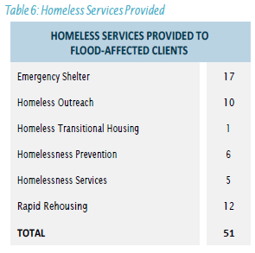
West Virginia will continue to interface with the WVCEH as well as the WVDHHR and document their efforts and the services provided to the special needs populations affected by the flood. Additionally, with regards to the population served through the State’s Housing Opportunities for Persons with HIV/AIDS (HOPWA) Program, the program manager confirmed that no HOPWA sites were specifically impacted by the June 2016 flood event.¹⁰

The State will ensure that the needs of any individual and/or family that is homeless or at-risk of becoming homeless are met through its CDBG-DR housing programs. Transitional housing, permanent supportive housing and permanent housing needs of this population will be prioritized, especially for those with incomes below 30% of the area median income, should unmet needs remain.

Emergency Shelters

Emergency shelters were set up by the Red Cross in the aftermath of the flood in all counties, coordinated in part by WV VOAD. Thousands of meals and supplies were delivered to these shelters by volunteer groups. While there was no reported damage sustained to any of the emergency shelters or transitional housing units in the declared counties, West Virginia understands the importance of capturing the increased client population and working together with the WVCEH to design a housing program that will benefit residents who are now homeless as a result of the flood by providing rapid rehousing and shelter. It is the intention of the State to prioritize the homeless population and other special needs populations through the application process of all housing programs outlined in this Action Plan

Image 14: The back of Nicholas County Nursing Home several days after the flood
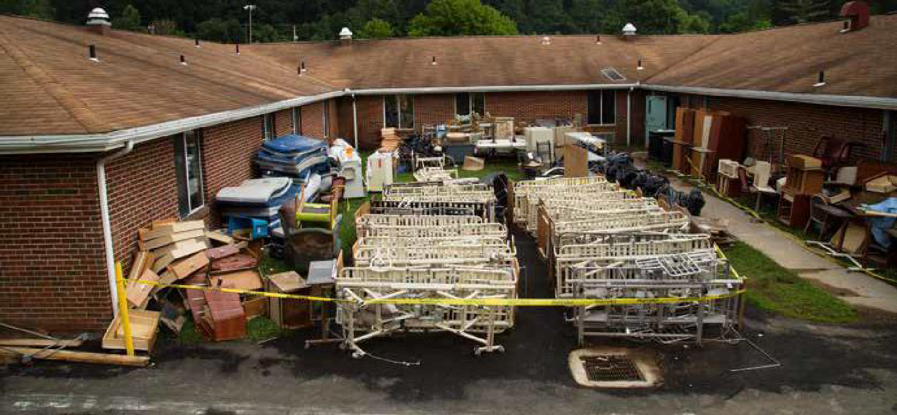

10 Interview with Kevin Meadows, program manager for West Virginia HOPWA Program.
Infrastructure Impact
Pre-Existing Condition of the State’s Infrastructure
West Virginia has 38,750 miles of public roads per the 2015 State Transportation Statistics report. The majority, 34,407, are owned by the West Virginia Department of Transportation. West Virginia has the 4th highest highway traffic fatality rate in the nation. Additionally, West Virginia has 7,163 bridges across the state, of which 96% are state-owned. One third of the bridges in the state are rated as structurally deficient or functionally obsolete by the U.S. Department of Transportation.¹¹

In the 2013 American Society of Civil Engineers (ASCE) Report Card for America’s Infrastructure, West Virginia was noted as needing $3 billion in wastewater and $1 billion in drinking water infrastructure needs over the next 20 years. It is estimated by the ASCE that it costs each motorist in West Virginia $469/year to drive on roads in need of repair. Investment in infrastructure has steadily declined in West Virginia in terms of capital expenditures for new construction of roads and bridges. State budgets indicate that capital expenditures from the Division of Highways are at a five-year low. During Fiscal Year 2009-2010, West Virginia spent $1,04 billion on new infrastructure - $807 million on roads and $223 million on bridges. Fiscal Year 2013-2014 shows a sharp decline. Only $586 million was allocated for infrastructure- $381 million for roads and $204 million for bridges.¹² The decrease in capital expenditures is a direct result of the budget crisis the state has experienced for the past few years.

Figure 13: Capital Expenditures in Infrastructure
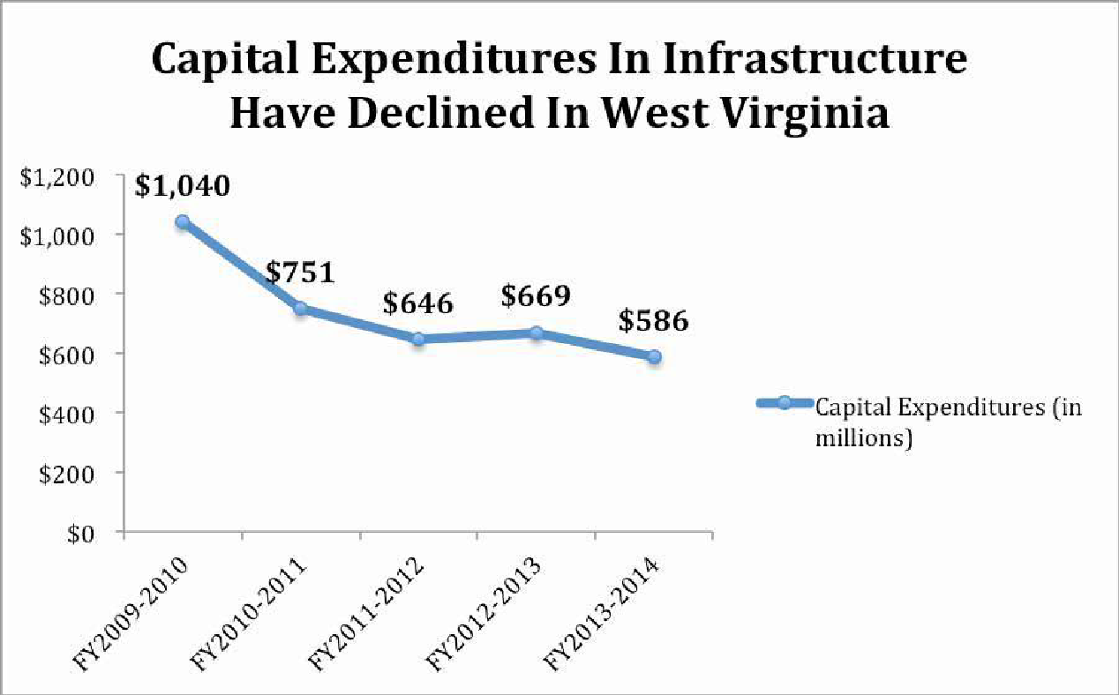

11 https://www.rita.dot.gov/bts/sites/rita.dot.gov.bts/files/STS_2015.pdf
12 https://wvpolicy.org/improving-infrastructure-good-for-west-virginia/

Impact to State’s Infrastructure
The June 2016 flooding caused significant damage to state infrastructure and facilities. Damaged facilities that provided essential services, such as wastewater treatment plants and educational facilities were among the most affected. Despite efforts to protect imperative infrastructure items, facilities, and other assets, damage to such property was extensive. The current calculated total impact to state infrastructure as of March 21, 2017 is $134 million per FEMA’s Public Assistance obligated by FEMA. The State, through the Department of Homeland Security and Emergency Management, is working one-on-one with impacted local jurisdictions to ensure that all eligible projects are captured under the FEMA PA program. Many of the small towns throughout West Virginia, such as Rainelle and Richwood, experienced heavy damage to their local water and wastewater systems. As a result, it will be incumbent upon the State to guide them through the FEMA PA process to have their systems restored and public services offered to the local constituency base once again.
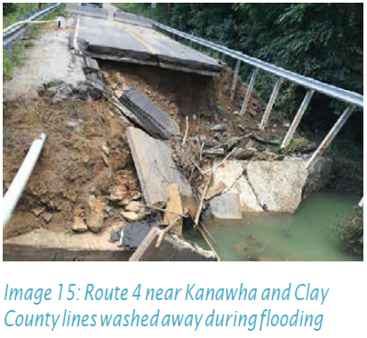
Department of Transportation
West Virginia is a key part of the East Coast transportation network and the damage from the 2016 floods stretches more than 200 miles. Per the National Weather Service, the state’s third-deadliest flooding event cause the Elk River to crest at more than 33 feet, rising 27 feet in a single day, causing significant damage to roads, such as large mud- and rockslides, roadway erosion, culvert and bridge failures, and the closure of many routes. The West Virginia Department of Transportation (WVDOT) has reported an estimated $56 million of damage caused to the state’s highway system. A total of 1,300 different locations of state roads were washed out by flood waters and 123 bridges received damage.
A total of 15 bridges were completely destroyed and 250 roads were closed due to the storms.¹³ In various communities across the state, streetlights and traffic signals were damaged by floodwaters and inoperable. The West Virginia Division of Highways is working closely with FEMA and WVDHSEM to account for all damage that may be eligible for Public Assistance (PA) on project worksheets (PWs). Currently half of the $56 million in damage has been approved for funding and obligated by FEMA.
Public Schools
Flood waters damaged a total of 67 schools, with five deemed substantially damaged and approved by FEMA for demolition and rebuild.¹⁴ The five substantially damaged schools are located in the counties of Kanawha and Nicholas. In Kanawha County, Herbert Hoover High School and Clendenin Elementary were severely damaged.¹⁵ Water from the Elk River crested about 7 feet deep in the first floor at Herbert Hoover High School. Richwood High and Middle Schools, and Summersville Middle School were also severely damaged. Per State Department of Education attendance records for the five schools, over 2,000 students had to be relocated to nearby schools with many of the students housed in portable classrooms until the new schools are built. The West Virginia School Building Authority has worked closely with FEMA to address the destruction of the schools. The schools will have to be moved outside of the floodplain to minimize the effect of future flooding. There is currently no timeline for when all schools will be rebuilt. FEMA granted $2 million to aid recovery efforts for schools in Nicholas County. Specifically, the $2 million grant is being used to pay for temporary
Interview with Henry Bergstrom, Deputy Secretary at WVDOT
14 http://wvmetronews.com/2016/11/17/fema-commits-to-replacing-five-schools-destroyed-in-june-flood/
^{15 NOAA Event}
facilities to replace those inundated by the floods. Students in the Elk River communities will be in portable classroom buildings before the end of the 2016-2017 school year, according to Kanawha County Facilities Director Chuck Wilson. Bridge Elementary is currently housing students and staff from Clendenin Elementary. Those schools have been operating on a split schedule this year after June flood waters destroyed Clendenin Elementary. Herbert Hoover High School is dealing with the same issue this school year. Those students and staff are on a split school day at Elkview Middle. Portables will also be installed at Elkview Middle. Wilson stated that project is slightly behind Bridge. “The portables at Bridge are scheduled to be complete by March 23 and Hoover will probably be mid-April,” he said. That’s nearly nine months since the flood.¹⁶

Public Parks

The Division of Natural Resources reported over $2 million in damage to the state’s public parks, recreation areas, and wildlife. The Greenbrier River Trail, which cuts through Greenbrier County, sustained the brunt of the damage with parts of the trail covered in storm debris and large areas completely washed out. The trail is a 78-mile long rail trail used for bicycling, backpacking, cross-country skiing, and horseback riding. It traverses one of the most remote areas in the state and lies adjacent to the Monongahela National Forest, Seneca State Forest and Watoga State Park. The trail remains closed between mile 6.8 and milepost 13 because of the hazardous conditions as a result of the flooding.¹⁷ A summary of the damage is provided below.
16 http://wvmetronews.com/2017/02/20/portable-classrooms-arrive-for-flooded-kanawha -county-schools/
17 http://www.greenbrierrailtrailstatepark.com/

Table 7: Damage to Public Parks
Greenbrier River Trail in Greenbrier & Pocahontas Counties | $2m
Little Beaver State Park in Raleigh County | $3k
Moncove Lake State Park in Monroe County | $5k
Greenbrier State Park in Greenbrier County | $100k
Babcock State Park in Fayette County | $35k
Hawks Nest State Park in Fayette County | $4k

In addition, four wildlife management areas sustained the following estimated damage:

Table 8: Damage to Wildlife Management Areas
Public Stream Access Sites in Summers County | $12k
Wallback Wildlife Management Area in Roane County | $10k+
Edray Trout Hatchery in Pocahontas County | $3k+
Bridge Handley Wildlife Management Area in Pocahontas County | $3k+

Impact to Infrastructure in Local Communities
West Virginia had numerous rural water and waste water collection systems which sustained extensive damage from the flood. Most of the damage was to electrical systems including substations, motors, control panels, junction boxes, and instrumentation. The communities which suffered the most severe damage to water and wastewater collections systems included the towns of Alderson, Clay, Clendenin, Rainelle, Richwood, and White Sulphur Springs. Through their elected officials all reported significant damage to their local infrastructure which is summarized here. WVDHSEM will continue to proactively guide these local jurisdictions through the FEMA PA process to ensure that all public services are restored to the impacted communities.

Figure 14: Map of impacted cities and towns
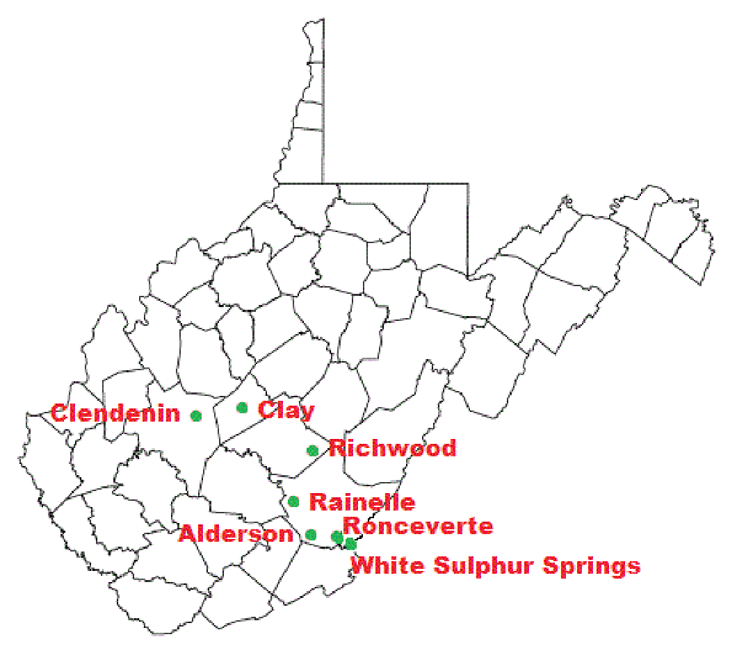
The town of Alderson reported extensive damage to the communities’ water and wastewater collections systems which serves approximately 700 residents. Funding needed is estimated at $2,500,000 and includes $1,500,000 to repair damaged and aging wastewater collection systems, inspection of systems, and engineering services. Another $1,000,000 will be needed to upgrade water filtration, increase water production and improve distribution systems.

The town of Clay will need $3,500,000 to repair damages to the distribution systems which serves almost 600 residents and extend services to the larger community, perform inspections of systems, and engineering services. Clay wastewater plant will require an additional $1,500,000 to improve services through emergency backup power, flood proofing of the plant and to remove silt from the processing tanks.

The town of Clendenin experienced significant damage and reports in excess of $12,000,000 needed to repair damages which includes $1,500,000 to improve the distribution systems and extend services to the community and perform inspections of systems and engineering services. Elk Valley PSD wastewater plant will require an additional $6,500,000 to improve the collection system, repair slips along the Elk River, insulate the temporary line at Reynolds Avenue, repair emergency backup power and flood proofing of the lift stations, suctions stations, and grinder stations. Additionally, Riverview Medical Center will require an estimated $4,000,000 to repair flood damage to the building, repair and flood proof the electrical service and to reopen the 18 apartments.

The town of Rainelle has reported needs estimated at $3,750,000 to repair damage to the water distribution systems which serves 900 residents, including the lift and pump stations and the back-up generator. The Rainelle wastewater plant will require an additional $1,500,000 to improve services through inspection, replacement and modernization of the collection systems to include emergency power and flood proofing. They also report they will require an additional $1,750,000 to improve public services.

The town of Richwood reports it sustained $66,000,000 in damage with most of the damage sustained at the water and wastewater processing plants which serve 1,000 residents. Water loss at the plant is reported at 68%. They need funding to improve distribution/collection systems and extend services to the community, perform inspections of systems and engineering services. They also report $9,000,000 in additional funding is needed to separate the storm and wastewater systems and to move the wastewater collection system currently located in the Cherry River. An additional $3,000,000 to correct the storm water management on Oakford Ave to the Cherry River will also be required.

The town of White Sulphur Springs experienced damage to the community water and wastewater distribution and collection systems which serves over 1,500 residents. Additional funding needed is estimated at $5,500,000 to repair damage to the water distribution systems and wastewater collection systems in the downtown area, perform inspections of systems, and engineering services.

Economic Impact
Pre-Existing Condition of the State’s Economy
Prior to the June Floods West Virginia’s economy was struggling from a downturn in coal production. Local economies throughout small towns all over West Virginia relied heavily on the coal industry. With reduced coal demand and natural gas markets trending downward, a substantial loss in jobs and in turn population, caused the State to fall into a recession beginning in 2015.¹⁸ As a result of the lagging economy, the State legislature has been forced to slash budgets in recent years. The budget deficit for the State’s coming fiscal year is expected to be about $500 million.¹⁹ The flooding event only worsened the economic problems experienced in the state, most notably a decline in income taxes due to joblessness and revenue losses due to less sales tax being collected.

Although affected communities are continuing the recovery process throughout the declared counties, they are faced with balancing the additional economic burden of long-term recovery in a state that has experienced significant population decline and stymied job growth in the last few years. The loss of coal jobs in recent years throughout Appalachia has halted the state’s economy and forced many out of the workforce. Many former coal miners have failed to secure adequate employment outside of the coal industry as a result. Coupled with the state’s opioid epidemic, the average West Virginian who has been affected by the flood will be vulnerable due to factors that other communities don’t typically have to account for on such a large scale.

18 West Virginia Economic Outlook 2017-2021
19 http://www.wvgazettemail.com/news/20170118/projected-2017-18-wv-budget-deficit-nears-500m

Image 17: Flooded businesses in Elkview
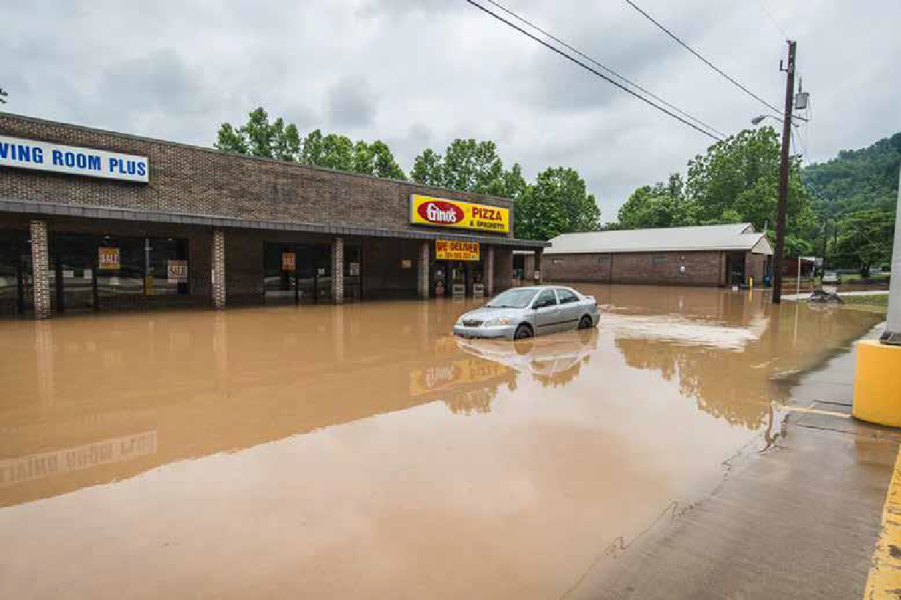

Workforce/Unemployment
Workforce West Virginia reported that the state unemployment rate was 6% prior to the flood. Although the unemployment rate improved slightly in the third quarter of 2016, it increased back to 6% by October 2016.²⁰
Compared to the U.S. unemployment rate in the same time period which decreased from 4.9% to 4.7%, West Virginia had the fourth highest unemployment rate in the U.S. The unemployment rate is directly tied to the state’s loss of coal jobs, many of which sustained generations of families for decades. Additionally, many non-coal industry workers were unable to return to work immediately following the flood because of the washed-out roads and bridges. Officials with WorkForce West Virginia reported over 1,200 disaster unemployment claims with over $2 million in lost wages as a result of the flood. The average weekly wage of the disaster claimants was $472 per week which indicates a high impact to low-wage workers across the declared counties.
^{20 http://lmi.workforcewv.org/}

Figure 15: Unemployment by County
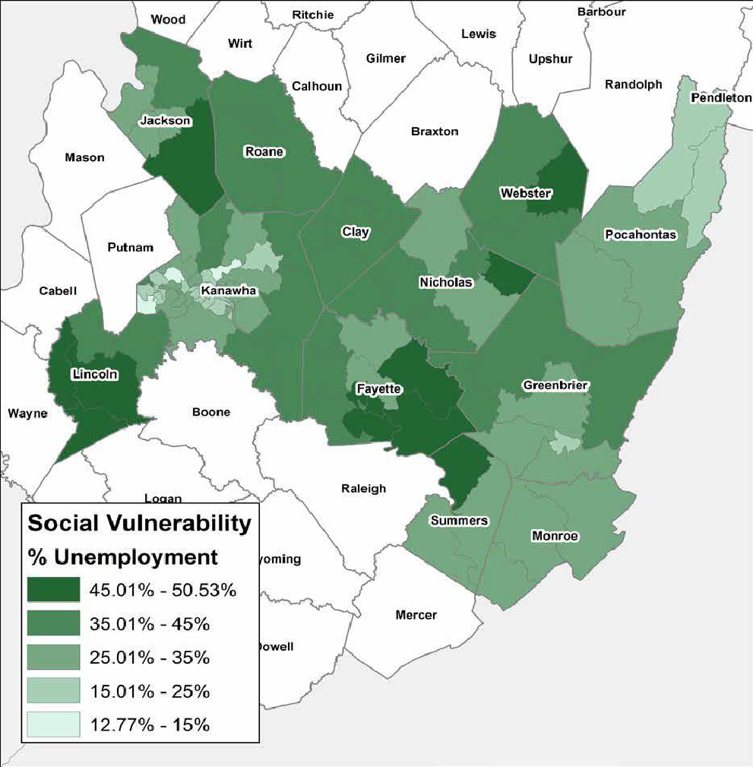

Small Business
The Small Business Administration received approximately 1,450 referrals for business loans of the nearly 9,000 applications submitted to FEMA, of which only 58 loans have been approved for a total of $10 million dollars with the largest industry assisted being lessors of residential real estate or landlords.²¹ The low approval rate of business loans is indicative of the economic conditions in the state with many small business owners either being overleveraged and not willing to take a loan or denied for loan funding due to low credit worthiness or lack of required minimum income.
Additionally, RISE West Virginia, a small business grant program created by former Governor Earl Ray Tomblin, awarded mini grants to 229 small businesses as of the deadline of November 23, 2016. Small businesses affected by the flood were eligible to receive mini-grants of up to $10,000.²²
21 SBA Data Business Loan dataset
22 http://wvmetronews.com/2016/12/29/rise-west-virginia-grants-for-flood-recovery-top-1-8-million/
Agriculture
The West Virginia Department of Agriculture reported approximately 40 counties with agriculture impact which includes the following estimates.
- 5,300 farms were affected
- $1.7 million reported in corn lost/damaged
- $1.6 million in hay lost/damaged
- $500,000 reported in pasture damage
- $1.2 million in reported damages to farm structures
- $60,000 worth of machinery damages/losses
- 700 total livestock were lost (poultry (600), cattle, sheep, hogs)
- Farm fences were damaged or destroyed in at least 26 counties
Furthermore, eleven counties have requested Emergency Conservation Program implementation with approximately $2 million in estimated damage for the following clean-up activities of agriculture land, not including streambanks or stream channels:
- Debris removal
- Grading/shaping and reseeding
- Fence replacement and repair
- Conservation structure replacement and repair
Multiple notices of loss related to mechanically harvested feed and purchased feed stuffs have been accepted through the Emergency Livestock Assistance Program (ELAP).

Tourism
The Greenbrier Classic, a world-class golf tournament held at the Greenbrier Resort near White Sulphur Springs, was forced to cancel its yearly event due to the floods. According to The Greenbrier Classic: Impacts and Opportunities report, the State is thought to have missed out on upwards of $2.5 million in tax revenue. In years past, the event produced an estimated $21 million in local lodging, shopping, food, tickets, transportation and other entertainment revenue, all of which was lost because of the cancellation. According to the 2011 economic impact study of the first tournament, the event had an overall economic impact of more than $111 million.²³ Additionally, the state’s whitewater rafting industry has seen declines due to the flooding. Recently released by the West Virginia Division of Natural Resources, which tracks the number of people rafting in the state each month, the 2016 commercial rafting numbers show that 100,312 people rafted the New and Gauley Rivers last year, down 4,687 people from 2015.

23 http://www.timeswv.com/news/effect-of-the-greenbrier-classic-priceless/article_cd042352-286d-11e5-a44f-cb2d73effb62.html

Unmet Needs Assessment
Housing Needs Assessment
Background
Once the State completed its full impact assessment, West Virginia turned its focus to the remaining unmet needs stemming from the flood in June 2016. As stated previously, this disaster affected 18 of the state’s 55 counties, with 12 counties declared eligible for both FEMA IA and PA funds. The unmet needs assessment below considers federal and state resources, including the most recently available data provided by FEMA, HUD, the Small Business Administration (SBA), National Flood Insurance Program (NFIP), and other sources to estimate unmet needs specific to the housing sector. HUD initially identified the two most impacted and distressed counties from this disaster as Kanawha and Greenbrier Counties. Accordingly, this unmet need assessment focuses on statewide impacts, with specific sections detailing particular needs within the initial HUD-identified most impacted and distressed areas and where relevant, additional locations such as Clay and Nicholas Counties.

Figure 16: FEMA Disaster Declared Counties
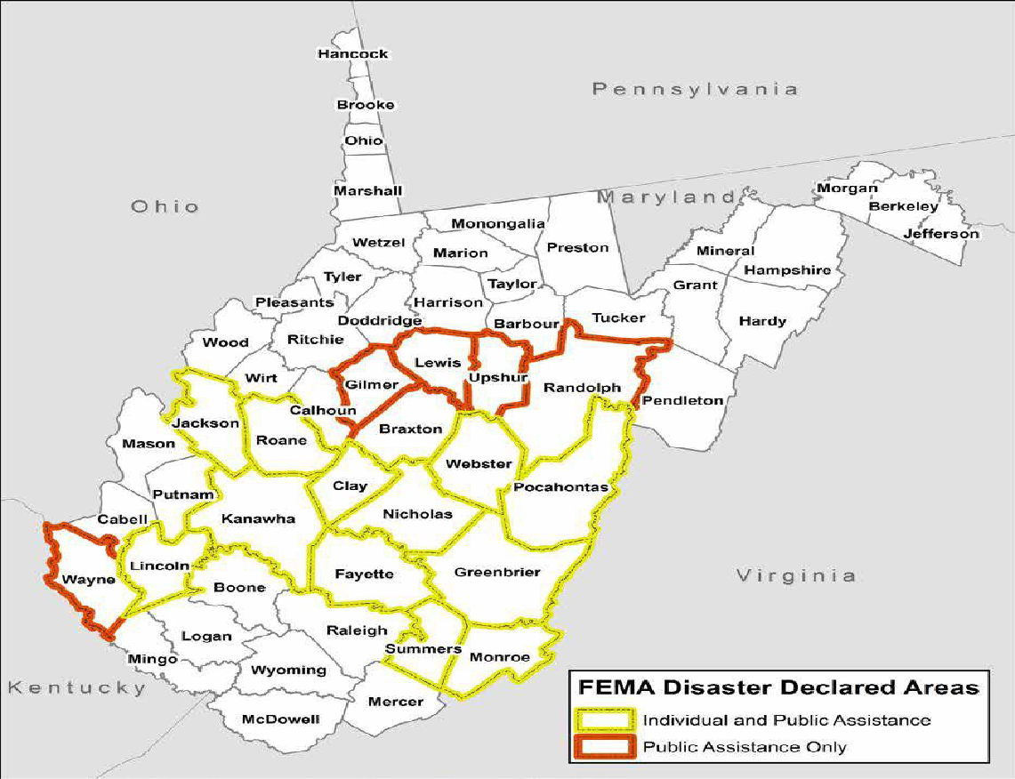
With a need for residential homes as well as temporary and permanent housing, the State analyzed FEMA and SBA applicant data to estimate the number of severity of damaged homes within the impacted counties. These sources included datasets from the FEMA Individuals and Households Program, SBA Disaster Loans, and NFIP claims data. The State overlaid these datasets with census data to measure the social vulnerability of impacted populations called the Social Vulnerability Index (SoVI).

FEMA Individuals and Households Program (IHP)
The following data has been summarized from the FEMA Individuals and Households Program (IHP) data set. The IHP provides financial help or direct services to those who have necessary expenses and serious needs if unable to meet the needs through other means. The IHP statistics for West Virginia show many impacted residents carried no flood insurance whether they were in a flood zone or not. Many residents have expressed that flood insurance in their areas is too expensive, and therefore, not a feasible option. Additionally, many of those impacted area low-to-moderate income households and will require additional funds to fully recover to their pre-storm position.
- 8,732 FEMA registrations were received across the declared counties.
- Of the 7,053 registrants referred to the IHP, 5,130 had a real property verified loss, of which approximately 3,500 were deemed eligible for repair/replacement funding.
- The average IHP home repair/replacement grant award was $8,260.
- Over $45 million calculated in FEMA Real Property Verified Loss (RPVL).
- Approximately 90% of flood damaged homes were deemed unsafe after inspection.
- Based on gross income reported by the IHP applicants, over 2/3 of the applicant pool was below the 80% AMI level for their county.
- Of the 2,302 IHP applicants whose properties were located in a flood zone, only 385 had flood insurance, or about 17%.
- Of the 4,751 IHP applicants whose properties were not located in a flood zone, only 301 had flood insurance, or about 6%.
The map on the following page illustrates which counties had the highest amount of FEMA real property verified losses. Clay, Greenbrier, and Kanawha Counties each sustained more than $6 million in FEMA real property verified losses, followed by Nicholas County which sustained between $3 and $6 million, then Webster and Roane Counties which experienced between $1.5 and $3 million. The remaining declared counties were recorded as having less than $1.5 million in FEMA real property verified losses.

Figure 17: Sum of FEMA Real Property Verified Loss by County
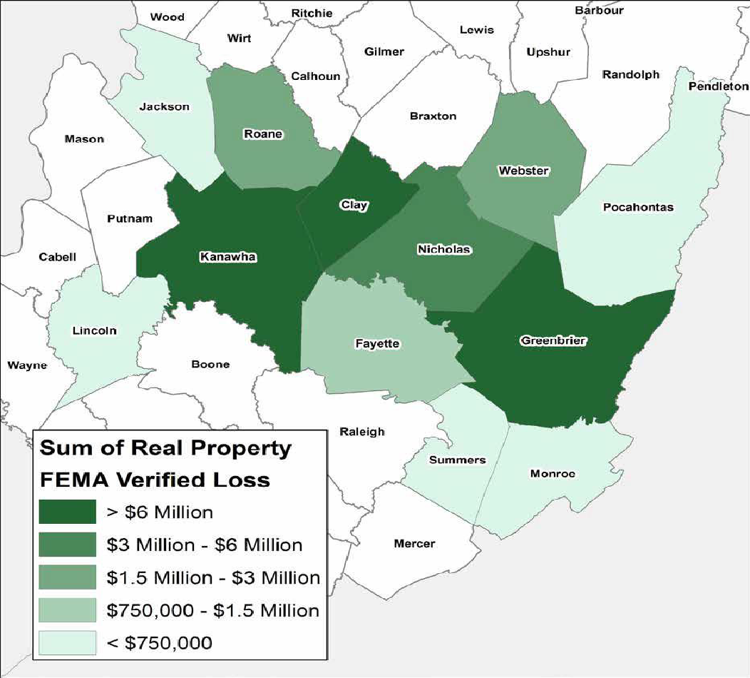

Small Business Administration Disaster Home Loans
The SBA Disaster Home Loan program offers low-interest loans to homeowners in a declared disaster area to assist with the repair or replacement of damaged real and personal property. After a review of the SBA Disaster Home Loan data in an economically depressed state such as West Virginia, it is evident that many disaster-affected residents were not eligible for SBA loans because of reasons such as failure of the minimum income test or lack of repayment ability due to unsatisfactory credit. Furthermore, over 65% of eligible FEMA applicants did not attempt to apply for SBA loans. During outreach, the State heard from constituents and other program administrators that many people could not take on additional financial obligations due to loss of employment and low wages and in turn, did not apply for the SBA Disaster Home Loan program. Below are some of the statistics gleaned from the data which support this fact. The following data has been captured from the SBA Disaster Home Loan data set.
1,762 SBA applications were received.
• 1,058 applications were declined or withdrawn (60%).
• 697 applicants were approved for a loan (40%).
• 973 applications were received with a total calculated verified loss to real estate of $62.6 million.
• The average home loan for damage to real estate was $42,571.
- 977 NFIP claims were filed.
- 82% of claimants received a building damage payment.
- The average building claim payment was $41,198.
- $32.8 million in total claims were paid for building damage across the 12 counties.
- Over 65% of building claim payments were approved in seven small towns: Clendenin, Elkview, Richwood, Rainelle, Ronceverte, Alderson, and White Sulphur Springs.

- NATIONAL FLOOD INSURANCE PROGRAM (NFIP)
- The following data has been extracted from the NFIP data set. As evidenced previously from the FEMA IHP data,
- many West Virginians were without flood insurance when the June flood hit, most notably for lack of affordability
- of coverage or because their property was located outside a flood zone; and therefore, not required to carry flood
- insurance. Of the 7,053 FEMA IHP applicants, 90% did not have flood insurance. Of the residents with flood
- insurance only approximately 800 received a building claim payment.
- • 977 NFIP claims were filed.
- • 82% of claimants received a building damage payment.
- • The average building claim payment was $41,198.
- • $32.8 million in total claims were paid for building damage across the 12 counties.
- • Over 65% of building claim payments were approved in seven small towns: Clendenin, Elkview, Richwood,
- Rainelle, Ronceverte, Alderson, and White Sulphur Springs.

Assessing the Demand for Housing Assistance
With limited funds available, the State was very deliberate in its assessment of demand for housing recovery funds. In order to address the demand for housing, the State coupled outreach efforts with a detailed assessment of damage at the unit level. This allowed the State to understand the demand for housing repairs in monetary terms and related support to households. To estimate the demand for housing rehabilitation, the State analyzed the FEMA Individual Assistance data set, SBA disaster home and business loan dataset, as well as NFIP claims data for Disaster 4273. FEMA Individual Assistance data accurately reflects registrations and applications for loans which result in valuations of verified loss that are more accurate to scale than FEMA verified loss calculations. Finally, NFIP claim data provides the state with one component necessary to perform the duplication of benefits calculation for the affected population and potential CDBG-DR applicant pool.

Determining Unmet Housing Needs
To understand the unmet need to be addressed by the State’s CDBG-DR programs, the State built upon the above estimates of the demand (or required funding) for flood-related reconstruction, rehabilitation, and mitigation by estimating the verified loss as well as the “supply” of funding already available to offset outstanding verified loss. Many local, state, and federal programs have funded some of the need for homeowners and landlords to undertake rebuilding and rehabilitation measures. The State will use CDBG-DR funding to complement and build upon such resources.

Image 18: Damaged home in Clendenin
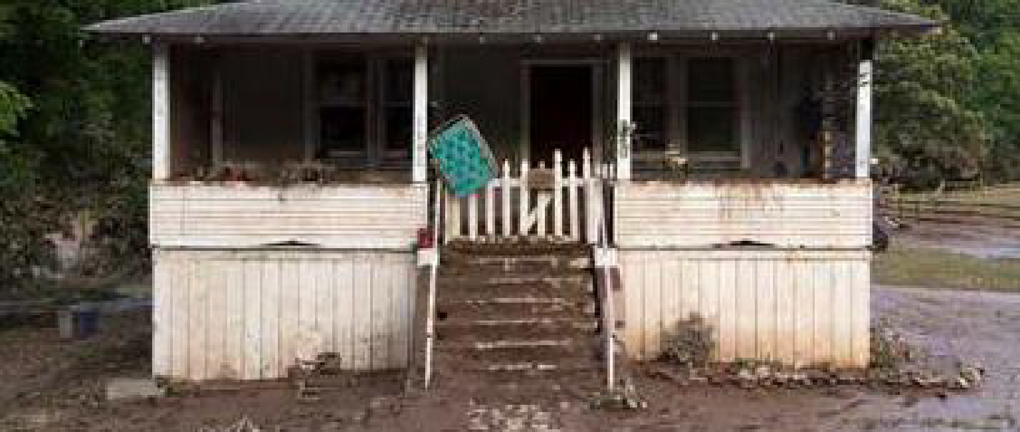
To determine the housing unmet need, the State first analyzed the 5,130 applicants to the FEMA Individuals and Households Program (IHP) who had a real property verified loss. Forty percent (or 2,088) of the FEMA applicants had an SBA status of FIT (failed income test). Such determination indicates, per SBA’s standard operating procedures, that automatic referral to SBA’s disaster loan program was bypassed and these applicants were instead referred directly to FEMA’s Individuals and Household Grant Program.²⁴ Additionally, of the applicants who passed the income test were automatically referred to SBA, twenty percent (or 376) failed the Fixed Debt Method analysis, which is an analysis to determine if applicants with household incomes above the income test table threshold have repayment ability. If they fail, a loan status of Summary Decline is indicated for the loan and the applicants are immediately referred to FEMA IHP. Given this analysis, the State understood early on in its unmet needs assessment that there would be a sizable unmet housing need due to the lack of recovery resources available to the average West Virginian, many of whom have experienced economic hardships in the last few years.
24 https://www.sba.gov/sites/default/files/SOP%2050%2030%207.pdf
West Virginia followed HUD’s lead in determining housing damage and the cost to repair that damage. Per the Federal Register Notices applicable to this Allocation (81 FR 83254, 82 FR 5591), the average cost to fully repair a home for a specific disaster to code is calculated using the average real property damage repair costs determined by the Small Business Administration for its disaster loan program for the subset of homes inspected by both SBA and FEMA for 2011 to 2013 disasters. Because SBA is inspecting for full repair costs, it is presumed to reflect the full cost to repair the home, which is generally more than the FEMA estimates on the cost to make the home habitable. Therefore, West Virginia used SBA’s disaster loan data for the flood and determined an average real property verified loss amount of $64,380 among 973 SBA disaster home loan applicants for a total verified loss of $62,642,237. The State analyzed the remaining 789 unapproved SBA disaster home loan applicants without a real property verified loss amount and found that they were almost all declined for an SBA loan for economic reasons already discussed above, such as lack of repayment ability, failure of minimum income test, and unsatisfactory credit. Because of this fact coupled with an understanding of SBA’s standard operating procedures, it is presumed by West Virginia that this population was declined for loan assistance very early on in the SBA application process and therefore, was never granted a damage assessment by SBA. Accordingly, West Virginia applied the average verified loss of $64,380 noted above to the unapproved population which yielded a total estimated verified loss for these 789 applicants of $50,795,820. Thus, a total of $113,437,560 in real property verified loss was determined for the 1,762 applicants who applied for SBA assistance and were ultimately approved or denied a loan.
Table 9: Verified Loss of FEMA Applicants Referred to SBA
Verified Loss of FEMA Applicants Referred to SBA
SBA Applicants with a Real Estate Verified Loss | 973
Average Real Estate Verified Loss | $64,380
Verified Loss of SBA Applicants with a Damage Assessment |  | $62,641,740
SBA Applicants without a Real Estate Verified Loss | 789
Average Real Estate Verified Loss | $64,380
Estimated Verified Loss of SBA Applicants without a Damage Assessment |  | $50,795,820
SBA Applicants with a Real Estate Verified Loss | 1,762 | $113,437,560

Next, the State of West Virginia set out to determine the total estimated SBA real property verified loss amount for those FEMA applicants who were determined to have physical damage to their property per the FEMA damage assessment process but did not apply or were not referred to the SBA Disaster Home Loan Program, namely because of economic hardship. The State reviewed the FEMA IHP dataset and determined that a total of 5,129 FEMA registrants had real property FEMA verified loss amounts. Applying the average SBA verified loss methodology above to this population yields an additional 3,367 applicants (5,129 FEMA applicants less 1,762 SBA referrals already accounted for) with a total of $216,767,460 in real property verified loss.
Table 10: Verified Loss of FEMA Applicants that did not Apply for SBA
Verified Loss of FEMA Applicants That Did Not Apply For SBA
FEMA Applicants with a Real Property Verified Loss | 5,129
Total SBA Applicants | (1,762)
Total FEMA Applicants with a Real Property Verified Loss that did not apply for SBA | 3,367
Average Real Estate Verified Loss | $64,380
Total Estimated Verified Loss on Non-SBA Applicants |  | $216,767,460

Finally, the State of West Virginia wanted to also determine the real property verified loss of impacted rental property in the state because of the incidence of low-to-moderate income individuals who typically occupy these properties, particularly in heavily impacted areas such as Clendenin, Rainelle, and White Sulphur Springs. The State reviewed the FEMA IHP dataset for renters and determined that of the 1,162 renters whose unit was inspected by FEMA a total of 783 had structural damage. Applying the average SBA verified loss methodology above to this population yields an additional $50,409,540 in estimated real property verified loss for rental properties.

Table 11: Estimated Verified Loss of Rental Properties
Estimated Verified Loss of Rental Properties
FEMA Renter Applicants with Inspected Damage | 783
Average Real Estate Verified Loss | $64,380
Total Estimated Verified Loss of Rental Properties |  | $50,409,540

In total, the State of West Virginia determined a total real property verified loss among its 5,912 potentially eligible applicants for housing repair and rehabilitation of $380,614,560. To complete the unmet housing needs assessment, the State reduced the total real property verified loss by FEMA repair payments ($28,656,603), NFIP building claim payments to individuals ($27,188,147), SBA home loans for real estate ($27,373,186), and SBA business loans to lessors of residential buildings and dwellings ($1,902,900) to determine a total housing unmet need of $295,493,724.

Table 12: Total West Virginia Unmet Housing Need
Total West Virginia Unmet Housing Need
Total Real Property Verified Loss | $380,614,560
FEMA Repair Payments | $(28,656,603)
NFIP Building Claim Payments to Individuals | $(27,188,147)
SBA Disaster Home Loans for Real Estate | $(27,373,186)
SBA Disaster Business Loans to Lessors of Residential Buildings | $(1,902,900)
Total Housing Unmet Need | $295,493,724
Total Housing Unmet Need including 20% Resilience Costs* | $354,592,469
*To calculate the Total Housing Unmet Need including 20% Resilience Cost, the State added 20% (the industry standard cost of resiliency measures) to the calculated unmet need.

Social Vulnerability Index (SoVI)
The State has recognized that it must be deliberate in delivering CDBG-DR programs to the most vulnerable and devastated communities. Because of the vast amount of damage throughout the declared counties and the limited recovery dollars available, the State has primarily assessed the unmet housing need of the most vulnerable populations by utilizing the SoVI method. Given the almost $300 million in remaining unmet housing need, but the limited funding available to address those unmet needs, West Virginia considered where within the impacted areas exists uneven capacity for preparedness and response; thus, where resources might be used most effectively to reduce the pre-existing vulnerability. To that end, West Virginia utilized the Social Vulnerability Index (SoVI), which is a tool for assessing pre-existing vulnerabilities to environmental hazards and was developed by the University of South Carolina in response to the devastating flood that hit South Carolina in October 2015. The SoVI is a comparative metric that facilitates the analysis of differences in social vulnerability at a certain level of geography- in the case of West Virginia, at the county level. The index, in this iteration, synthesizes 29 socioeconomic variables, listed below, which, with support from research literature, can contribute to a reduction in a community’s ability to prepare for, respond to and recover from hazards.

Table 13: Socioeconomic Variables
Variable | Description
QASIAN | Percent Asian
QBLACK | Percent Black
QHISP | Percent Hispanic
QNATAM | Percent Native American
QAGEDEP+ | Percent of Population under 5 Years of 65 and over
QFAM+ | Percent of Children Living in Married Couple Families
MEDAGE | Median Age
QSSBEN | Percent of Households Receiving Social Security
QPOVTY | Percent Poverty
QRICH200K | Percent of Households Earning Greater than $200,000 Annually
PERCAP | Per Capita Income
QESL+ | Percent Speaking English as a Second Language with Limited English Proficiency
QFEMALE | Percent Female
QFHH | Percent Female Headed Households
QNRRES | Percent of Population Living in Nursing and Skilled Nursing Facilities
HOSPTPC | Hospitals Per Capita (County Level Only)
QNOHLTH+ | Percent of Population without Health Insurance (County Level Only)
QED12LES | Percent with Less Than 12th Grade Education
QCVLUN | Percent Civilian Unemployment
PPUNIT | People Per Unit
QRENTER | Percent Renters
MDHSEVAL+ | Median House Value
MDGRENT+ | Median Gross Rent
QMOHO | Percent Mobile Homes
QEXTRCT | Percent Employment in Extractive Industries
QSERV | Percent Employment in Service Industry
QFEMLBR | Percent Female Participation in Labor Force
QNOAUTO+ | Percent of Housing Units with No Car
QUNOCCHU | Percent of Unoccupied Housing Units
The SoVI built in West Virginia’s impact and needs assessment is primarily derived from U.S. Census Bureau and FEMA IHP data. The SoVI created for the state’s 12 counties affected by DR-4273 incorporates six general components synthesizing the 29 socioeconomic variables:
- Class and race
- Non-extractive (less rural)
- Age
- Ethnicity
- Gender
- Housing characteristics (persons per unit, renters, unoccupied units, female-headed households)
In order to identify communities with the greatest need for additional resources, West Virginia combined SoVI with other data sources, such as the FEMA IA dataset, NFIP data and SBA data. The State has collaborated with Dr. Christopher Emrich with Disaster Metrics, Inc. who was a key partner for the development of South Carolina’s long-term recovery plan stemming from the state’s 2015 floods. This collaboration resulted in West Virginia’s ability to target the use of these resources to the communities most impacted and least able to recover on their own from the 2016 floods.
The following SoVI map illustrates the results of the analysis by overlaying the most vulnerable and severely impacted population among the declared counties. It highlights specific areas within the declared counties where the most impacted populations reside by layering the disaster data over census tract data. By utilizing the longitude and latitude coordinates of the disaster affected properties gleaned from the FEMA IHP data set, the State has been able to identify exactly which towns were hit the hardest and consist of the most critically vulnerable populations.
This SoVI map identifies multiple areas determined to have the highest levels of pre-existing social vulnerability of those which experienced high concentrations of damage. These communities are located in eastern and southwestern Greenbrier, central Clay, northeastern Nicholas and northern Kanawha Counties.

Figure 18: FEMA verified losses
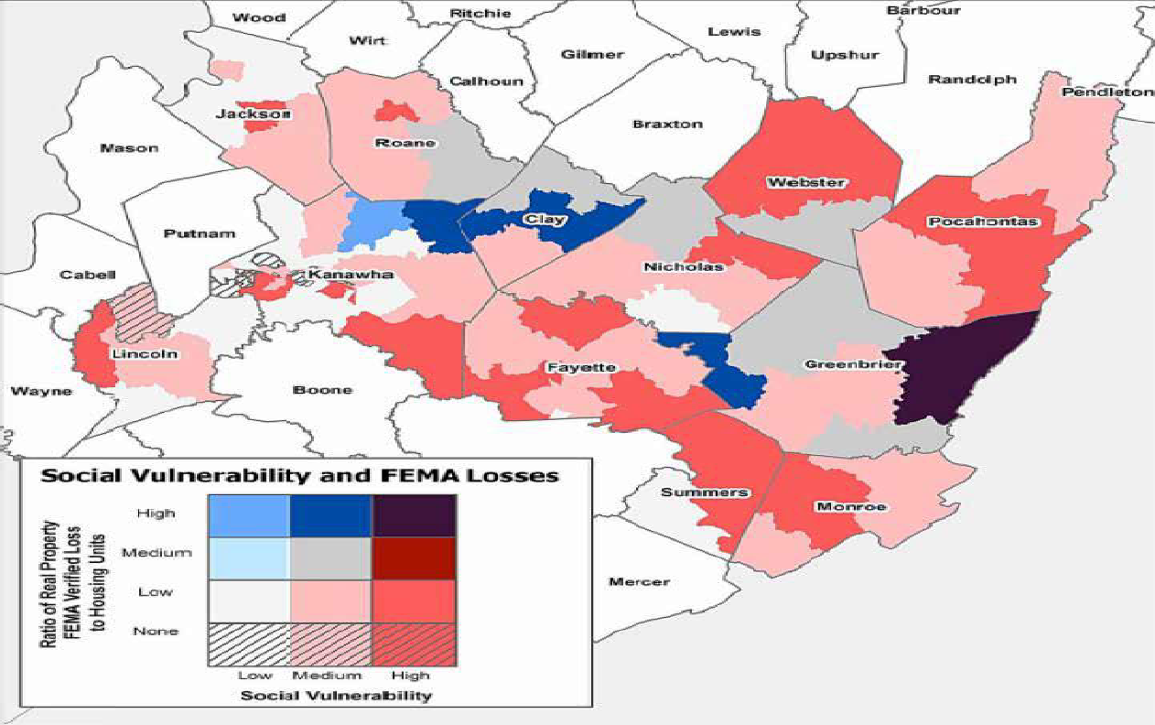

The SoVI method allows the State to effectively target the communities in which recovery from the flood has been especially hindered by the economic conditions presently experienced in those areas. With this Action Plan the State will implement programs which will be primarily focused on housing recovery, ensuring that supplementary activities will further support that mission. The State will comply with the requirement that 80% of all CDBG-DR are spent in the four most impacted and distressed counties, Greenbrier, Kanawha, Clay and Nicholas Counties (Clay and Nicholas included pursuant to an approved waiver request received by the State from HUD), as directed by the Federal Register Notice.

SoVI Town Analysis
A SoVI analysis of the 12 declared counties indicates that 10 of the counties have areas with high levels of pre-existing social vulnerability. The town of White Sulphur Springs, located in the county of Greenbrier, has the highest social vulnerability and highest ratio of real property FEMA verified loss. Using the unmet housing need calculation methodology previously explained translates to an unmet housing need of almost $19 million in White Sulphur Springs alone. Also, of note, there are numerous other high and medium level SoVI areas, such as Clendenin, Rainelle, and Richwood which sustained high losses and have an estimated unmet housing need of $32 million, $19 million, and $11 million, respectively.
Table 14 & 15: SoVI
High SoVI
County | Town | Estimated Unmet Housing Need
Greenbrier | White Sulphur Springs | $18,426,353
Webster | Webster Springs | $7,018,445
Nicholas | Richwood | $5,838,704
Medium SoVI
County | Town | Estimated Unmet Housing Need
Kanawha | Clendenin | $32,173,124
Greenbrier | Rainelle | $18,981,818
Clay | Procious | $6,650,364
Nicholas | Summersville | $6,448,227
Greenbrier | Rupert | $6,265,507
Nicholas | Richwood | $5,828,709
Clay | Procious | $6,650,364

The following maps (Figures 19-23) show towns within the declared counties that have more than $6 million in estimated housing needs with high and medium levels of SoVI. Please note that the town of Richwood is split between medium and high SoVI areas.
Figure 19: Unmet Housing Need 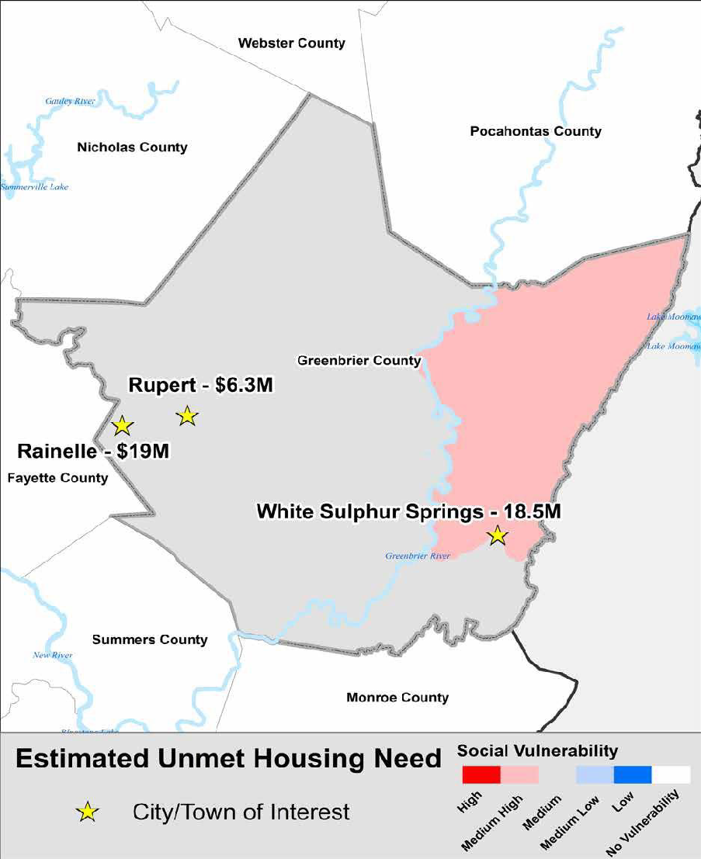

Figure 20: Unmet Housing Need
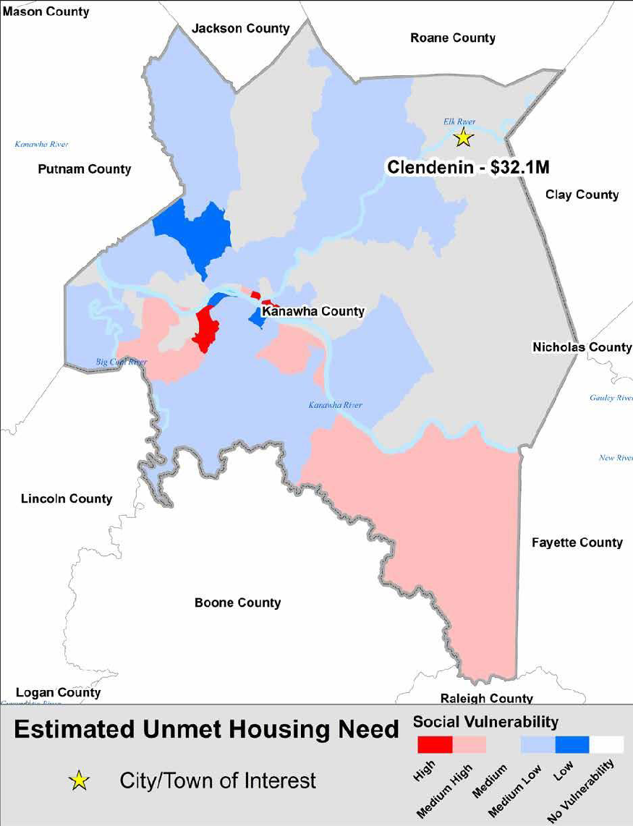

Figure 21: Unmet Housing Need
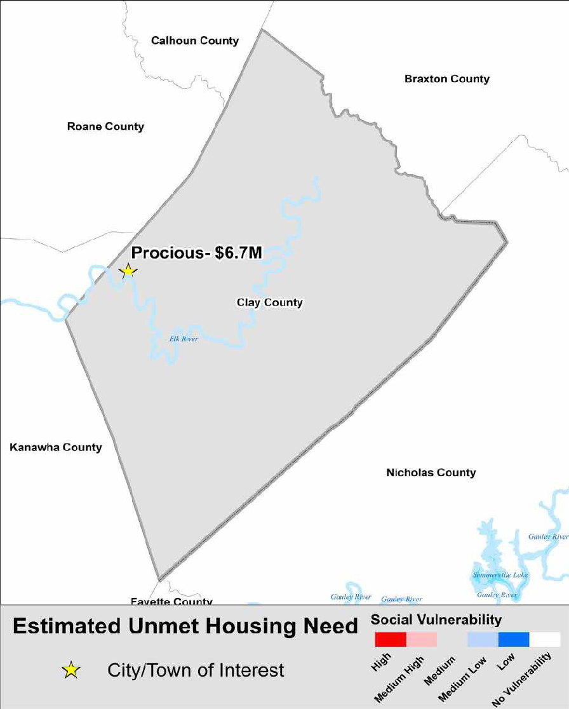

Figure 22: Unmet Housing Need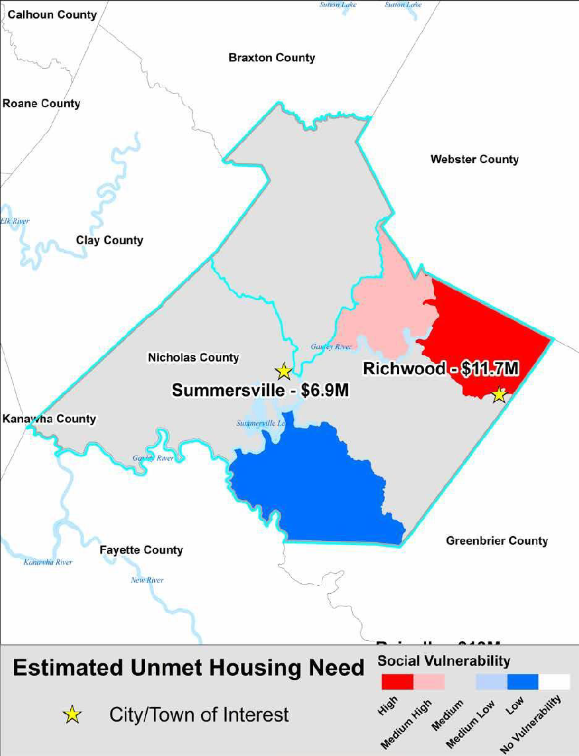using

Figure 23: Unmet Housing Need
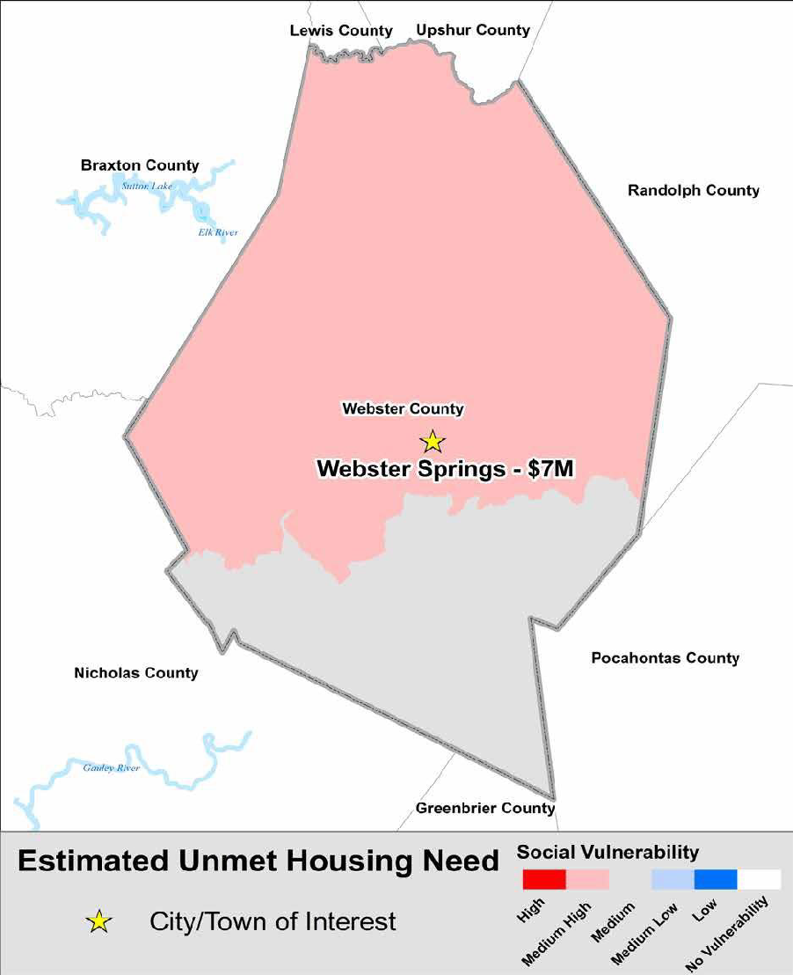

Housing Goals
The State’s housing recovery programs are designed to meet the unmet needs of the most vulnerable people described above affected by June 2016 flooding, including homeowners and tenants of rental properties. The State’s assessment of the flood impact magnified the remaining unmet need for housing recovery funds, especially in relation to the most vulnerable populations in the State. Therefore, the State’s goal is to deliver a housing recovery program that primarily considers and addresses those unmet housing needs, namely single-family owner occupied housing and small rental affordable housing.
Figure 24: Median Household Value
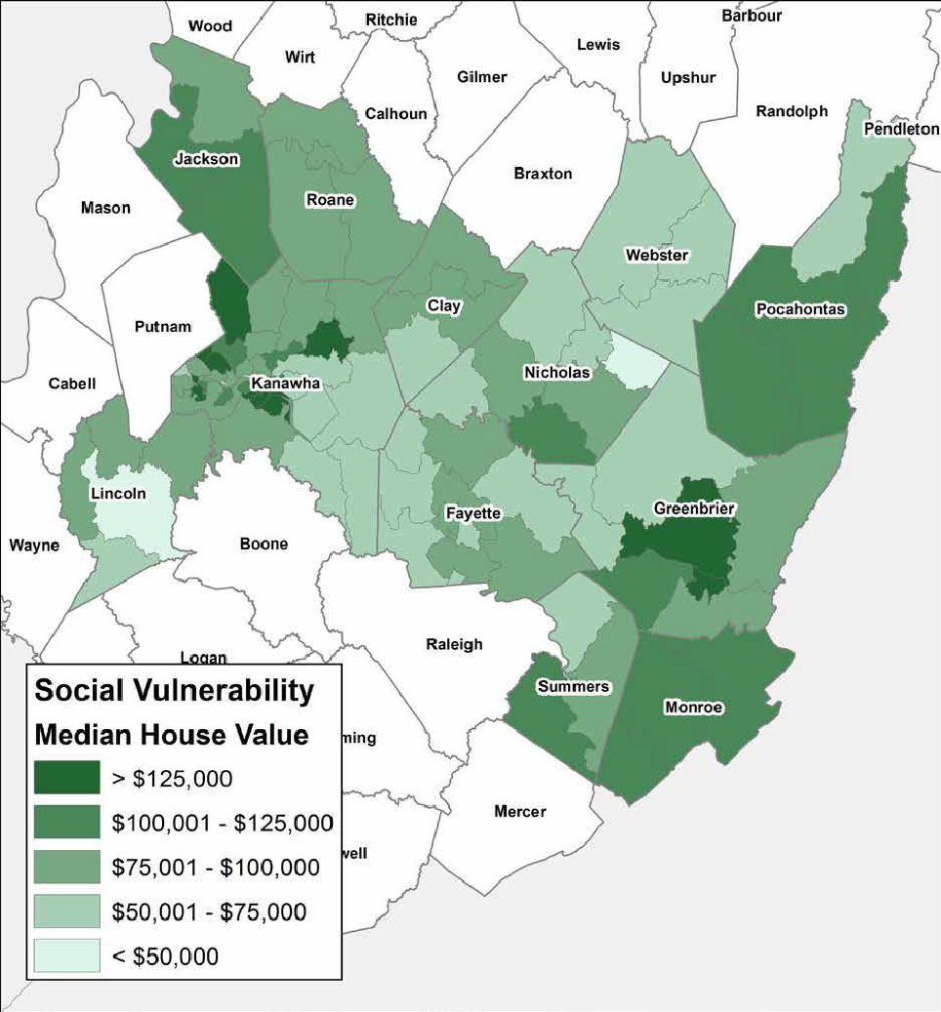

With the oldest population in the country, having the highest homeownership rate, and an average low median home value, the State believes it can deliver the most cost-effective recovery effort by focusing on single family homes throughout the declared counties. The State of West Virginia is unique in that it has the highest rate of owner-occupied housing units without a mortgage in the nation.²⁵
25 2011-2015 American Community Survey 5-Year Estimates
Table 16: Housing Units without a Mortgage by State
State | Total Housing Units | Housing Units Without a Mortgage | Percent | State | Total Housing Units | Housing Units Without a Mortgage | Percent
Alabama | 1,269,145 | 530,527 | 42% | Montana | 275,063 | 118,398 | 43%
Alaska | 159,056 | 54,955 | 35% | Nebraska | 487,948 | 183,748 | 38%
Arizona | 1,513,861 | 518,999 | 34% | Nevada | 559,793 | 165,946 | 30%
Arkansas | 752,312 | 326,537 | 43% | New Hampshire | 369,175 | 117,791 | 32%
California | 6,909,176 | 1,873,462 | 27% | New Jersey | 2,056,107 | 633,834 | 31%
Colorado | 1,302,266 | 347,018 | 27% | New Mexico | 519,676 | 220,929 | 43%
Connecticut | 906,227 | 271,065 | 30% | New York | 3,894,722 | 1,432,507 | 37%
Delaware | 244,849 | 77,318 | 32% | North Carolina | 2,459,072 | 849,813 | 35%
Florida | 4,765,260 | 1,917,391 | 40% | North Dakota | 192,185 | 89,660 | 47%
Georgia | 2,263,697 | 724,493 | 32% | Ohio | 3,040,444 | 1,057,106 | 35%
Hawaii | 256,389 | 84,141 | 33% | Oklahoma | 961,384 | 411,135 | 43%
Idaho | 405,865 | 135,701 | 33% | Oregon | 939,637 | 305,401 | 33%
Illinois | 3,177,705 | 1,073,539 | 34% | Pennsylvania | 3,431,790 | 1,322,343 | 39%
Indiana | 1,726,338 | 563,783 | 33% | Rhode Island | 246,909 | 73,468 | 30%
Iowa | 883,808 | 342,647 | 39% | South Carolina | 1,244,998 | 496,104 | 40%
Kansas | 742,564 | 287,105 | 39% | South Dakota | 225,219 | 96,982 | 43%
Kentucky | 1,148,752 | 464,388 | 40% | Tennessee | 1,672,329 | 651,501 | 39%
Louisiana | 1,136,709 | 521,658 | 46% | Texas | 5,693,770 | 2,297,484 | 40%
Maine | 393,995 | 144,764 | 37% | Utah | 629,584 | 178,002 | 28%
Maryland | 1,447,662 | 366,182 | 25% | Vermont | 182,584 | 65,366 | 36%
Massachusetts | 1,583,667 | 463,504 | 29% | Virginia | 2,027,005 | 595,569 | 29%
Michigan | 2,728,815 | 1,021,100 | 37% | Washington | 1,668,071 | 500,583 | 30%
Minnesota | 1,522,618 | 487,597 | 32% | West Virginia | 537,266 | 279,165 | 52%
Mississippi | 749,982 | 357,741 | 48% | Wisconsin | 1,547,197 | 530,963 | 34%
Missouri | 1,590,020 | 578,530 | 36% | Wyoming | 156,675 | 64,130 | 41%

This puts residents at risk for recovery because of a lack of insurance required by most mortgage companies. By targeting recovery efforts to the most vulnerable population, keeping in mind the distinctive factors that affect the average resident, the State will stretch its limited funds to achieve permanent, sustainable housing solutions that allow residents with the weakest ability to recover to remain in West Virginia and, where possible, return to their beloved neighborhoods. The objectives of the programs include:
- Helping vulnerable populations affected by June 2016 flooding directly by replacing and rehabilitating housing units, including identifying opportunities for mitigation enhancement measures;
- Assisting vulnerable populations affected by flooding by improving the resilience of their housing units while restoring their buildings/residences; and,
- Supporting resilience improvements to reduce risk and strengthen neighborhoods in flood zones.
To pursue these objectives, the State has designed a program that incorporates lessons from past disasters; builds upon stakeholder input from agencies and relevant organizations across the local, State, and Federal levels; and leverages the experience of locally-based organizations to ensure the diverse needs of West Virginia’s affected residents are addressed. Current economic challenges have been taken into account and the State aims to leverage private sector and other funding where possible. The State’s focus is to provide assistance to the most vulnerable West Virginians quickly while ensuring accountability and proper use of funds. The State’s strategy will balance speedy response with adequate planning and support equity and take into account the distinct needs of different communities and abilities of those community members. For program operations, the State will maximize private and non-profit sector expertise and the deep experience of the housing infrastructure in West Virginia while putting appropriate accountability and oversight mechanisms in place.

Infrastructure Needs Assessment
West Virginia’s Responses to Infrastructure Damage
The State’s survey of the damage inflicted on infrastructure and the restoration thereof is ongoing. In conjunction with FEMA’s Public Assistance Grant Program, the State is identifying and assessing damaged sites to develop cost estimates that quantify the scope of work and financial commitment required for the necessary infrastructure projects. A few examples of the State’s response to the flooding are discussed below.
Emergency Response
Emergency response was critical for search and rescue and the basic health and welfare of citizens. A total of 570 National Guard troops were deployed to assist local jurisdictions to aid in emergency response. Several hundred rescue missions were completed to remove people from flooded homes. During this time, it was imperative that bridges, water treatment facilities, roads, as well as sewer and water were operating in rapid emergency recovery time. The death toll continued to rise while private citizens, police and other law enforcement and volunteers worked tirelessly to search for missing residents across the State after heavy rains flooded several towns. Hundreds of roads and bridges were washed away, and thousands of homes were severely flooded leaving hundreds of people with no place to go. In Elkview, West Virginia, an estimated 500 individuals were stranded in a mall for almost three days due to the road entrance being washed away.²⁶
26 http://www.wlwt.com/article/hundreds-stuck-at-wv-shopping-center-after-raod-washed-away/3566904
West Virginia Rural Water Association’s (WVRWA) began repairing wastewater treatment plants as soon as feasible and electric equipment was repaired rapidly to get the plants operational again. The Department of Transportation (DOT) and local jurisdictions worked closely with the U.S. Army Corps of Engineers (USACE) to clear away debris to ensure the safety of citizens.
Restoration Services
During and immediately after flooding damaged West Virginia, shelters were staged with assistance offered from over 400 American Red Cross volunteers in the most affected areas.²⁷ Additionally, one of West Virginia’s most prized tourist attractions, The Greenbrier, was transformed overnight into a flood recovery shelter. The Greenbrier is a National Historic Landmark and world-class resort that has been welcoming guests from around the world since 1778, including presidents, international royalty, the famed Greenbrier PGA tournament, and NFL training teams. It housed 300 of the neediest victims who were now homeless and displaced due to the flooding. In all, a total of 17 shelters housing over 400 individuals were operational during and after the storm. The American Red Cross operated 8 of these shelters and other faith-based and local jurisdictions assisted with the others.

Emergency Supply
Immediately after the catastrophic flooding many nonprofit entities such as the Red Cross provided food, water, emergency supplies, and shelter. Emergency distribution sites were opened in the hardest hit communities to protect the health and safety of the populations. The sites were staffed with an arrangement of individuals, including local and outside volunteers, the Salvation Army, and the National Guard.
Debris Removal
Flooding debris was more prominent once flood waters started to recede, resulting in the accumulation of debris on streets, sidewalks, and other public properties. Debris consisted of woody material, sand, street and building wreckage, and other objects deposited by the flood waters. Current FEMA Public Assistance Project Worksheet data indicates that there has been over $20 million dollars’ worth of debris removal completed due to the flooding. Debris clean-up is still underway and continues to 2017 with local jurisdictions and the USACE taking on the burden per FEMA.
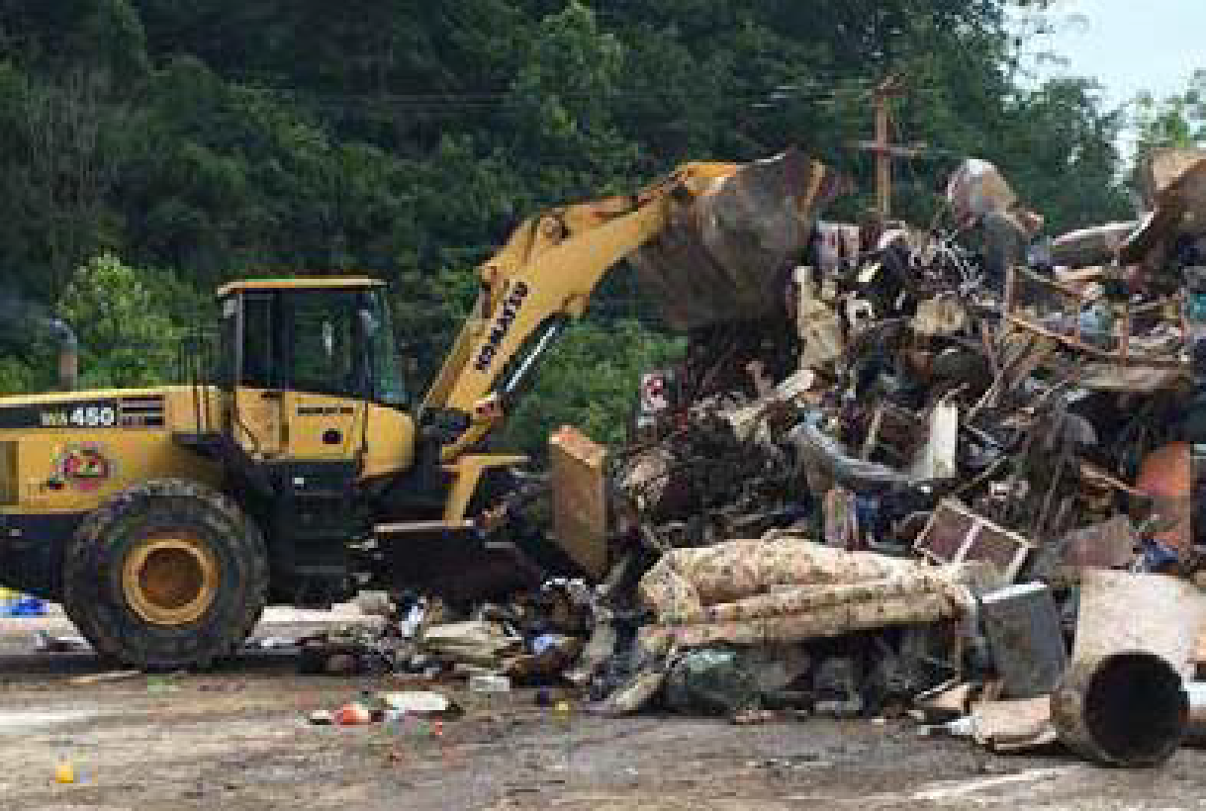
Analysis of Unmet State Infrastructure Needs
Preliminary data provided by the FEMA Public Assistance Program indicates $134 million in project costs have been approved across the 12 declared counties. The State expects this number to at least double in the coming months as new projects are approved and obligated, namely the reconstruction of five schools that were substantially damaged. Of the approved project costs, 75% will be funded by FEMA. The State is required to provide the remaining 25% of funds. In preparation for these costs, West Virginia’s Legislature passed a law in September 2016 providing $85 million purported to contribute to the non-federal local 25% match required for the PA program. If the State’s PA obligated project Image 19: Flood debris being removed off I-79’s Clendenin Exit
costs exceed $253 million, then the match
requirement will drop to 10% required from West Virginia. Below is a summary of the current PA obligated projects and estimates of additional projects to be obligated. The State is well on its way to meeting the required minimum threshold to receive the lower 10% match requirement. The State estimates their share of all projects to be $41.3 million if the 10% match requirement is granted.

Table 17: Infrastructure
Category | Project Amount | Federal Share | State Share
A-Debris Removal | $20,675,209 | $15,596,491 | $5,078,718
B-Protective Measures | $40,954,307 | $30,715,730 | $10,238,577
C-Roads and Bridges | $29,586,833 | $22,190,125 | $7,396,708
E-Public Buildings | $30,666,998 | $23,000,249 | $7,666,749
F-Public Utilities | $5,922,803 | $4,442,103 | $1,480,701
G-Recreational or Other | $5,538,728 | $4,154,046 | $1,384,682
Z-State Management | $427,105 | $427,105 | $0
PA Current Projects Grant Total | $133,771,983 | $100,525,849 | $33,246,134
Additional Roads & Bridges | $26,413,167 | $19,809,876 | $6,603,292
Additional Public Utilities | $94,077,197 | $70,557,898 | $23,519,299
Public Schools Estimate | $130,000,000 | $97,500,000 | $32,500,000
Current Infrastructure Estimate | $384,262,347 | $288,393,622 | $98,973,725
Reallocate as 10% State Share |  | $57,639,352 | $(57,639,352)
Total Estimated Infrastructure Unmet Need | $384,262,347 | $346,032,974 | $41,334,373
Total Estimated Infrastructure Unmet Need Including 20% Resilience Costs* | $384,262,347 | $346,032,974 | $49,601,247
*To calculate the Total Infrastructure Unmet Need including 20% Resilience Cost, the State added 20% (the industry standard cost of resiliency measures) to the calculated unmet need.
Infrastructure Goals
West Virginia is committed to addressing its infrastructure needs and securing the health and stability of local communities and economies by helping to provide these essential services to attract and retain businesses as well as residents.
Infrastructure objectives carried out through the FEMA PA program include:
- Potable water treatment and distribution systems
- Wastewater treatment and collection systems
- Storm water management
- Power or energy, electrical and gas (including motor fuel storage and distribution)
- Municipal and public services/works vehicles and equipment
- Law enforcement and emergency response
- Transportation and horizontal drainage
- Public buildings used for government, education, medical care, and a variety of public services
- Damage and Losses to businesses, residential structures, and other public use structures such as community meeting locations that frequently include religious worship/education facilities
The State continues to receive and analyze data regarding unmet needs stemming from the disaster. Accordingly, should additional unmet needs within the infrastructure sector be identified and the State need to address those remaining needs through a Substantial Amendment to its initial Action Plan, the State will develop and implement infrastructure programs with the following considerations in mind.
- The proposed mitigation measures will be integrated into rebuilding activities and the extent to which infrastructure activities will achieve objectives outlined in regionally or locally established plans and policies must be established.
- All infrastructure activities will be informed by a consideration of the costs and benefits of the project.
- The State will seek to ensure that infrastructure activities will avoid disproportionate impact on vulnerable communities and create opportunities to address economic inequities facing local communities.
- The State will align investments with other planned state or local capital improvements and infrastructure development efforts. Additionally, the State will work to foster the potential for additional infrastructure funding from multiple sources.
- The State will employ adaptable and reliable technologies to guard against premature obsolescence of infrastructure.
With the passage of the $85 million bill from the West Virginia legislature, the State believes it is in a good position to fund the required FEMA PA match, whether that be 25% or the lower 10% match. However, CDBG-DR funds may be used to provide match for FEMA Hazard Mitigation Grant Program approved projects.

Economic Needs Assessment
Background
In addition to the housing and infrastructure crises, the State estimates a $9 million sales tax loss for July and August 2016 alone, mostly due to the cancellation of the famed Greenbrier Classic and the West Virginia State Fair. The total economic loss of these canceled events is expected to exceed $22 million.²⁸ Impact to agriculture and conservation efforts exceeds $6 million, while disaster unemployment claims could exceed $3 million. Additionally, West Virginia’s state parks sustained over $2 million in damage with another $8 million in stream debris clearance required.²⁹ It is estimated that twice that amount will be needed for stream restoration and bank stabilization. Before the flooding in June 2016, the state’s economy had already experienced a significant downtown caused by the deterioration of the coal industry. The flood only worsened the already depleted financial resources in West Virginia. As a result, the state experienced a rise in unemployment rates in the months following the flood with estimates of over $2 million in lost wages.³⁰
²⁸
http://www.tristateupdate.com/story/33104084/back-in-business-greenbrier-county-business-owners-continue-to-salvage-their-livelihoods-while-hoping-to-welcom-tourists-again-soon
29 Interviews with agency heads at Department of Agriculture, Workforce West Virginia, and Division of Natural Resources
30 Workforce WV Disaster Unemployment Claims 2nd Quarter 2016

Workforce
West Virginia’s citizens have long prided themselves on their hard-working demeanor and commitment to manual labor jobs. For over a century the State has consisted of residents willing to work long hours in coal mines and factories that span Appalachia. Much of that work, however, has disappeared due to the extreme downturn in industry of such blue-collar jobs. West Virginians who once worked long hours in coal mines now find themselves jobless, with little hope for learning new trades and skills. Many of the coal mines that were once the lifeblood of the State are now shut down, a product of technological advances in automation and environmental regulation. Overall, more than 10,000 jobs have been lost in the past 10 years in the State, per the Bureau of Economic Analysis. Compared to 5 years ago, there are nearly 8,000 less jobs to be had in the mining industry (except oil and gas) alone.

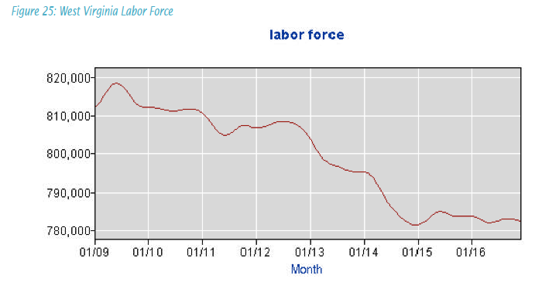

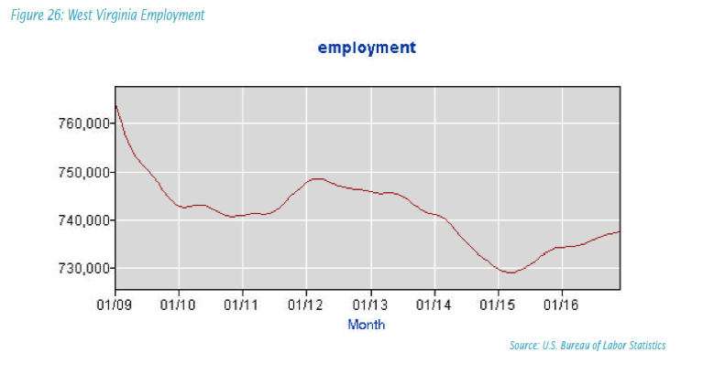

Figure 27: Annual Coal Production
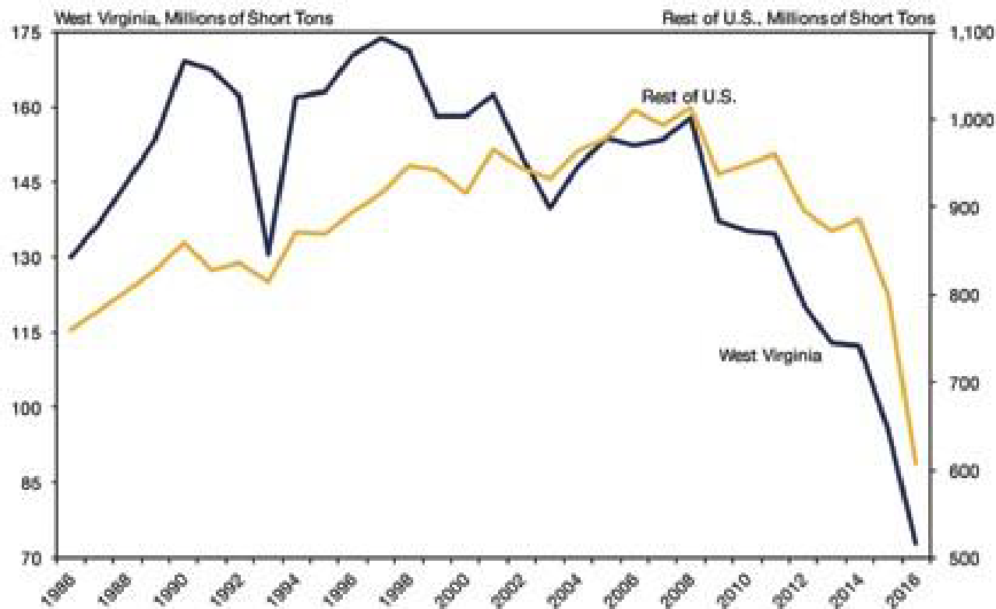

Figure 28: Coal Production Forecast
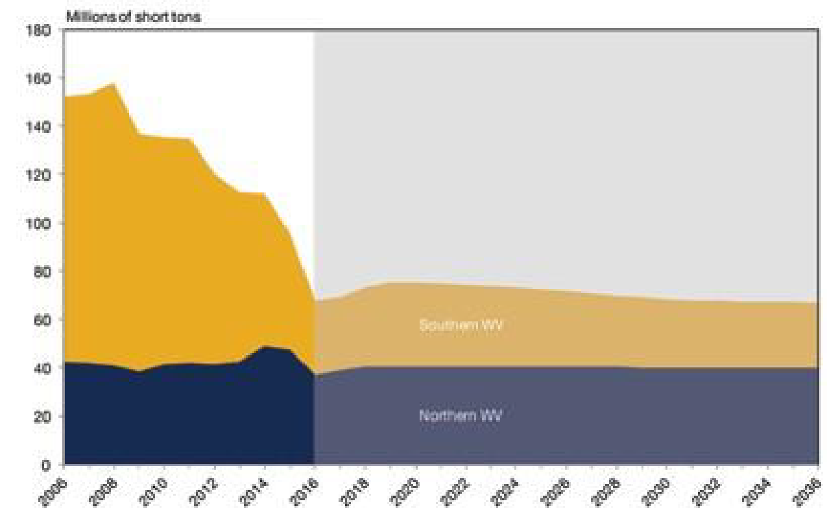
Education and the Economy
Nationally, West Virginia ranks near the bottom in almost every category of education. Secondary education was not a necessity for West Virginians in the past because of the opportunity for young men to enter the coal mining industry straight out of high school with good take-home pay rates. With coal mining jobs dissipating, West Virginians are being forced to adjust in a job market that offers few solutions. According to Forbes, West Virginia ranks as the least educated state in the nation. West Virginia possesses the lowest percentage of associates degree holders, bachelor’s degree holders, professional degree holders and college experienced adults.
- Percent of adults with at least a bachelor’s degree: 19.2%
- Percent of adults with at least a high school diploma: 85.2%
The lack of secondary education directly correlates to the high unemployment rate and loss of manual labor jobs.

Impact of the State’s Economy
Significant losses were felt by the State’s economy as a result of the 2016 flood. Many businesses experienced direct damage or destruction to buildings, equipment, inventory, and supplies, as well as indirect damage such as lack of access, all of which caused a loss of revenue or forced closure. Tourism within the state experienced significant decline due to the floods. According to The Register-Herald, by June of 2016 the number of visits to hotel stays had increased by 15 percent compared to years past. However, the numbers soon deviated due to the floods and by the end of 2016, the rates proved to be below 2015. The Convention and Visitors Bureau office in Oak Hill saw nearly 2,000 fewer guests pass through in 2016. Commercial rafting trips, which had been on the rise every year since 2007, dipped by almost 5,000 marking the lowest total since 2013.³¹
Workforce West Virginia reported over $2 million in disaster related unemployment claim payments due to the flood. A summary of those claims is included below.
31 http://www.register-herald.com/news/june-flood-affected-tourism-but-looks-bright/article_1ca0c4bb-9f29-55f1-8305-89d6c179443c.html
Table 18: Unemployment Claims
County of Residence | Number of Claimants | 2016 Reported Wages | Weeks Claimed | Average Weekly Wages 2016 | Wages Lost
Greenbrier | 649 | $4,855,092 | 1,563 | $575 | $899,428
Kanawha | 145 | $518,259 | 1,055 | $275 | $290,051
Nicholas | 108 | $622,798 | 918 | $444 | $407,206
Monroe | 62 | $443,590 | 108 | $550 | $59,438
Roane | 35 | $110,709 | 173 | $243 | $42,093
Clay | 29 | $82,903 | 170 | $220 | $37,383
Fayette | 26 | $164,412 | 116 | $486 | $56,425
Webster | 22 | $161,565 | 158 | $565 | $89,256
Other | 130 | $956,835 | 333 | $542 | $167,562
Total |  |  |  |  | $2,048,842

As many as 500 employees found themselves without a job in Elkview. The Crossings Plaza shopping center is still inaccessible because the access bridge was wiped out by flood waters. The Kmart within the shopping center has been unable to reopen due to the lack of access and was forced to lay off 69 employees.³² The fate of the shopping center is unknown at this time because of a bankruptcy filing submitted by the owner of Crossings Plaza.

Image 20: Collapsed bridge at the Crossings Mall in Elkview
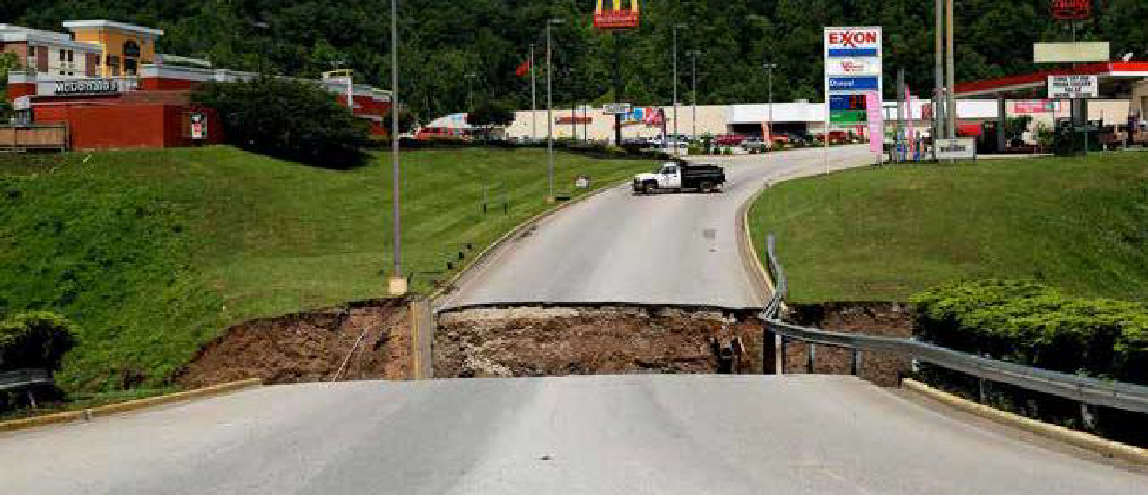

West Virginia’s Response to Impact to the State’s Economy
In response to the flooding, former Governor Earl Ray Tomblin created RISE West Virginia, a small business grant program that awarded up to $10,000 to businesses affected by the flood. The program was co-sponsored by West Virginia native and Intuit CEO and Chairman Brad Smith. RISE West Virginia was created to help the Mountain State’s small businesses keep their doors open and their operations up and running after the June flood. Applicant criteria included being located in one of the affected counties, being in good standing with the state, having a verifiable business at the time of the June flooding and a plan for usage of the grant assistance. A total of 233 grants were awarded, with 2/3 given to affected businesses in Kanawha and Greenbrier Counties.³³
As a result of flooding at The Greenbrier Resort, the owner and now-Governor Jim Justice offered the resort to citizens affected by the flood as a shelter option. More than 200 people stayed at The Greenbrier while new housing options were located for them. Hot meals were served and a total of 700 tetanus shots were given to impacted citizens.³⁴
Determining Unmet Economic Need
The economic unmet need analysis signifies the aggregate sum of unfulfilled business needs caused by, or directly related to the 2016 flood events, specifically reconstruction, rehabilitation, and hazard mitigation of real property. The State utilized all available data of substantial reliability to develop the economic unmet need analysis. This analysis has been used to shape a comprehensive recovery from the 2016 flood events and serve as the basis of long-term recovery to its economy. The State has accounted for business losses including loss of revenue, debris removal, property damage or destruction, and mitigation, among other things.
The State relied upon data made available from the U.S. Small Business Administration (SBA) to determine the estimated unmet economic need across the declared counties. SBA received approximately 1,500 business loan application, of which over 1,300 were never completed and processed for funding. Additionally, over 140 of those applications were withdrawn or declined. As a result of the analysis of unmet need the State performed for housing, it is assumed that the low application and approval rate of business loans is also a direct result of the depressed economic conditions in the state. Small business owners, in particular, have limited resources to take on additional debt and instead, made do
32 http://wvmetronews.com/2017/02/22/carper-crossings-mall-kmart-workers-laid-off/
33 http://wvmetronews.com/2016/12/29/rise-west-virginia-grants-for-flood-recovery-top-1-8-million/
34 http://wsls.com/2016/06/27/greenbrier-resort-housing-more-than-200-now-homeless-as-flood-recovery-efforts-begin/
without, relied upon limited NFIP payouts, or turned to the State’s RISE West Virginia grant program.
To estimate the economic impact to local businesses across the SBA application population that never resulted in a loan, the State looked to the 101 businesses who did follow through with an application for a loan and observed an average verified loss of $103,673 across all counties and industries. With 1,437 applications received, the State was able to estimate almost $149 million in verified losses to affect businesses using this approach. The current SBA loan amount outstanding for this population is only $9.8 million. Coupled with the RISE West Virginia grant funding of $1.8 million NFIP building claim payments of $4.5 million, the State estimates a $132.8 million remaining unmet need as illustrated below.
Table 19: Remaining Economic Unmet Need
Verified Loss of SBA Business Applicant
SBA Applicants with a Verified Loss | 101
Average Verified Loss | $103,673
Verified Loss of SBA Applicants with a Damage Assessment |  | $10,470,973
SBA Applicants without a Verified Loss | 1,336
Average Verified Loss | $103,673
Estimated Verified Loss of SBA Applicants Without a Damage Assessment |  | $138,507,128
Total Verified Loss of all SBA Business Applicants | 1,437 | $148,978,101

Total West Virginia Unmet Economic Need
Total Verified Loss | $148,978,101
NFIP Building Claim Payments to Businesses | $(4,531,162)
SBA Disaster Business Loans Current Amount | $(9,861,100)
RISE West Virginia Grant Program | $(1,800,000)
Total Unmet Economic Need | $132,785,839
Total Economic Unmet Need including 20% Resilience Costs* | $159,343,007
*To calculate the Total Unmet Economic Need including 20% Resilience Cost, the State added 20% (the industry standard cost of resiliency measures) to the calculated unmet need.

Economic Revitalization Goals
With limited funding and an overwhelming unmet housing need, it is imperative upon the State to get residents, particularly those who rent, back into safe and sanitary housing as a precursor to realizing economic recovery. The State’s Rental Assistance Program will serve a dual purpose by prioritizing safe, sanitary and affordable housing for the rental community as well as supporting the local economies of these markets.
Additionally, the State eventually hopes to assist areas within the declared counties who have little to no broadband service. Getting residents connected to broadband will empower local communities with information that is most helpful in times of recovery, such as job training and access to web-based education. Given the limited amount of funding, the State will not prioritize such activities with this allocation.
Indirect support for small businesses and jobs occurs from the various program investments. Specifically, program delivery will require the support of the local construction industry and labor pool. Local economies will be stimulated as jobs are returned which has since been suspended due to the disaster. During the implementation phase of its programs, the State will perform intentional outreach to its contracting community to ensure awareness of the economic opportunities created through its CDBG-DR programs. Section 3 business concerns and small businesses will be deliberately notified of the numerous opportunities. West Virginia’s goal remains to enable recovery for all sectors.
Public Services Unmet Needs
In July 2016, after the devastating June floods, FEMA deployed an Advance Evaluation Team (AET) to West Virginia to assess the damages from the 2016 severe storms, flooding, landslides, and mudslides. The report from the AET indicated that additional federal support was required. The additional support included the appointment of a Federal Disaster Recovery Coordinator (FDRC) to coordinate the recovery efforts and the activation of three Recovery Support Function (RSF) agencies and organizations: Community Planning and Capacity Building (CPCB), Economic Recovery, and Housing. FEMA deployed staff from the National Disaster Recovery Support (NDRS) cadre, an External Affairs Advisor and a Mitigation Advisor which, along with the RSF Field Coordinators, constituted the Interagency Recovery Coordination (IRC) group.
The IRC group collaborated with the state’s recovery officers and key stakeholders to identify critical needs and gaps in the State’s capacity to recovery. The IRC group, FEMA, WVDHSEM, and WVDOC held multiple Community Planning and Capacity Building meetings throughout the impacted areas. These meetings facilitated the identification of needs in all service areas handled by a government entity, such as the flooding of fire, police stations and other government buildings, which provide key public services to citizens as well as large-scale infrastructure projects that will need to be implemented to recover. This experienced team evaluated all aspects of potential needs within the public service sector.
The possible need of specific public services to complement the CDBG-DR activities was also considered. The Recovery Support Strategy (RSS) for DR-4273 serves as a coordination document between recovery efforts to assist with the recovery. This comprehensive report identifies 69 strategies that the State, RSF agencies and their partners can take to address the 15 identified recovery issues. After these collaborations, while ideal, the lack of public services complementing the proposed CDBG-DR activities was not identified by the IRC group, the communities or the RSS as a key recovery strategy which needed to be prioritized for an allocation of CDBG-DR funds.
The universal conclusion from these collaborations was that funding is not only a concern, but a severe handicap. In West Virginia, this fact is compounded by the fact that other state revenue streams to local government have declined given the downturn in the State’s coal industry. Thus, the most critical needs within the public service sector were identified for prioritized funding through the IRC group, the State’s stakeholders, the impacted communities and the FEMA Public Assistance Program. To date, all identified public service needs are being met through the FEMA PA program and, as referenced previously, West Virginia has already provided state funds for the required local match. The match funding will lessen the financial burden placed on the local communities and assist them to continue normal operations and address recovery needs.
Therefore, due to the limited funding available to address the full breadth of recovery needs, the state is not prioritizing funding to address the public service needs described above or the addition of new public service needs to be provided to complement its CDBG-DR programs.
Resiliency and Mitigation Measures
Over a recent period of 21 years (between 1996 and 2017), West Virginia suffered 27 major flooding events resulting in a federal disaster declaration. Given its long and well-documented history of flooding, specifically devastating to the most vulnerable areas, West Virginia is committed to intentionally implementing appropriate and cost-effective resiliency measures through its CDBG-DR program.
Thus, in conducting its impact and unmet needs assessment, the State considered the additional costs associated with protecting housing and community investments from future disasters. Throughout its assistance to impacted residents, the State’s programs will not only repair or replace lost housing but will also invest resources in efforts that promise to mitigate damage from future disasters.
The State is mindful that such measures will add costs to its programs but is confident that the mitigating efforts will reduce the cost of future damages. After examining industry standards and various costs associated with its previous Hazard Mitigation Grant Program mitigation activities, the State estimated twenty percent (20%) in additional resiliency costs to the ultimate unmet needs cost associated with each sector: housing, infrastructure and economic revitalization.
Specific resiliency solutions for housing units could include:
- Elevating the first flood of habitable area;
- Breakaway ground floor walls;
- Reinforced roofs;
- Retention basins;
- Fire-safe landscaping;
- Landscaped floodwalls; and,
- Mold and mildew resistant products.
Although West Virginia’s CDBG-DR allocation is being prioritized for housing needs given the limited amount of funds, if infrastructure activities are funded in the future, resiliency solutions could include, but are not limited to, the following:
- Raising facilities above base flood elevation;
- Having backup power generators for critical systems (water, sewer, etc.);
- Elevating critical systems;
- Provide retention basins, larger culverts, culvert debris guards;
- Provide erosion control solutions; and,
- Raising roadways.
Once West Virginia considered the amount of resiliency solutions that will be tied to housing and potential infrastructure projects, the amount of unmet need increased significantly.

Sources of funding to be leveraged & CDBG-DR Award
Sources of Funding to be Leveraged
The CDBG-DR award of $149 million to the State of West Virginia will be leveraged with other available funding and serve as a last resort source of funding for disaster recovery. Since the catastrophic flood events, the State has worked with HUD, FEMA, SBA, VOADs, and numerous other organizations to identify sources of assistance available to aid with recovery efforts. The comprehensive allocation provided by the different funding sources will result in a thorough recovery effort by: 1) ensuring that a variety of recovery unmet needs are met; 2) providing flexibility to address short-term as well as long-term recovery needs 3) empowering communities to meet needs that would not likely be addressed with other funding sources; and 4) assisting communities to best leverage themselves to meet post disaster needs.
The State will continue its efforts to identify and leverage other federal funding sources. Specifically, in response to the 2016 disaster, the State has seized on the opportunity to utilize existing relationships as well as create new partnerships with other federal and state agencies, corporations, foundations, nonprofits and other stakeholders as a means of utilizing all viable sources of funding to ensure a comprehensive recovery.
FEMA Funding
In total, FEMA has allotted the State of West Virginia over $181 million to aid disaster recovery thus far. The funding consists of $42 million for individuals and household assistance available through the FEMA Individual Assistance Program, $5 million for case management activities, and approximately $134 million available through the FEMA Public Assistance Program which will continue to grow in the coming months as new projects are approved and obligated.¹
Disaster Case Management
On November 23, 2016, it was announced by then-Governor Earl Ray Tomblin that West Virginia would receive $5 million for disaster case management from FEMA. These funds will enable case managers to be placed across the state in areas affected by the June flooding. The case managers will aid individuals who are struggling with remaining unmet needs. “Dedicated case management work will play a significant role moving forward as individuals in our communities continue to heal, rebuild and recover. The federal government continues working together with the state in our long-term recovery process. And the state will continue working hand-in-hand with local communities to ensure all remaining needs are met”, stated then-Governor Tomblin in his November 23 press release.
The case managers will develop and carry out individualized disaster recovery plans with timely goals for resources and services. Unmet needs may include basic immediate emergency needs such as food, clothing, shelter or first aid, as well as long-term needs such as financial, physical, or emotional well-being. The Bureau for Behavioral Health and Health Facilities at the West Virginia Department of Health and Human Resources (DHHR) is overseeing the grant, in collaboration with the State’s Division of Homeland Security and Emergency Management. The caseworks process includes an assessment of the survivor’s verified disaster-caused unmet needs; development of a goal-oriented plan that outlines the steps necessary to achieve recovery; organization and coordination of information on available resources that match the disaster-caused need; and monitoring of progress toward reaching the recovery plan goals.
WVDOC will utilize these case managers for the CDBG-DR housing programs. Additionally, these case managers will be trained alongside additional state-hired case managers to assist with delivering the disaster housing programs to affected populations. They will assist applicants with the application process and guide applicants through questions they may have about program eligibility and requirements. The State will assign each applicant to a case manager to assist the applicant through the entire program.
1 https://www.fema.gov/disaster/4273
FEMA Individual & Household Assistance
FEMA has approved $42 million in individual assistance (IA) for household and other programs. Nearly 9,000 applications were submitted with nearly 5,000 households approved for assistance. Over $35 million of the assistance was granted for housing assistance, with another $6.5 million going to other needs. According to FEMA data, the average FEMA IHP grant was less than $9,000 per applicant.²
FEMA Public Assistance
The Public Assistance Program provides grants to state, local, and federally recognized tribal governments and certain private non-profit entities to assist them with the response to and recovery from disasters. Specifically, the program aids with debris removal, emergency protective measures, and permanent restoration of infrastructure. FEMA has obligated $134 million in Public Assistance to West Virginia thus far. The current funds obligated of $134 million is expected to grow to as much as $500 million as damage assessments are finalized and new projects are approved.³
FEMA Public Assistance State Match
The State of West Virginia’s Legislature passed flood relief legislation in September 2016 to provide $85,000,000 for the state’s share of the PA match. The bill appropriated $21 million from lottery reserves, $9 million from an unappropriated surplus from the previous fiscal year, and $55 million from the state’s Rainy Day Fund, and was passed on a vote of 92-1.⁴
HUD CDBG-DR
The Department of Housing and Urban Development has awarded West Virginia approximately $149 million in CDBG-DR funds. West Virginia’s CDBG-DR Award will address remaining unmet needs existing even after assistance provided by other federal and state sources. These funds will focus primarily on housing activities including housing repair, replacement, reconstruction and assistance to landlords within the most impacted and distressed areas.
Small Business Administration
The U.S. Small Business Administration has approved home and business disaster loans totaling nearly $40 million for the flood events so far.⁵ Per the SBA’s July 2016 press release, businesses and private nonprofit organizations may borrow up to $2 million to repair or replace disaster damaged or destroyed real estate, machinery and equipment, inventory, and other business assets. For small businesses, small agricultural cooperatives, small businesses engaged in aquaculture and most private nonprofit organizations, the SBA offers Economic Injury Disaster Loans to help meet working capital needs caused by the disaster. Economic Injury Disaster Loan assistance is available regardless of whether the business suffered any physical property damage.
Disaster loans up to $200,000 are available to homeowners to repair or replace disaster damaged or destroyed real estate. Homeowners and renters are eligible for up to $40,000 to repair or replace disaster damaged or destroyed personal property. West Virginia will capitalize on this available assistance for unmet needs. These funds will provide valuable leverage to the CDBG-DR funds.
2 FEMA IHP data set for DR-4273
^{3 FEMA PA data set for DR-4273}
4 http://wvpublic.org/post/wva-house-approves-85-million-flood-relief-bill#stream/0
5 SBA Disaster Home and Business Loan data set
Other Funding
Other public funding of nearly $31.5 million has been made available in the wake of the flood and is made up of six different sources of funding, including the following:

Federal Highway Administration (FHA)
As of April 4, 2017, it was announced that the West Virginia Department of Transportation will receive an additional 14 million dollars. The monies stem from a grant from the Federal Highway Administration and shall be used to repair and rebuild federal-aid highways and roads existing on federal lands.⁷
RISE West Virginia (RISE)
RISE is a public-privately funded grant program which set aside $2 million for assistance to small businesses. The program is overseen by the West Virginia Chamber of Commerce Foundation. Grants of up to $10,000 are awarded on the basis of need and recommendation from a review committee. Project considerations include long term viability, contributions to building and sustaining local economies, number of jobs retained/created, and ownership’s determination to rebuild.⁸
Emergency Relief (ER)
The Federal Highway Administration (FHWA) granted $5.7 million in Emergency Repairs funding to the state. The funds will solely aid repairs of roads, highways, and bridges.⁹
Disaster SNAP (D-SNAP)
The Disaster-Supplemental Nutrition Assistance Program (D-SNAP) is funded by the U.S. Department of Agriculture (USDA) and provided over $4.5 million for nutrition assistance to eligible residents of West Virginia. The assistance is made available to low-income individuals and families that may or may not have previously been SNAP members.¹⁰
Rebuild West Virginia
Rebuild West Virginia was established by the West Virginia Housing Development Fund to provide assistance to owner occupied residences that were damaged or destroyed as a result of the flood. The program has made $1.85 million in funding available to families who were unable to qualify for sufficient federally funded resources to restore their home and whose household income, as adjusted for family size, meets HUD’s HOME Investment Partnership Program (HOME) income limits.¹¹
National Dislocated Workers Grant
The U.S. Department of Labor provided $3.5 million in grant money to provide 250 temporary jobs for flood disaster clean-up activities via the National Dislocated Workers Grant, formerly known as National Emergency Grants (NEG). This program is administered through WorkForce West Virginia.
Total Leveraged Funding
The total funding available to the state of West Virginia through various federal and state sources, coupled with the extensive volunteer and non-profit effort throughout the affected counties, places West Virginia in a good position for a targeted recovery for the most vulnerable residents. West Virginia’s dedication to recovery is evident given its early commitment of state funds to recovery needs. All West Virginians are motivated to effectively recover from this flood and are dedicated to seeing their state rebound better and stronger as a result.
7 http://www.herald-dispatch.com/news/federal-funds-to-repair-flood-damaged-roads/article_954ed9bc-661b-5949-b86d-0181c9c4336c.html
8 http://wvflood.com/RISE/Pages/default.aspx
9 http://www.fhwa.dot.gov/pressroom/fhwa1638.cfm
10 http://wvpublic.org/post/disaster-snap-benefits-provide-more-45-million-nutrition-assistance-flood-victims#stream/0
11 https://www.wvhdf.com/programs/rebuild-west-virginia
West Virginia will use the majority of its CDBG-DR award to meet some of its most pressing unmet housing needs throughout the declared counties. The State will implement a housing program that will assist low-to-moderate income homeowners with repair and rehabilitation costs of their primary residences that were not covered by again, starting first and foremost with safe and secure housing. Additionally, West Virginia will allocate 15% of its award to assist rental property owners with repair costs of rental units which were occupied by low-to-moderate income tenants and damaged by the flood. It is vital to make these units available in the most damaged and vulnerable areas to low-to-moderate income tenants again. Additional programs which will support housing in the hardest hit communities include a Hazard Mitigation Grant Program Match and a residential bridge repair program. Additionally, the State will restore a multi-use property in Clendenin. The State intends to spend the remainder of its award on planning and administration activities.

Figure 29: Program Allocation
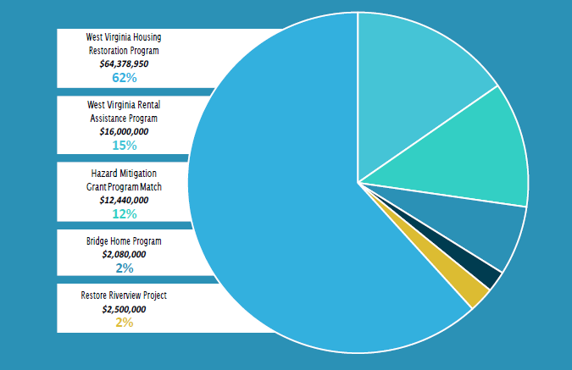

Method of Distribution & Connection to Unmet Need
West Virginia will directly implement all programs funded by the CDBG-DR award. Depending on a continued assessment of unmet needs and additional funding, the state may allocate funds to subrecipients as needed.
Administering Entity
The State’s Department of Commerce has been designated by Governor Jim Justice as West Virginia’s responsible entity and lead agency for administering the 2016 CDBG-DR Award. Secretary H. Wood Thrasher was appointed by Governor Justice to serve as the Secretary of the Department of Commerce in his role, he answers directly to the Office of the Governor. The West Virginia Development Office (WVDO), an agency within WVDOC, will be responsible for the implementation and oversight of all program activities stemming from the 2016 CDBG-DR Award.
The WVDO has extensive experience in successfully administering CDBG funded projects as its team administers the state’s annual CDBG program. Since 2007 the WVDO has managed over $148 million in CDBG funding benefiting over 230,000 persons.¹ And, CDBG is not the only HUD Program successfully administered by WVDO. Additionally, the WVDO has administered $104 million in Emergency Shelter, ESG, CoC, HOME, HOPWA, and NSP funds since 2007.²
Because of the WVDO’s successful experience in administering CDBG program dollars in accordance with HUD guidelines, the State believes the agency’s knowledge perfectly positions them to oversee the CDBG-DR program. The management staff in this office is skilled in administering programs that are compliant with federal guidelines and they are committed to delivering a CDBG-DR recovery program which will make the state more resilient following this devastating flood.
Although the WVDOC is the lead agency for the administration and management of the 2016 Award, other State, quasi-state and intergovernmental agencies will have key roles in the implementation of the various CDBG-DR program activities. WVDO will enter into Memoranda of Agreement with each entity to set forth the terms, conditions and specific roles each agency will have in the program. The Regional Planning and Development Councils and West Virginia VOAD will assist with the implementation of multiple disaster recovery programs including the WV Housing Restoration Program, WV Rental Assistance Program, and Bridge Home Programs. It is also anticipated that the State will leverage existing housing expertise within the West Virginia Housing Development Fund to administer the housing programs. Finally, the West Virginia Department of Homeland Security and Emergency Management will partner with WVDOC in carrying out all program activities under the HMGP/CDBG-DR Coordinated Match Program.
West Virginia will focus most of its $149,875,000 award of CDBG-DR funds on the most urgent housing needs in the areas hit hardest by the June floods. In accordance with the requirements of the 2017 Appropriations Act, West Virginia will deliver programs that fund eligible activities in accordance with the Housing and Community Development Act and meet a HUD national objective. Additionally, the State will expend 80% of the funds in the HUD-identified most impacted and distressed areas of Greenbrier, Kanawha, Clay and Nicholas Counties as required by the Federal Register Notice.³ The State intends to meet and even exceed the requirement that 70% of the funds will serve low-to-moderate income populations through the use of the SoVI®method and prioritization based on the areas that are defined by high and medium social vulnerability. Given the significant unmet need for repairs or replacement housing, the State has designed a single-family housing repair program and a rental housing repair program which account for over 75% of the total CDBG-DR award and will return affected residents to safe, decent, and affordable housing. Additional programs include a project to restore and increase rental stock in Kanawha County, a bridge repair program, and a coordinated match program. Funds will also be used for administration of the programs and for long-term disaster recovery planning. The budget and justifications specific to each sector are described below.
3 The State submitted, and HUD approved, a request to add Clay and Nicholas Counties to the HUD-determined MID so those heavily impacted areas can be assisted with greater amounts of funding.

Table 20: Original Program Budget
Program Budget
HOUSING | RISE WV Housing Restoration Program | $87,638,800.01
HOUSING | RISE WV Rental Assistance Program | $8,250,000
HOUSING | WV Coordinated Match Program (HMGP/CDBG-DR Match) | $3,450,000
HOUSING | Bridge Home Program | $7,280,000
HOUSING | Restore Riverview Program | $4,000,000
HOUSING | RISE WV Clearance and Demo Program | $5,875,000
HOUSING | RISE WV Multifamily Rental Housing Program | $14,875,000
ECONOMIC | RISE WV Economic Development Program | $8,000,000
PLANNING AND ADMINISTRATION | Planning | $3,012,499.99
PLANNING AND ADMINISTRATION | Administration | $7,493,750
Total Budget |  | $149,875,000

Housing Recovery (Original Budget Numbers)
Given the extraordinary $295 million remaining unmet need amount in the State’s housing sector, West Virginia is allocating $71,899,250 towards a single-family owner-occupied housing repair program with a focus on prioritizing low-to-moderate income households who received a high amount of flood damage. The State has been deliberate in calculating the unmet housing need in the affected areas and designed programs which seek to meet those specific needs. Given the limited amount of funding, the State utilized SoVI® scores of affected areas to pinpoint the most vulnerable residents with an unmet housing need; the priorities of the housing programs will ensure these populations are served first. West Virginia believes that providing funding to the most vulnerable populations first will be the most effective recovery model to deliver with limited funds.
The State is allocating $16,000,000 for a rental housing repair program with a focus on prioritizing those properties that are occupied by low-to-moderate income tenants and received a high amount of flood damage. Utilizing FEMA renter data and interviewing local housing authorities confirms the post-flood need for safe, sanitary, affordable rental housing, particularly Section 8 housing. Thus, the State will prioritize funding to rental property owners with low-to-moderate income tenants and Section 8 recipient households. Again, by targeting recovery efforts to the most vulnerable, the State believes it will deliver the most effective program with the limited funds available to it.
The State will designate $12,440,000 as the State’s required non-federal local match required under FEMA’s Hazard Mitigation Grant Program. Through an extensive outreach initiative, the State has identified eligible households and will coordinate all aspects of administering the programs including applicant intake, case management and construction work, where applicable.
The State is allocating $2,080,000 to a bridge repair program which will replace home access bridges washed away during the flood. These bridges provide the primary (and in most cases the only) access to homes of flood victims. Given the ineligibility of these bridges to be repaired with other federal funds such as FEMA Public Assistance, yet the critical safety and health concerns connected to this need, the State believes it is critical to use this CDBG-DR allocation to address some of this unmet need within its housing sector. The State will leverage the WV VOAD’s experience with delivering previous similar programs for carrying out the rebuilding efforts.
Finally, given the critical need for affordable rental housing and job creation in the town of Clendenin located in Kanawha County, the State is allocating $2,500,000 to the Restore Riverview Project. This mixed-use project will rehabilitate and restore rental units and possibly build out space to function as a training space and office space. The priority will be to create LMI training positions and jobs through the use of the training/office space and provide LMI housing through all rental units developed under this project. This complete strategy will both restore housing, increase the available rental stock, and provide support for the local economy desperate for rehabilitation after the disaster.
Economic Revitalization (Original Budget Numbers)
The State is allocating $12,500,000 for economic revitalization. The Restore Riverview Project, while primarily a project supporting housing recovery, could potentially create jobs in the Clendenin community. Given the extraordinary remaining unmet need within the housing sector and the vulnerabilities of the impacted communities, the State is prioritizing the provision of safe, decent, and affordable housing to its most impacted and distressed communities. The State will reassess its unmet needs for housing and propose economic revitalization activities if reasonable.
To facilitate economic recovery, thus far, West Virginia has relied on loans to its homeowners and businesses available through the Small Business Administration as discussed in detail in this Action Plan. Other programs providing aid to this sector have been payouts received by businesses through the National Flood Insurance Program and other State programs such as the RISE grants ($1.8 million) to resolve current economic revitalization needs. The State is aware of the remaining unmet needs related to economic revitalization; however, the tremendous amount of remaining unmet housing needs within the impacted communities has been prioritized for the CDBG-DR funds. The State will continue to seek other funds on behalf of its business communities in order to further economic recovery specifically from the June 2016 disaster. Finally, should the remaining housing needs be served, and CDBG-DR funds remain available for use, the State will re-assess the economic needs of its most impacted and distressed communities to determine if remaining funds can meet those critical needs.
Infrastructure Activities (Original Budget Numbers)
Given the eligibility of most infrastructure activities under the FEMA PA program and the $85 million allocation of state funds already appropriated by the legislature for the required 25% match, the WVDOC is not allocating CDBG-DR funds for infrastructure activities at this time. Other state resources and the FEMA PA program are addressing remaining infrastructure needs such as the repair of roads and bridges, water control facilities, repair and replacement of public buildings and equipment. Specifically, the West Virginia Division of Highways is working closely with FEMA and WVDHSEM to account for all damage that may be eligible for Public Assistance (PA). Also, the State’s School Building Authority has worked closely with FEMA to address the destruction of the schools and this effort continues. Accordingly, the State believes that prioritizing the provision of safe, decent, and affordable housing to its most impacted and distressed communities with CDBG-DR dollars will complement the eligible FEMA PA infrastructure projects in the most impacted local jurisdictions by allowing citizens to return to their homes. The WVDO will coordinate with DHSEM any future anticipated unmet infrastructure needs not eligible for FEMA PA funding and if required, propose the usage of CDBG-DR dollars at that time, if reasonable.
Planning and Administration Activities (Original Budget Numbers)
The State will reserve $6,881,050 of its award for planning and administrative activities. A priority for this allocation is the development of a disaster recovery and response plan that addresses long-term recovery and pre- and post- disaster hazard mitigation.
Proportionality of CDBG-DR Award
The following table demonstrates the proportionate allocation of CDBG-DR funds relative to areas and categories of unmet need. These figures are based upon best available data and projections for unmet need. For more information on these amounts, please see the assessment of unmet need included in this Action Plan.
CDBG-DR Eligible Activities Not Undertaken
The State has taken into consideration all CDBG-DR eligible activities allowed under the Housing and Community Development Act of 1974 when designing its CDBG-DR programs. With limited funds available, the State understands that it must be intentional in its use of the CDBG-DR award to ensure that the most critical needs of its citizens are addressed first. Consistent with the results of its unmet needs assessments and the requirements of the Award, West Virginia primarily considered its unmet housing recovery needs and is committed to delivering a rapid single-family housing repair program and small rental program that prioritizes funding for the most vulnerable affected populations. The State expects to serve approximately 1,500 households with the CDBG-DR funding.
If and when additional funding becomes available to assist West Virginia with its flood recovery, other eligible activities will be considered only after all unmet housing needs and those activities which support housing recovery are addressed. The State has outlined all potential eligible activities below and explained in detail why certain activities were not undertaken at this time.
The activities listed below were considered but will not be funded at this time due to the following reasons: 1) Data related to DR 4273 did not establish an unmet need, 2) The State identified an unmet need; however, the need is being addressed through other federal, state and/or local programs, 3) The amount of critical need within the housing sector is being prioritized over the identified unmet need to ensure the provision of safe and sanitary housing to impacted communities.
- Loss of Rental Income Payments
- Interim mortgage assistance
- Financing assistance
- Preservation or Restoration of Historic Sites
- Beautification of Urban Lands
- Conservation of Open Spaces
- Conservation of Natural Resources
- Conservation of Scenic Areas
- Guidance of Urban Development
- Provision of Recreational Opportunities
- Provision of Public Works
- Repair of Dams and Levees
- Provision of Public Facilities
- Provision of Public Improvements
- Construction of public works, facilities, & site or other improvements
- Reconstruction of public works, facilities, & site or other improvements
- Installation of public works, facilities, & site or other improvements
- Relocation payments & assistance for displaced businesses, organizations, & farm operations
- Comprehensive community development
- Provision of public services
- Technical assistance

Programs
Housing Overview
Based on the unmet needs assessment, realizing the large amount of unmet needs remaining in the housing sector, the State will fund two separate programs which focus activities on housing repair and rehabilitation. To maximize the impact of these programs, WVDO will synthesize coordination across the state’s agencies yet function as the central point of the effort. In this way, the State’s program will leverage scale, where possible, while providing solutions tailored for the different needs of homeowners or landlords in need of assistance and capitalizing on the institutional knowledge within the network of partner agencies (e.g., by geography, building type, and size). Specifically, the State will create the following core programs to provide assistance to those who sustained damage to their homes from the floods:
- West Virginia Housing Restoration Program (WV-HRP): This program will provide grants for repair, rehabilitation, or reconstruction of single-family owner-occupied homes that have been destroyed or damaged by flooding. Assistance will incorporate resilience measures for homes that are destroyed or have substantial damage.
- West Virginia Rental Assistance Program (WV-RAP): This program will provide grants for reconstruction or rehabilitation of rental property that has been destroyed or damaged by flooding. Assistance will incorporate resilience measures for property that is destroyed or has substantial damage.
Definitions, eligibility requirements, and other specifics for each of these programs are described below. The State will prioritize assistance to homeless populations or other populations with special needs, provide additional program paths as rehabilitation and redevelopment options through the State and funds permitting, acquisition for redevelopment and will consider further program activities described in this Action Plan to enhance investment in impacted areas listed, subject to sufficient funds.
Summary of Program Priorities
The CDBG-DR funding will allow the State to serve its targeted population, as follows:
- Owner-occupied housing: With more than $82 million allocated for owner-occupied housing, the State will prioritize assistance for those applicants who reside in high and medium SoVI® areas. Accordingly, the State’s focus will be to assist up to 700 units of low-to-moderate-income homeowners whose primary residences were destroyed or experienced major damage.
- Tenant-occupied housing: The State will invest an additional $6.5 million in its affordable rental housing stock to rehabilitate and enhance the resiliency of approximately 300 units of housing for low-to-moderate-income renters. The State will prioritize assistance for those properties located in high and medium SoVI ®areas.
These priorities will be addressed through the various paths described below. These program paths will share unified program elements:
- Coordinated outreach;
- Application intake procedures;
- Geographic areas to be served; and
- Program administration.
Coordinated Outreach
The State’s housing recovery program will have a common outreach strategy, executed by the WVDO in coordination with stakeholders, most notably the Long-Term Recovery Committees, the Regional Planning and Development Councils, and the West Virginia VOAD. The State will also leverage its relationship with the West Virginia Army National Guard with well-established ties to the affected communities. Additionally, the housing program will have a single branding that will be leveraged in all its communication and outreach activities. Public meetings were held in two of the most affected counties, Kanawha and Greenbrier, on weekday evenings to present the published Action Plan and strategy for long-term recovery to the citizenry. A copy of the presentation provided to the public at these meetings as well as public comments received at these meetings will be included in the Appendices (See Appendix A) of this Action Plan upon submission to HUD. Directors with the WVDO will attend and provide information regarding each program to specifically inform the communities about opportunities for recovery assistance. Other state and local officials involved in recovery efforts throughout the state will also be invited to attend and speak.
Intake Procedures
A single program management entity under the director of the State will oversee intake and processing of all applications to both housing programs. All communications with applicants will occur via assigned case managers and intake support staff to ensure that each applicant keeps a single point of contact throughout their recovery. Intake procedures will be updated regularly as program implementation progresses, remaining nimble to applicant barriers.
Geographic Areas to be Served
The program will primarily serve high and medium SoVI® areas in all of the declared counties in West Virginia that were affected by the June floods with 80% of the award expended in the most impacted and distressed areas identified by HUD. The State will prioritize web-based mobile intake operations to ensure that services are delivered quickly to the most impacted areas. Other impacted populations will be allowed to apply. However, funding will first serve those that are especially vulnerable per the State’s SoVI® analysis.
Affirmatively Furthering Fair Housing
The State’s housing programs have been reviewed to ensure the activities will affirmatively further fair housing. Such review included an assessment of a proposed priority area’s demography, socioeconomic characteristics, housing configuration and needs, educational, transportation, and health care opportunities, environmental hazards or concerns, and all other factors material to the AFFH determination. Applications should show and will be reviewed to determine whether projects are likely to lessen area racial, ethnic, and low-income concentrations, and/or promote affordable housing in low-poverty, non-minority areas in response to natural hazard-related impacts. Any subrecipients and partner agency will certify that they will affirmatively further fair housing (AFFH) in their agreements with WVDOC and will receive fair housing training and technical assistance in carrying out all CDBG-DR activities to ensure fair housing obligations are met.
Basis for Calculating Housing Assistance Awards
If eligible and awarded, housing assistance award calculations may be based on the following factors:
1. A review of all funding received by the Applicant from any source to calculate the total previous assistance received by the Applicant and to ensure no Duplication of Benefits (DOB),¹
2. Damage/scope of project work needed; and,
3. Pre-disaster housing unit value.
Housing assistance awards will be determined after factoring in the inputs listed above, subtracting any unaccounted-for duplication of benefit, and then factoring in the pre-determined program assistance maximums that apply to the particular housing assistance activities to be used. Funds qualified as DOB may be required to be placed in escrow while assistance is provided.
Awards may include expenses for additional related costs such as elevation, insurance, ADA modifications or emergency repair of water or sewer connections. An award may include assistance to pay for a defined period (e.g. 1-2 years) of flood insurance premiums for eligible program applicants. Such parameters to determine eligibility for assistance with flood insurance premiums shall be further defined in the State’s policies and procedures.
1 DOB will be further defined in the State’s policies and procedures. Although a construction contract is held by the State, the Applicant will also enter into a grant agreement with the State requiring the performance of a DOB calculation to determine assistance available.
Cost effective energy measures and improvements that meet Housing Quality Standards, especially those improvements which add enhanced resilience, such as elevation of major electrical components, roof-strapping, and other items are also eligible. Lead-based pain abatement, asbestos abatement, or other remediation components shall also be eligible.
It is possible that, upon review of an application and the completion of a damage assessment and estimated scope of repair will be determined as not suitable for rehabilitation. If a damage assessment or scope of repair estimation determines that the rehabilitation of a structure will exceed the tax assessed value of the home (including 20% of the tax assessed value for resiliency measures as necessary), then the structure shall be deemed “Not Suitable for Rehabilitation.” In this case, a more cost-effective type of assistance will be offered to the applicant such as, but not limited to, reconstruction. Additionally, if the structure is considered to be “blighted”; it will be assumed that such conditions could expose persons to risks, dangers or unsanitary conditions and, thus, unfit for habitation. In this case, the structure shall be deemed “Not Suitable for Rehabilitation.” A blighted structure is any structure that contains deterioration which poses a threat to the health & safety of the inhabitants and/or the surrounding community.
Elevations
Elevations will be included for Applicants that meet requirements determined by the program, including substantially damaged properties in the floodplain. Elevation will be evaluated on a case by case basis. Elevations will not be conducted on properties outside of the floodplain, with the possible exception where elevation is required by local ordinance or in order to support the housing structure due to uneven terrain and topography in West Virginia. WVDOC will follow HUD guidance to ensure all structures, defined at 44 CFR 59.1, designed principally for residential use and located in the 1 percent annual (or 100-year) floodplain, that receive assistance for new construction, repair of substantial damage, or substantial improvement, as defined at 24 CFR 55.2(b)(10), will be elevated with the lowest floor at least two feet above the 1 percent annual floodplain elevation. Thus, awards may include expenses for additional related costs such as elevation. Residential structures with no dwelling units and no residents below two feet above the 1 percent annual floodplain will be elevated or flood-proofed in accordance with FEMA flood-proofing standards at 44 CFR 60.3(c)(3)(ii) or successor standards, up to at least two feet above the 1 percent annual floodplain. If the Applicant’s original structure is located inside the floodplain and therefore requires elevation, the project will be deemed a reconstruction (even if the home was originally assigned as a rehabilitation) due to the cost of elevating the original home 2ft above base flood elevation. The cost of this elevation and any unforeseen residential, building code requirements will cause the home to surpass the 50% plus one dollar set forth under this Action Plan.
Cost Effective
West Virginia will utilize various sources of information to evaluate the cost effectiveness of the assistance for each applicant under consideration. WVDO will consider the prior costs of buyouts and acquisition activities associated with WVDHSEM’s Hazard Mitigation Grant Program. As set forth above in the details regarding the maximum amount of assistance available to applicants under the Housing Restoration Program, various thresholds have been established to determine whether different types of assistance are cost effective. These thresholds, in addition to previously realized costs associated with buyouts and acquisitions will be utilized to determine whether one type of assistance is more cost effective. Under the Housing Restoration program guidelines, an average cost of rehabilitation and reconstruction will be established which will be used as a threshold for cost effectiveness to determine whether alternative solutions should be considered in lieu of a rehabilitation or reconstruction. Specifically, if elevation measures are required for a repair/rehabilitation applicant, the required elevation would bring the total assistance available to an amount greater than the applicable cap for the specific type of assistance necessary, then in that case, the applicant would be provided reconstruction assistance yielding a more cost-effective resolution. However, the State reserves the right to continue with a rehabilitation or reconstruction if the impact of a buyout on the applicant, neighborhood or jurisdiction could be detrimental.
Flood Insurance Covenant
Federal law requires people who live in a floodplain and previously received Federal disaster funds to repair their homes as the result of a flood to carry flood insurance in perpetuity on that property. The Robert T. Stafford Disaster Relief and Emergency Assistance Act prohibits the receipt of disaster assistance because of lack of required flood insurance; accordingly, whether a property is subject to this requirement will be reviewed during the eligibility phase of the programs. If an applicant is eligible for program assistance, a covenant will be required to be placed on the property requiring that flood insurance be maintained on that property in perpetuity.
Limited Optional Relocation Assistance
Limited optional relocation assistance will be provided, at the discretion of the State, to Applicants needing to move out of homes during construction on a case-by-case basis. Assistance will be determined on a case-by-case basis for eligible applicants in either single family stick-built or manufactured housing units. The maximum amount of optional relocation assistance will be $2,500.
Acquisition and Disposition of Real Property
During the Program's implementation and delivery of the RISE WV Housing Restoration Program, the State of West Virginia is responsible for the federal requirements for environmental review and to follow OMB Uniform Guidance to recovery applicants. The State’s intent is to recover applicants in their original footprint of their damaged home as indicated in the environmental review records. The State will strive to deliver equal and fair opportunity to each individual applicant based on the guidance of established policies and procedures, at the time of grant delivery. However, due to the National Environmental Policy Act and 2 CFR 200, the Grantee reserves the right to relocate housing applicants to a new site in order to best serve their recovery efforts. The Grantee will follow the governing Federal Registers and approved Action Plan for the RISE WV Housing Restoration Program to include land acquisition and disposition of property.

RISE West Virginia Housing Restoration Program (WV-HRP)
Program Objective and Description: The primary focus of the RISE West Virginia Housing Restoration Program is to provide housing assistance to LMI households impacted by the 2016 floods. West Virginia has allocated $87,638,800 million for this program which will offer different types of assistance for impacted homeowners. Assistance will be provided through multiple housing activities including, but not limited to, the repair, rehabilitation, reconstruction, and assistance with property elevation of impacted housing units. Additional objectives of the program will be to facilitate decent, safe, and sanitary housing in flood-impacted areas through these activities as well as ensuring this same housing for elderly and disabled populations. With the almost $250 million in remaining unmet housing need attributed to 5,000 households across the state as a result of the flood it is critical for West Virginia to focus its recovery efforts on housing, particularly for vulnerable populations first. By prioritizing recovery funding this way West Virginia will return a sense of normalcy to life for those who continue to struggle with basic needs.
West Virginia will manage and complete the construction process for the rehabilitation or reconstruction of damaged homes on behalf of eligible applicants. The State will contract with a pool of contractors and assign them to repair or reconstruct damaged properties. Homeowners will not select their own contractors and will not contract with the construction contractor. Homeowners will be required to enter into grant agreements with the State setting forth the terms and conditions of the program.
Administering Entity: WV-HRP will be administered by the State through the West Virginia Department of Commerce with specific phases of the administration of WV-HRP conducted in coordination with the West Virginia VOAD and the West Virginia National Guard.
Geographic Areas Eligible to be Served: Disaster declared counties: Clay, Fayette, Greenbrier, Jackson, Kanawha, Lincoln, Monroe, Nicholas, Pocahontas, Roane, Summers, Webster. Eighty percent of the CDBG-DR funds will be awarded to those properties located in the most impacted counties of Greenbrier, Kanawha, Clay and Nicholas Counties.²
Eligibility Criteria:
a) The applicant household meets HUD’s Low-to Moderate-Income (LMI) requirements.
b) Owners of single-family homes, including mobile homes. NOTE: Mobile Housing Units (MHUs or mobile homes) are eligible for rehabilitation at the discretion of the program. However, in order to be cost effective, the MHU to be rehabilitated must be no more than 5 years old at the time of assistance and the repair costs necessary to rehabilitate the MHU must not exceed $5,000 (hard and soft construction costs). Any MHU that is older than 5 years old or has an estimated repair cost greater than $5,000 shall require the MHU to be replaced with a MHU. The MHU must meet HQS upon completion.
c) Structure was impacted by the June 2016 floods (DR-4273)
d) Structure was the primary residence of the applicant at the time of the disaster. NOTE: Second homes as defined by IRS Publication 936 are not eligible for assistance. Additionally, seasonal, short-term and vacation rental properties are not eligible for assistance.
e) Homes that have suffered substantial damage will also qualify for assistance to mitigate against future losses and to comply with local building and zoning codes to address future flood risk. Based on recent federal guidance (Federal Register Notice 81 FR 5989, published on November 21, 2016), the State will require that buildings elevated with CDBG-DR dollars adopt standards using the best available flood elevation data plus freeboard, a factor of safety specified in the Building Code. The State’s intention is to utilize Flood Insurance Rate Maps (FIRMs) when they are issued and to require that projects funded with CDBG-DR meet FIRM elevation plus freeboard, a factor of safety specified in the Building Code.
2 The State submitted, and HUD approved, a waiver request to include the counties of Clay and Nicholas in the MID areas.
f) The homeowner must agree to own the home and use the home as their primary residence for a period of 3 years after rehabilitation or replacement as secured through a housing covenant.
g) If located in a floodplain, the applicant must acquire flood insurance for the duration of ownership and comply with obligations to notify future owners of flood-insurance requirements. The West Virginia Department of Commerce will provide a flood insurance premium for one year for each applicant that has been elevated in the 100-year floodplain.
Ineligible Activities: Forced mortgage payoffs; SBA home/business loan payoffs; funding for second homes; assistance for those who previously received Federal flood disaster assistance and did not maintain flood insurance; and compensation payments.
Program Priorities: In order to address the greatest need with the limited amount of funding available, program priorities have been established. These priorities allow the WV-HRP to assist citizens with the greatest need based on level of damage and areas with the highest SoVI® score.
Eligible applications will be reviewed and processed based on the SoVI® analysis of the impacted applicant household. Specifically, each applicant household will be reviewed to determine whether it is located in a HIGH, MEDIUM, or LOW SoVI® area. This designation will be referred to as an applicant’s “SoVI ®score.” The components which make up an applicant’s SoVI® score are outlined in Table 13.
The State will prioritize applicants with a SoVI ®high score for the first 60 days of the application intake period. Thus, these will be the only applications processed and assisted for this time period. Once this time period has expired, the State will prioritize applicants with both a SoVI® high and medium score for a period of 30 additional days and processed based on the order in which the application’s eligibility is determined. After this 90-day period the prioritization period will be concluded. Accordingly, after the 90-day period, applicants receiving a SoVI ®high, medium, or low score will be processed based on the order in which the applicant’s eligibility is determined.
Grant Limit: Single-Family Homeowner Rehabilitation: up to $75,000 per applicant for homes with damages totaling up to or less than 50% of its pre-disaster value without a program exception. Furthermore, If the Applicant’s original structure is located inside the floodplain and therefore requires elevation, the previously assigned rehabilitation project will convert to reconstruction of the home due to the cost of elevating the original home 2ft above base flood elevation. The cost of this elevation and any unforeseen residential, building code requirements will cause the home to surpass the 50% plus one dollar set forth under the West Virginia Disaster Recovery Action Plan.
Single-Family Homeowner Reconstruction: Due to the global pandemic and the significant increase in building supplies, the competitive contracts secured through the WV Purchasing Division will stand as cost reasonableness to complete the remaining homes as of June 3, 2021.
Mobile Home Replacement: Due to the global pandemic and the significant increase in building supplies, the competitive contracts secured through the WV Purchasing Division will stand as cost reasonableness to complete the remaining homes as of June 3, 2021.
Optional Relocation Assistance: up to $2,500 per applicant eligible for reconstruction and $1,000 per applicant eligible for rehabilitation (when the rehabilitation work requires applicant to temporarily relocate) or mobile home replacement. This assistance will be provided to households who are not able to re-enter their homes. Additional funds may be available with a program exception.
Eligible Activities: 42 U.S.C. 5305(a)(4); HCDA Sections 105 (a)(1), 105(a)(3-4) 105 (a)(7), 105(a)(11). Also eligible are elevation expenses related to rehabilitation and reconstruction activities.
National Objective: Benefit to low- and moderate-income persons. [24 CFR 270.208(a)(3)]
CDBG-DR Allocation: $75,246,301.74
Projected Accomplishments: The State estimates it will be able to assist up to 500 low and moderate-income homeowners. Using the most current and best available data, West Virginia projects that the majority of the affected population will need home repairs rather than reconstruction or replacement. Accordingly, it is anticipated that not all applicants will require the maximum amount of assistance available.
Start Date: The State anticipates launching the RISE West Virginia Housing Restoration Program in the third quarter of 2017.
End Date: WV-HRP will end upon the expenditure of all funds allocated for this program or within six years after the execution of the grant agreement with HUD.

Image 21: Home destroyed by flood waters.
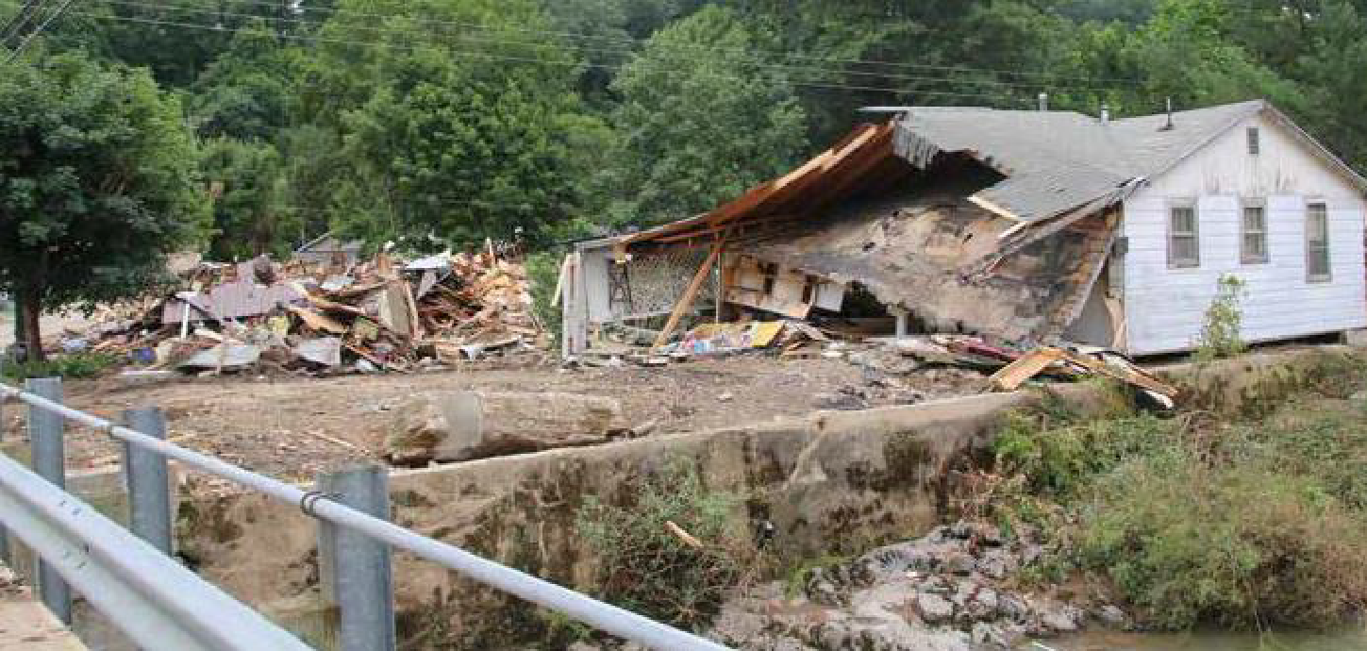

West Virginia Rental Assistance Program (WV-RAP)
Program Objective and Description: West Virginia used the most current available data from FEMA and SBA to complete its needs assessment. Based on this data and its consultation and coordination with the State’s partners in county and local governments, other State and local government agencies and affected communities, loss has been suffered across a variety of housing types, including single-family and two-family homes, and other non-conventional structures such as mobile homes.
The floods of June 2016 affected both market-rate rental properties and affordable rental properties. Even before the flood, demand for affordable, government-subsidized, conventional rental housing was strong throughout West Virginia. Of all 55 counties, 47 have overall government-subsidized occupancy rates of 98% or higher. Additionally, the senior renter household growth in Jackson County is projected to be one of the highest at 21% for 2014-2019. Similarly, in Webster and Clay counties the family-renter household growth projection for residents under the age of 55 for the same time period indicates decreases of 44% and 37% respectively.³ This is a direct result of the state’s aging population and sluggish economic environment.
Accordingly, a priority of West Virginia is to help rebuild damaged rental properties and return these impacted citizens to their homes as soon as possible. WV-RAP will address a portion of the unmet need within the rental housing sector identified by the State’s unmet needs assessment. Specifically, WV-RAP will focus on rehabilitation, repair, and reconstruction needs within the rental market and ensure resilience by incorporating mitigation measures to reduce impacts of future disasters.
The Rental Assistance Program (WV-RAP) will focus on rebuilding the affordable rental housing stock in impacted counties. Specifically, the WV-RAP will aid small properties (typically 1-4 units) damaged by the June 2016 floods. The program will provide financial assistance to small rental property owners who serve a low to moderate income market. West Virginia has prioritized this need as a state has many small rental property owners in need of assistance to bring their rental units back to the State’s market. The program expands affordable rental options while also spurring economic growth.
Small rental housing may include accessibility modifications to assist with West Virginia’s aging population.
Administering Entity: The West Virginia Rental Assistance Program will be directly administered by the State through the West Virginia Department of Commerce with specific phases of the administration of WV – RAP.
Geographic Area Eligible to be Served: Disaster declared counties: Clay, Fayette, Greenbrier, Jackson, Kanawha, Lincoln, Monroe, Nicholas, Pocahontas, Roane, Summers, Webster. Eighty percent of the CDBG-DR funds will be awarded to those properties located in the HUD-identified most impacted and distressed areas of Clay, Greenbrier, Kanawha, and Nicholas Counties.⁴ Properties in the floodway will not be eligible for reconstruction or rehabilitation activities.
Eligible Applicants: The State defines properties eligible for WV-RAP as small rental properties containing one to four residential units. Rental units must have experienced major to severe damage with remaining unmet needs and have not been able to occupy any tenants. After completion of the assistance provided, the owner of the property shall be required to offer the unit(s) at affordable rates to renters earning less than or equal to 80% AMI for a period of three (3) years. Units must be affordable to renters earning less than 80% AMI for three years.

3 West Virginia Housing Development Fund 2015 Housing Needs Study
Eligibility Criteria:
a) Small rental property with one to four units. Owners may include individuals, community development non-profits, Public Housing Authorities (PHA), Community Housing Development Organizations (CHDO) and/or private entities. NOTE: Manufactured Housing Units (MHUs or mobile homes) are eligible for rehabilitation at the discretion of the program. However, in order to be cost effective, the MHU to be rehabilitated must be no more than 5 years old at the time of assistance and the repair costs necessary to rehabilitate the MHU must not exceed $5,000 (hard and soft construction costs). Any MHU that is older than 5 years old or has an estimated repair cost greater than $5,000 shall require the MHU to be replaced with a MHU.
b) Structure must have been directly or indirectly impacted by floods of June 2016 (DR-4273).
c) Second homes as defined by IRS Publication 936 are not eligible for assistance. Additionally, seasonal, short-term and vacation rental properties are not eligible for assistance.
d) Structures that have suffered substantial damage will also qualify for assistance to mitigate against future losses and to comply with local building and zoning codes to address future flood risk. Based on recent federal guidance (Federal Register Notice 81 FR 5989, published on November 21, 2016), the State will require that buildings elevated with CDBG-DR dollars adopt standards using the best available flood elevation data plus freeboard, a factor of safety specified in the Building Code. The State’s intention is to utilize Flood Insurance Rate Maps (FIRMs) when they are issued and to require that projects funded with CDBG-DR meet FIRM elevation plus freeboard, a factor of safety specified in the Building Code.
e) The owner of the property must agree to rent the unit according to the affordability requirements set forth below for a period of 3 years after reconstruction, rehabilitation or replacement as secured through a recorded use restriction or other mechanism (e.g. forgivable promissory note or lien) to ensure that rental housing remains affordable for the stated period of time.
f) If located in a flood plain, the applicant must acquire flood insurance and comply with obligations to notify future owners of flood-insurance requirements. Owners of rental properties will be responsible for flood insurance.
Affordability Requirements:
Definition of Affordable Rents: Housing is considered “affordable” if the rent (including utilities) is no more than 30 percent (30%) of a household’s pre-tax income.
Number of Units: In order to be eligible for the program, at a minimum, the owner/applicant must agree to meet the following occupancy requirements established by HUD:
- All assisted single unit structures must be occupied by LMI households,
- An assisted two-unit structure (duplex) must have at least one unit occupied by a LMI household, and
- An assisted structure containing more than two units must have at least 51 percent (51%) of the units occupied by LMI households.
(However, as will be detailed in the program guidelines, the state may require recipients to provide affordable housing to low-to-moderate income housing through additional units within assisted structures.)
Duration of Affordability: The provision of affordable rents to qualified tenants will be required and monitored by the State for three (3) years.
Ineligible Activities: Forced mortgage payoffs; SBA home/business loan payoffs; funding for second homes; assistance for those who previously received Federal flood disaster assistance and did not maintain flood insurance; and compensation payments.
Program Priorities: In order to address the greatest need with the limited amount of funding available, program priorities have been established. Priorities of this program will include the restoration of all HUD-financed rental properties and structures directly impacted by the June 2016 floods located in areas determined to have a high and medium SoVI® score based on census tract data. These priorities allow the program to assist citizens with the greatest need based on level of damage and areas with the highest SoVI® score. Eligible applications will be reviewed and processed based on the following priority factors listed below in order of priority:
1. The impacted structure is a HUD-financed rental property and experienced damages confirmed by a FEMA-designation or has damage that meets a standard defined by FEMA;
2. The current tenant household meets HUD’s Low-to Moderate-Income (LMI) requirements or, if the property is currently vacant, the applicant certifies that they will obtain a tenant who meets HUD’s Low- to Moderate- Income (LMI) requirements;
3. Eligible applications will be reviewed and processed based on the SoVI® analysis of the impacted rental property. Specifically, each property will be reviewed to determine whether it is located in a HIGH, MEDIUM, or LOW SoVI ®area. This designation will be referred to as an application’s “SoVI® score.” The components which make up an application’s SoVI ®score are outlined in Table 13.
The State will prioritize applications with a SoVI® high score for the first 60 days of the application intake period. Thus, these will be the only applications processed and assisted for this time period. Once this time period has expired, the State will prioritize applications with both a SoVI® high and medium score for a period of 30 additional days and processed based on the order in which the application’s eligibility is determined. After this 90-day period the prioritization period will be concluded. Accordingly, after the 90-day period, applications receiving a SoVI®high, medium, or low score will be processed based on the order in which the application’s eligibility is determined.
4. Activities assisting providers of service to homeless populations, seniors, or other populations with special needs shall also be prioritized.
Grant Limit:
Small Rental Structures One to Four Units Rehabilitation: up to $75,000 per unit with damages totaling up to or less than 50% of the structure’s pre-disaster value.
Single Unit Rental Reconstruction: Due to the global pandemic and the significant increase in building supplies, the competitive contracts secured through the WV Purchasing Division will stand as cost reasonableness to complete the remaining homes as of June 3, 2021.
Single Unit Mobile Home Replacement: Due to the global pandemic and the significant increase in building supplies, the competitive contracts secured through the WV Purchasing Division will stand as cost reasonableness to complete the remaining homes as of June 3, 2021.
Eligible Activities: HCDA Sections 105(a)(3)-(4); 105(a)(11); 105(a)(15); 105(a)(18); 105(a)(25); Also eligible are elevation expenses related to rehabilitation and reconstruction activities including all applicable alternate eligibility requirements set forth under 81 FR 83254 and 82 FR 5591. [24 CFR 570.202(a)(1)]
National Objective: Benefit to low to moderate-income persons. [24 CFR 570.208(a)(3)]
CDBG-DR Allocation: $8,009,907.30
Projected Accomplishments: The State estimates it will be able to assist 40 units of rental property.
State Date: The State anticipates launching the WV-RAP during the third quarter of 2017.
End Date: WV-RAP will end upon the expenditure of all funds allocated for this program or within six years after the execution of the grant agreement with HUD.

Typical Flow for Housing Programs
Applicant intake and case management
Upon approval of this program, the State intends to undertake a targeted outreach strategy to reach high and medium SoVI® areas, which will include the following:
- A social media and local media campaign within SoVI® areas to describe program parameters, announce program intake, and provide guidance on how to apply;
- Community outreach in SoVI® areas that sustained damage, including communication with public officials, non-profits, and local community groups; and
- Direct community-based meetings, discussions, and forums in SoVI® areas to provide further guidance and capture feedback from impacted areas.
Owners of properties damaged by flooding are expected to register either online, via phone, or by coming to any of the program-designated locations. Once registered, applicants will be assigned a case manager who will accompany the applicant throughout the application process. The applicant will provide all required documentation to their case manager to answer questions.
Financial and Eligibility Review
The case manager will validate applicant and property eligibility and determine their priority in the program. They will conduct all compliance and duplication of benefit reviews and analyses. The State will utilize Melissa Data to conduct eligibility reviews to expedite the intake process. Melissa Data® will automatically verify certain data provided by Applicants, confirming data points such as the street address, county, and zip code of the damaged property.
In certain cases, Melissa Data® may not validate an applicant’s eligibility automatically. If additional documentation is required, the case manager will counsel the applicant on the documentation needed to prove eligibility. Examples of criteria for which documentation may be required include:
- Identification (e.g., government-issued identification);
- Citizenship (e.g., passport or birth certificate);
- Ownership (e.g., deed);
- Primary residence of owner/tenant (where applicable) (e.g., utility bills), lease agreement;
- Level of available assistance, (e.g., letters from insurance providers, FEMA grant documentation, SBA loan documentation); and
- Income (e.g., tax forms).
Damage Assessment
A damage assessment expert will also be assigned to visit the applicant’s property to assess the cost to complete rehabilitation. This damage assessor will make an appointment with the applicant to visit the property only after eligibility verification is complete. The damage assessor will document the required scope of work, type of damage, property size, and calculate estimated costs for use by the program in determining the amount and type of assistance required.
Determination of Unmet Need
The case manager will receive the cost to complete the estimate from the damage assessor and compare it to the financial review file, documenting all resources and assistance already received by the applicant. Based on these two inputs, the case manager will determine the unmet need and will work with the applicant to determine the most appropriate recovery path for the property.
Ongoing Applicant Point of Contact
Each path will provide specific customer service and housing counseling to the applicant throughout the rehabilitation/reconstruction process. However, the assigned case manager will remain an available point of contact throughout the entire process, allowing for continuity of service.

RISE West Virginia Multifamily Rental Housing Program
Program Objective and Description: The primary focus of the RISE West Virginia Multifamily Rental Housing Program is to provide affordable housing to vulnerable households in areas impacted by the 2016 floods and severe storms.. Assistance will be provided through multiple housing activities which may include, but is not limited to, the repair, rehabilitation, reconstruction, and new construction of housing units. Additional objectives of the program will be to facilitate decent, safe, and sanitary housing in flood-impacted areas through these activities, targeting assistance to developments that provide housing for veterans, elderly, and or low to moderate income households (LMI).

Administering Entity: The RISE WV Multifamily Rental Housing Program will be directly administered by the West Virginia Development Office through a Subrecipient Agreement with the West Virginia Housing Development Fund.

Geographic Area to be Served: Disaster declared counties: Clay, Fayette, Greenbrier, Jackson, Kanawha, Lincoln, Monroe, Nicholas, Pocahontas, Roane, Summers, and Webster Counties. Eighty percent of the CDBG-DR funds will be awarded to those properties located in the most impacted counties of Clay, Greenbrier, Kanawha, and Nicholas.

Eligible Applicants/Criteria: Developers building new affordable multi-family projects (of 5 or more), or substantially rehabilitating multi-family projects (5 units or greater) that withstood damage in the declared counties. Developers will respond to a Request for Proposal (RFP) released by the West Virginia Housing Development Fund and/or West Virginia Development Office. Properties must be Multifamily with five units or more to be considered for funding. There is no maximum project size. Mixed-use projects are not eligible. Eligible property types range from single structures to large complexes.

Affordability Requirements: All assisted properties must have at least 51% of the units occupied by LMI households. The provision of affordable rents to qualified tenants will be required and monitored by the State for five (5) years.

Program Priorities: Priority will be given to projects that provide housing to veterans, seniors, LMI persons, and that leverage other resources to produce new housing that is sustainable, integrated with neighborhood services and jobs, and provides deeper affordability. Projects will be selected through a competitive application process with priority scoring thresholds that will be clearly defined in the Multifamily Rental Housing Program Policies and Procedures along with the Request for Proposal.

Grant Limit: Awards will be restricted to the maximum per-unit subsidy limits established for HUD’s HOME Program which will not exceed a cap of $300,000 per unit.

Eligible Activities: Eligible under HCDA Sections 105(a)(4) and 105(a)(11); Construction of New Replacement Housing, Construction of New Housing, Acquisition of Property for Replacement Housing; and all applicable alternate eligibility categories set forth under 81 FR 83254 and 82 FR 5591.

National Objective: Benefit to low- and moderate-income persons [24 CFR 570.208(a)(3)]

CDBG-DR Allocation: $14,397,691.51

Start Date: The State anticipates launching the RISE WV Multifamily Rental Housing Program in the second quarter of 2018.

End Date: The RISE WV Multifamily Rental Housing Program will end upon the expenditure of all funds allocated for this program or within six years after the execution of the grant agreement with HUD.

In July 2025, the State requested and received authorization from HUD for a three-year extension to the CDBG-DR period of performance til September 2028. The extension allows the state adequate time to expend remaining funds, close out projects and complete an additional Multi-Family housing project. This project will include Rehabilitation of a scattered site, multi-family project. Three of the sites are located in one of our MID counties, while one is located in one of our NMID counties. This project will involve the rehabilitation of 16 units across 3 buildings in each of the 3 MID locations, that will serve families at or below 60% AMI. Additionally, it will include the rehabilitation of 24 units in 4 buildings designed for seniors at or below 60% AMI. According to a housing needs assessment conducted by the WV Housing Development Fund, the number of units of unmet need has increased from 2019 to 2024, indicating that this new project will help mitigate some of that demand.

RISE West Virginia Clearance and Demolition Program
Program Objective and Description: The purpose of the RISE West Virginia Clearance and Demolition Program is to remove structures damaged by flooding, landslides, and/or mudslides from the June 2016 severe storms, which will promote the well-being of the community facilitating long-term recovery. Many homes and commercial properties have been abandoned by their owners in favor of relocating to higher ground. Immediately following the flood into this year, the West Virginia National Guard utilized FEMA funding to tear down homes and remove personal property at no cost to the homeowner through the Private Property Debris Removal Program. While their efforts have been monumental, the National Guard, along with local emergency managers and code enforcement officials, have expressed that some areas within the affected counties are still left with remaining abandoned properties and have provided data to the State that corroborates this reality. Many of the local jurisdictions have already identified code enforcement cases but lack the funds to demolish the blighted structure. The Clearance and Demolition Program intends to continue the prior efforts of the Guard by working with local jurisdictions through their code enforcement offices to remove all standing structural components and any remaining debris. The purpose is to address slum and blight on a spot basis, and assist in the removal of vacant, deteriorated or abandoned buildings through code enforcement activities. The program will address voluntary participation for any dwelling, building, structure or property that is unfit for human habitation or for commercial, industrial, or business use and not in compliance with applicable codes and constitutes an endangerment to the public health or safety as a result of unsanitary or unsafe conditions.
Administering Entity: The RISE WV Clearance and Demolition Program will be directly administered by the State through the West Virginia Department of Commerce through an interagency agreement with the WV National Guard. The role of the WV National Guard ended in April 2021.
Geographic Area to be Served: Disaster declared counties: Clay, Fayette, Greenbrier, Jackson, Kanawha, Lincoln, Monroe, Nicholas, Pocahontas, Roane, Summers, and Webster Counties. Eighty percent of the CDBG-DR funds will be awarded to those properties located in the most impacted counties of Clay, Greenbrier, Kanawha, and Nicholas.
Participation: Applicants may apply, requesting voluntary demolition of an applicant owned structure. The structure must meet the WV State definition of Slum and Blight.
Eligibility Criteria: All voluntary applicants must currently own the property. The property must have been damaged by the flood, located in one of the 12 disaster declared counties, and currently be vacant. Eligible properties include both residential and commercial.
Program Priorities: Storm damaged structures will be eligible for demolition activities. Further, the State will do outreach to owners of properties located in the eligible counties by utilizing FEMA flood zone data.
Eligible Activities: Eligible under HCDA Sections 105(a)(3) and 105 (a)(4).
National Objective: Elimination of Slum and Blight and/or Urgent Need [24 CFR 70.483(d)]
CDBG-DR Allocation: $5,661,110.43
Projected Accomplishments: The State estimates it will be able to demolish up to 200 dilapidated properties.
State Date: The State anticipates launching the WV Clearance and Demolition Program in the second quarter of 2018.
End Date: The Revitalize WV Demolition Program will end upon the expenditure of all funds allocated for this program or within six years after the execution of the grant agreement with HUD.

Bridge Home Program
Program Objective and Description: Given the state’s rugged and rural landscape, many properties have only one access point via private roads with bridges, a substantial amount of which were damaged or destroyed during the flood. Due to the large amount of private, non-county-maintained bridges that were damaged, affected residents have limited or no access to their homes and some do not have access to evacuation routes or emergency services. Homeowners and renters in West Virginia need this specific assistance. FEMA Public Assistance may not be available to repair these roads due to their lack of public maintenance, even though they provide critical emergency access to families and homeowners. Without the reconstruction and mitigation of the private roads and bridges, residents will be at high risk when the next disaster occurs.
The State will coordinate with WV VOAD to administer the Bridge Home Program. Specifically, applicants will apply to the WV VOAD for assistance and WV VOAD will submit the applications of those residences located in Clay, Fayette, Greenbrier, Jackson, Kanawha, Lincoln, Monroe, Nicholas, Pocahontas, Roane, Summers, and Webster Counties. Once an applicant is deemed eligible for assistance, WVDOC will fund the costs of repair. WV VOAD will provide the voluntary labor necessary to complete the repairs consistent with all program requirements. All bridges will be constructed in compliance with HUD environmental and all other applicable requirements. Additionally, bridges will be constructed to mitigate future damage.
Administering Entity: The Bridge Home Program will be directly administered by the State through the West Virginia Department of Commerce in partnership with the West Virginia VOAD.
Geographic area to be served: Disaster declared counties: Clay, Fayette, Greenbrier, Jackson, Kanawha, Lincoln, Monroe, Nicholas, Pocahontas, Roane, Summers, Webster. Eligibility Criteria:
- Applicants must prove that the private bridge access was directly damaged or destroyed by the flood (DR 4273) and provides primary access to the target homes.
- Applicants should demonstrate that lack of access is a health and safety issue and provide emergency vehicle access.
- The private bridge should serve at least one primary residential property.At least 50 percent of the properties that the bridge provides access to must be low-and-moderate income households unless an urgent need can be substantiated.
Program Priorities: Applicants deemed eligible for the WV Housing Restoration Program or WV Rental Assistance Program will be prioritized for Bridge Home Program funds.
Eligible Activities: Eligible under HCDA Sections 105 (a)(1); 105(a)(3); 105(a)(4); 105(a)(5); 105(a)(7)
National Objective: Benefit to low- and moderate-income persons or households and Urgent Need (24 CFR 570.208(a); and, 24 CFR 570.208(c)).
CDBG-DR Allocation: $6,500,111.87
Projected Accomplishments: The State estimates that up to 130 bridges can be repaired or replaced.
Grant Limit: $30,000 per primary residence access
Start Date: The State anticipates the launch of the Bridge Home Program during the third quarter of 2018.
End Date: The State anticipates the completion of the Bridge Home Program by June 2023.

Image 22: After their house was destroyed by rushing flood waters, a family of 5 is living in this camper, the left-hand side of the photo shows where their home once stood.
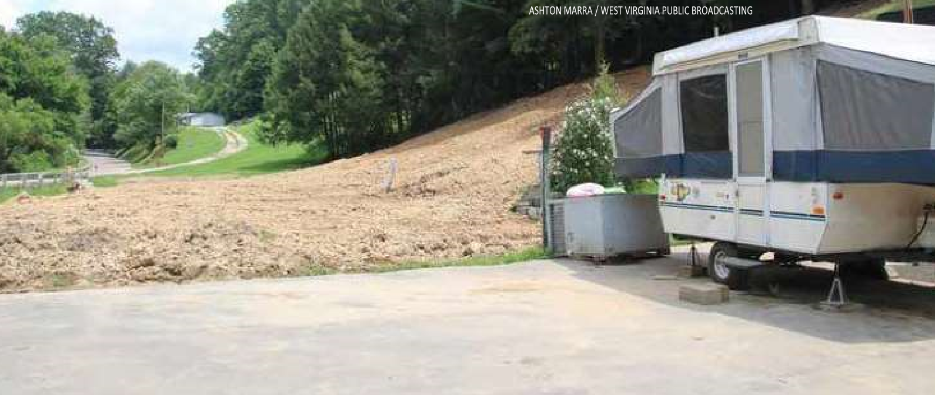

West Virginia Hazard Mitigation Grant / CDBG-DR Match Program
Program Objective and Description: As documented in the States’ unmet needs assessment, a large number of homes in the declared counties reported damages as a result of the June 2016 floods. A close examination of the damages reveals a high concentration of homeowners spread across a wide geographic area within the state. Not only was this damage extensive, but it disproportionately affected the low- and moderate-income (LMI) population. As set forth in the State’s impact and unmet needs assessment, the location and substantial nature of these damages yielded a tremendous unmet need in the state. Accordingly, given the limited resources and the identified housing needs, West Virginia seeks to leverage investment for long-term resilience.

A critical component of its recovery strategy is West Virginia’s intention to leverage any available funds with CDBG-DR funds to ensure that the most impact can be achieved by the CDBG-DR investment. FEMA’s Hazard Mitigation Grant Program (HMGP) will be a critical part of long-term resilience improvements for infrastructure in West Virginia’s impacted area. The State will be providing a match for FEMA approved Infrastructure projects through CDBG-DR funds. As of March 1, 2017, the amount available for mitigation and resilience activities statewide is $60 million. Accordingly, West Virginia will combine the HMGP funds with the CDBG-DR funds for discretionary resilience projects. CDBG-DR funding will be applied to the local cost share of projects funded under HMGP. These projects will be determined in advance to be those that reduce risk to future disaster to life, private property and/or public infrastructure. Projects must pass a cost-benefit analysis and be determined as cost-effective. FEMA provides 75 percent federal funding (75% of the project total) and West Virginia will provide the remaining non-FEMA-cost-share of 25 percent (25% of the project total). CDBG-DR funds would go to pay for some or the entire local 25% cost share. The State will utilize its CDBG-DR allocation within the eligible areas to elevate residential structures, with a particular emphasis on LMI households.

At the time of developing the West Virginia CDBG-DR Action Plan, the State’s HMGP policy guidelines had not been released for the HMGP grant related to DR-4273. These guidelines will be a significant component in the determination of project types prioritized for the match of CDBG-DR funds to HMGP funds. The eligibility criteria under the CDBG-DR program will be the deciding factor as to whether the CDBG-DR funds can be used for the local match under the State’s HMGP. Not all FEMA or other federal projects contain activities that are eligible under CDBG-DR. Only CDBG-DR eligible activities will be funded under this program.

Image 23: Cleaning up flood damage in Richwood.

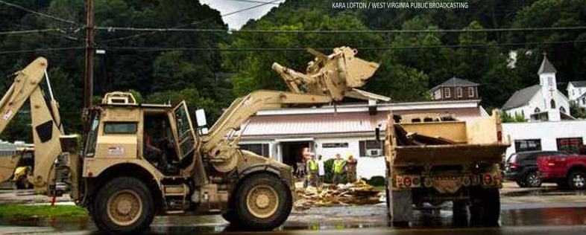

Administering Entity: The proposed programs will be administered through the West Virginia Department of Commerce in coordination with the West Virginia Department of Homeland Security and Emergency Management. Through an extensive outreach initiative, the State has identified eligible households and will coordinate all aspects of administering the programs including applicant intake, case management and construction work, where applicable.
Eligible Applicants: Homeowners, Counties, Municipalities, Public Housing Authorities, other county and local program applicants eligible to receive federal HMGP funds, including eligible private non-profit organizations.
Eligible Activities:
- Housing Activities which may include Buyout and Elevation
- Property acquisition and demolition (stick-built homes and mobile homes)
- Property Elevation
- Minor localized flood reduction projects (i.e. detention ponds, increased channel capacity)
- Infrastructure improvements or replacement
Eligibility Criteria: Eligibility criteria will include all program eligibility criteria for both the FEMA Hazard Mitigation Program and the CDBG-DR program.
Grant Limit: The grant limit will be the amount equal to the entire local 25% cost share of the HMGP project.
Program Priorities: Benefit to LMI households and / or persons will be prioritized. Activities assisting providers of service to homeless populations or other populations with special needs shall also be prioritized.
Projected Accomplishments: The State anticipates a variety of accomplishments to be realized through its leverage of the CDBG-DR funds and FEMA HMGP funds. Given West Virginia’s current state of economy, a critical value and accomplishment realized through this funding approach is the ability to use the CDBG-DR funds and not deplete state or local resources desperately needed for other recovery efforts.
Eligible Activities: HCDA Sections 105(a)(4); 105(a)(9).
National Objective: Benefit to low- and moderate- income persons or households and Urgent Need (24 CFR 570.208(a); and, 24 CFR 570.208(c)).
CDBG-DR Allocation: $0.00
Start Date: The State of West Virginia anticipates the launch of the Restore West Virginia FEMA HMGP Non-Federal Share Match Program in the third quarter of 2017.
End Date: The program will end when all funds are expended, or within six years after the execution of the grant agreement with HUD.

Restore Riverview Program
Program Objective and Description: Clendenin School served as the center of education for this community from its design in 1911 until 2003. Long considered a community icon, the structure has nurtured many citizens of Kanawha County, West Virginia.
In 2009, various stakeholders and interested partners collaborated to develop a plan for the redevelopment and rehabilitation of this community cornerstone. Together, the partnership leveraged HUD NSP funds, USDA funds and private funds to facilitate the development of a mixed-use facility which would provide both affordable housing for seniors and health care to this region. The 3-story building was re-opened in 2011 to provide 18 residential units and a medical clinic which served both the residents of Riverview and the Clendenin community. Specifically, the Clendenin Health Center provided services such as primary care services for all ages, prenatal and perinatal care, pediatric care, pharmacy services, behavioral health services, dental services, and in-house laboratory services. After its adaptation, Riverview continued to serve as a cornerstone of this vital community.
Like the majority of Clendenin, the 2016 floods caused devastating damage to Riverview. All of the residential units located on the first-floor sustained substantial damage. Third floor common areas were also damaged along with the laundry room, electric room, mechanical room, elevator, and elevator machine room. The infrastructure and HVAC unit on the exterior of the building was also heavily damaged. Yet even in the midst of suffering such devastation, this cornerstone of the Clendenin community continued to serve its neighbors. Within days of the floods, supported by emergency generators, the medical clinic provided desperately needed medical care to the community.
The Restore Riverview Program will consist of two separate projects to include the Restore Riverview Building Onsite and the Relocation Riverview Offsite.

Restore Riverview Building Onsite
As stated previously in the Impact Assessment, local officials within Clendenin initially estimated that $4 million would be required to repair flood damage to this building and to reopen the 18 rental units vacated after the flood. Given the building’s location, the extensive damage suffered to the first floor, the height of the flood waters of 2016 and the possibility of future flooding, the State has considered whether it is advisable to rebuild housing units on the first floor of this property. After further discussion with local officials, the State intends to restore the ten units on the third floor and relocate the eight first-floor units. Any units rehabilitated and restored will primarily benefit the low- and moderate-income population and be considered for a location for additional senior housing needed in this community.
Administering Entity: The Restore Riverview Project will be directly administered by the State through the West Virginia Development Office through a Subrecipient Agreement.
Geographic Area to be Served: Clendenin, Kanawha County.
Eligible Activities: HCDA Sections 105(a)(1); 105(a)(4); 105(a)(6); 105(a)(11); 105(a)(15); Construction of New Replacement Housing, Construction of New Housing, Acquisition of Property for Replacement Housing; and, all applicable alternate eligibility categories set forth under 81 FR 83254 and 82 FR 5591.
Affordability Requirements: All assisted properties must have at least 51% of the units occupied by LMI households. The provision of affordable rents to qualified tenants will be required and monitored by the State for five (5) years.
National Objective: Benefit to low-and moderate-income persons through job creation or housing (24 CFR 570.208(a)).
CDBG-DR Allocation: $7,581,591.44
Projected Accomplishments: This project will restore affordable rental housing to the Clendenin community by providing a minimum of 10 units. A minimum of 51% of all units created under this project as being required to benefit LMI persons.
Start Date: The State anticipates the launch of this project during the Second quarter of 2018.
End Date: The State anticipates the completion of this project by December 2024.

Restore Riverview Offsite
The Restore Riverview Offsite Project will relocate the eight first-floor units of the Clendenin School building that were damaged during the 2016 floods and severe storms. Developers will respond to a Request for Proposals (RFP) that will be released by the West Virginia Development Office and/or West Virginia Housing Development Fund. Projects will be selected through a competitive application process that will be clearly defined in the RFP. Priority will be given to proposals that are close in proximity to the Clendenin School building.
Administering Entity: Restore Riverview Offsite will be directly administered by the State through the West Virginia Development Office through a Subrecipient Agreement with the West Virginia Housing Development Fund.
Geographic area to be served: Kanawha County
Eligible Activities: HCDA Sections 105(a)(1); 105(a)(4); 105(a)(6); 105(a)(11); 105(a)(15); Construction of New Replacement Housing, Construction of New Housing, Acquisition of Property for Replacement Housing; and, all applicable alternate eligibility categories set forth under 81 FR 83254 and 82 FR 5591.
Affordability Requirements: All assisted properties must have at least 51% of the units occupied by LMI households. The provision of affordable rents to qualified tenants will be required and monitored by the State for five (5) years.
National Objective: Benefit to low- and moderate- income persons through housing (24 CFR 570.208(a)).
CDBG-DR Allocation: $11,281,102.62
Grant Limit: Awards will be restricted to the maximum per-unit subsidy limits established for HUD’s HOME Program which will not exceed a cap of $300,000.
Projected Accomplishments: This project will restore affordable rental housing to the Clendenin community by providing a minimum of eight units. A minimum of 51% of all units created under this Project as being required to benefit LMI persons.
Start Date: The State anticipates the launch of this project during the Second quarter of 2018.
End Date: The State anticipates the completion of this project by September 2023.

RISE West Virginia Economic Development
Program Objective and Description: The purpose of the RISE West Virginia Economic Development Program is to assist communities affected by the June 2016 Severe Storms. Since its residential communities cannot fully recover and grow without businesses returning to the community, the State supports critical economic revitalization activities. Upon its review of the remaining unmet economic needs and a post disaster data analysis, West Virginia will facilitate economic and community development through a suite of activities outlined below. The data analysis from the most impacted and distressed areas of Clay, Greenbrier, Kanawha and Nicholas counties demonstrate economic downturns. The funds will be awarded in the form of grants to units of local government to be used for community and economic improvements in the four counties.

The RISE West Virginia Economic Development Program supports the long-term housing recovery in the following ways:
- Fund improvements to basic infrastructure (e.g. water, sewer, storm water) needed to attract and grow commercial and industrial businesses.
- Support the development and enhancement of parks and recreational facilities through acquisition, construction, or rehabilitation that will improve the quality of life and eliminate factors that affect environmental quality or public health.
- Strengthen downtown cores through assistance in street improvements, sidewalks, and street landscaping that will significantly contribute to revitalization or redevelopment of downtown cores.
- Invest in commercial/industrial improvements through the acquisition, rehabilitation, or construction of commercial and industrial buildings and parks.

Provision of reliable water and wastewater systems is essential for furthering economic development and growth. Such systems:
- Influence the decisions of firms to locate in a community or region
- Facilitate economic diversification by making it easier for a mix of businesses to develop or locate in an area
- Mitigate environmental pollution in streams, thereby increasing opportunities for recreational and outdoor tourism
- Promote better public health and quality of life through the provision of clean water.
West Virginia will prioritize infrastructure projects that serve commercial and industrial customers or sites, target existing population centers and downtown areas (“infill strategy”), protect environmental resources that can be utilized for recreation-based economic development, or serve critical community facilities such as medical establishments, schools, and community centers.
West Virginia will work with the local Regional Planning and Development Councils (regional councils) to develop infrastructure projects and assist local communities in administering projects. We will also work with the regional councils to identify commercial and industrial sites and parks that can be improved in the impacted areas. Applicants for infrastructure projects will be strongly encouraged to partner with their relevant regional council for project development and administration.
Administering Entity: The program will be administered by the State through the West Virginia Department of Commerce, West Virginia Development Office (WVDO).
Geographic Area to be Served: Most impacted and Distressed counties of Clay, Greenbrier, Kanawha, and Nicholas.
Eligible Applicants: Units of local governments.
Maximum Award Amount: $5,000,000
Eligibility Criteria:
- The proposed activities must meet one of the following HUD National Objectives:
  - Benefit persons of low- and moderate income
- The proposed activity must address a disaster related impact either directly or indirectly.
- The proposed activity must define the economic development impact.
Method of Distribution:
1) WVDO will issue a Request for Proposals (RFP) outlining priorities for economic development funding, how interested applicants can apply for funding, and application deadlines. WVDO will offer technical assistance to interested parties throughout the application process.
2) Applications received will be evaluated and scored based on the criteria outlined below. WVDO may conduct follow-up discussions with applicants as needed to clarify project design and negotiate any project revisions requested by WVDO. All applicants will be notified whether their application was awarded funding or declined for an award.

Criteria | Description | Points
Economic Development Impact | Project demonstrates quantifiable benefits that increase economic development in the area (number of businesses served, workers trained, acres improved, critical facilities served) and describes in detail how the project will increase economic development opportunities in the area for low to moderate income persons. | 25
Underwriting | Project budget is reasonable, all sources of financing are committed, CDBG-DR funds are not replacing non-federal financial support, the project is financially feasible, and, to the extent practicable, the return on applicant’s equity investment will not be unreasonably high. | 25
Project Description | Project demonstrates detailed scope of work, firm and up-to-date cost estimates, clearly defined milestones, and quantifiable outcome measurements. | 20
Readiness to Proceed | Project has completed pre-construction requirements such as design, permitting, and environmental review and can quickly proceed to construction phase (see important note below scoring chart) | 15
Capacity and Implementation | Subrecipient demonstrates extensive project management experience | 10
Leverage | Project demonstrates committed matching dollars from federal and other sources of funding | 10
Green Infrastructure/Energy Efficiency | Project incorporates energy-efficiency and/or green infrastructure elements into the project design, including: bioretention areas such as rain gardens and bioswales, permeable pavements, street trees, and open spaces that incorporate drainage and infiltration functions. Higher scoring applications will include multiple forms of green infrastructure and include extensive planning. | 10
Investment Linkage | Project complements other community development activities and projects in the area and demonstrates consistency with local, regional, or state plans. | 10
Total |  | 125

Eligible Activities: Eligible under HCDA Sections 105(a)(2), 105(a)(4), 105(a)(8), 105(a)(14), and 105(a)(17)
National Objective: Benefit to low- and moderate-income persons [24 CFR 270.208(b)(1)-(4)
CDBG-DR Allocation: $7,142,216.41
Start Date: The RISE WV Economic Development Program will begin accepting project applications in the first quarter of 2021.
End Date: In July 2025, the State requested and received authorization from HUD for a three-year extension to the CDBG-DR period of performance til September 2028. The extension allows the state adequate time to expend remaining funds, close out projects and complete an additional Multi-Family housing project and Planning project. The Planning project will be a Pilot Demonstration to install deployable flood protection systems at selected critical infrastructure locations for increased community resiliency. Project sites will tie back to the 2016 disaster in the 12 declared counties, MID (Clay, Greenbrier, Kanawha & Nicholas) and NMID (Fayette, Jackson, Lincoln, Monroe, Pocahontas, Roane, Summers & Webster). Project locations may not include all counties, but the MID counties will be priority. The strategy utilized for this project include:
- Site visits to ensure locations are suitable for deployable flood protection use and gauge facility interests.
- Interaction with each designed facility to perform mock system installations to demonstrate system installation, removal and storage
- Outreach & Education to local and regional critical infrastructure entities across the designed region on utilization of deployable flood protection products available.
Ineligible Activities: Forced mortgage payoffs; SBA homes/business loan payoffs; funding for second homes; assistance for those who previously received Federal flood disaster assistance and did not maintain flood insurance; and compensation payments.
SBA Declined Loans: Business owners approved for SBA loans who declined their loans or have drawn less than the full amount of the approved SBA loans will be reviewed for eligible award amounts and duplication of benefits, per the State’s program policies and procedures.

Planning
Program Objective and Description: West Virginia’s Department of Commerce worked closely with the DHSEM, who manages disaster preparedness, mitigation, response, and recovery across West Virginia, by coordinating with all responsible government agencies, emergency managers, and first responders and the Governor’s Office. The severe storms, flooding, landslides, and mudslides of June 22-29, 2016 severely impacted the 12 declared counties. Many of the affected communities are small municipalities who were already dealing with pre-disaster community and capacity challenges, including declining populations, strained economies, economically vulnerable residents, and significant blight. Recovery will require local capacity to address complex problems in infrastructure, housing, commerce, community resources, and the natural environment. Thus, West Virginia will use CDBG-DR funds for long-term State planning and rebuilding efforts. Some of the planning funds are intended for use in the following categories: planning, community outreach and implementation of neighborhood recovery strategies; environmental review of zoning and land use changes; integration of local land use and geographical planning. All associated activities will be having a focus on the full development of a comprehensive resiliency strategy for the State.
Priorities: Development of a disaster recovery and response plan that addresses long-term recovery as well as pre- and post-disaster hazard mitigation. Specifically, the State will use some of the Planning funds to support planning activities carried out by the newly established State Resiliency Office as further detailed in the Long-Term Recovery Section of this Action plan.
Eligible Activities: HCDA Section 105(a)(12).
National Objective: There is no HUD National Objective for Planning Activities.
CDBG-DR Allocation: $6,749,216.67. Funds expended will follow overall grant percentages for low to moderate income and most impacted and distressed requirements.
Program Administration: West Virginia Department of Commerce
Geographic Area to be Served: Disaster declared counties: Clay, Fayette, Greenbrier, Jackson, Kanawha, Lincoln, Monroe, Nicholas, Pocahontas, Roane, Summers, and Webster Counties.
Program Start and End Dates: Duration of the CDBG-DR grant.

Administration
Program Objective and Description: This function provides administrative support services for the management and citizen participation necessary to formulate, implement, and evaluate all of the State’s CDBG-DR Program activities. Administrative activities have already included some of the following and are anticipated to include in the future:

Administrative activities associated with the activities carried out by the State Resiliency Office

Preparation of CDBG-DR Action Plan and all subsequent Amendments;

Ensuring citizen participation (including publication of public notices);
- Preparation of the required CDBG-DR quarterly reports;
- Maintenance of the CDBG-DR website;
- Preparation and oversight of Environmental Reviews;
- Monitoring expenditures for CDBG-DR programs;
- Delineation of population groups served by CDBG-DR programs;
- Liaison function with HUD, FEMA, and other federal departments; and
- Certification and maintenance of the necessary records that demonstrate that federal requirements for environmental review, fair housing, relocation, labor standards, equal opportunity, and citizen participation are met.
Eligible Activities: Administration
National Objective: There is no HUD national objective for Administration activities.
CDBG-DR Allocation: $7,305,750.00 Funds expended will follow overall grant percentages for low to moderate income and most impacted and distressed requirements.
Program Administration: West Virginia Department of Commerce (State Resiliency Office); Regional Planning and Development Councils; West Virginia Housing Development Fund; West Virginia VOAD; and, West Virginia Department of Homeland Security and Emergency Management.
Program Start and End Dates: Duration of the CDBG-DR grant.

Long-Term Recovery Planning & Coordination
In the wake of a disaster such as that suffered by West Virginia in June 2016, a state is acutely aware of any gaps in its capacity to respond to such sudden devastation. Such was the case in West Virginia. The State immediately realized it would need not only the help but the expertise of its federal partners to recover both in the short-term and develop a sustainable long-term recovery strategy. Thus, West Virginia began immediately coordinating with federal, state and local partners to identify urgent needs and resources to resolve those needs. It was during that effort that a gap in its own capacity to handle such events was realized by the State. This realization impassioned West Virginia’s leaders to undertake a simultaneous effort: address direct disaster impacts suffered by the communities while using the lessons learned from 2016 to develop a long-term recovery strategy focused on building capacity, coordination and resiliency.
The first step taken by West Virginia in this effort was to foster a collaboration between federal, state and local partners to examine recovery issues within six specific areas. The following support functions for recovery were prioritized for the initial collaboration:
- Community Capacity and Planning
- Housing
- Infrastructure Systems
- Economic
- Health and Social Services
- Natural and Cultural Resources
West Virginia was aware that a strong long-term recovery and resiliency strategy would require organization, cooperation and coordination of its entire federal, state and local network. Consequently, the collaboration was comprised of, but is not limited to, the following agencies:
Table 22: West Virginia Recovery Agencies
DHS/FEMA | Department of Agriculture | Department of Labor
WV Department of Commerce | Environmental Protection Agency | Department of Energy
WV Department of Health and Human Services | Department of Treasury | Department of Veteran Affairs
Department of Housing and Urban Development | Small Business Administration | American Red Cross
US Army Corps of Engineers | Department of Education | National VOAD
Department of Interior | Department of Transportation | WV VOAD
Appalachian Regional Commission | WVU Land Use & Sustainable Development Law Clinic | WV National Guard
WV Economic Development Authority | WV Municipal League | WV Regional Planning and Development Councils
WV Housing Development Fund

Together, these partners worked to identify gaps in the State’s capacity to recover as well as a comprehensive strategy to address these gaps. The goal was to define recovery issues, goals, objectives, and strategies to support recovery and build resiliency following the devastating effects of the severe storms, flooding, landslides, and mudslides. These partners will continue to coordinate throughout the actions necessary to achieve these goals. Through these defined strategies, the State developed its comprehensive plan pursuant to which it will promote sound, sustainable long-term recovery planning as the same was informed by its in-depth post-disaster evaluation of hazard risk and flood plain management.

West Virginia State Resiliency Office
Over the past 52 years, more than 280 West Virginians have died from flooding events. Between 1996 and 2017, the State experienced 27 federal disaster declarations stemming from flooding. Unfortunately, when the disaster of June 2016 hit the region, the State was acutely reminded that its communities lack sufficient capacity to effectively and efficiently address large and complex challenges. Even though many state and federal flood protection programs and projects exist to assist when such events occur, flooding continues to be a threat to West Virginia communities.
Here again in 2016, many communities had the necessary capacity for day-to-day operations; however, the disaster shed light on the strains placed on the resources of the state, local officials, and staff after such a large disaster. Many of the affected communities are small municipalities who were already dealing with pre-disaster community and capacity challenges, including declining populations, strained economies, economically vulnerable residents, and significant blight.
Thus, West Virginia’s leaders immediately realized that a key to the State’s recovery from this disaster and future events was the establishment of a State Resiliency Office (SRO). The effort to establish this office was born out of leaders’ dedication to long-term recovery and resilience. Multiple discussions ensured between State and federal stakeholders considering the best model for West Virginia. Some of the stakeholders collaborating on this initiative included cabinet secretaries and agency deputies from the West Virginia Department of Commerce, the West Virginia DHSEM, the West Virginia Air National Guard, the US Economic Development Administration, and the Federal Emergency Management Agency (FEMA). This united focus intentionally collaborated to develop the structure, purpose, and responsibilities of the new West Virginia State Resiliency Office.
In April 2017, the State legislature passed, and Governor Justice signed into law House Bill 2935 which established West Virginia’s State Resiliency Office. The key purpose of the SRO will be to coordinate the development of community and economic resiliency plans including, but not limited to, planning to mitigate flood damage, protect the environment and the promotion of efforts to support the State’s economy. Upon the receipt of certain federal and/or state disaster or resiliency funds, the SRO shall coordinate all activities related to those funds. This central office will be critical to the long-term recovery and resiliency of West Virginia.
The SRO will be housed within the WV Department of Commerce and governed by an eight-member board. The SRO governing board will be compromised of the following leaders (or his or her designee) within the State of West Virginia:
- The Secretary of the Department of Commerce, Chair of the Board
- The Director of the Division of Homeland Security and Emergency Management
- The Director of the Division of Natural Resources
- The Secretary of the Department of Environmental Protection
- The Executive Director of the State Conservation Agency
- The Secretary of the Department of Military Affairs and Public Safety
- The Secretary of Transportation
- The Adjutant General of the West Virginia National Guard
The new law provides that the Chair of the Board (the Secretary of the Department of Commerce) coordinate quarterly meetings of the SRO Board to discuss current plans, initiatives and issues. It further requires that the Chair provide adequate staffing from its office to ensure effective capacity to carry out the decisions of the SRO Board. Accordingly, the WVDOC has organized its staff pursuant to the newly established SRO and will coordinate the CDBG-DR programs along with other federal and state recovery programs.
While the general purpose of the SRO is to oversee and coordinate implementation of long-term recovery efforts, the SRO will also look to proactively develop strategies to enhance West Virginia’s overall resiliency. In some cases, the SRO will implement these developed strategies. Additionally, some of the additional responsibilities of the SRO include:
- Serve as coordinator of all economic and community resiliency planning and implementation efforts;
- Annually review the State’s flood protection plan and update the plan no less than biannually;
- Recommend legislation as necessary to reduce or mitigate flood damage;
- Report to the Joint Legislative Committee on Flooding at least quarterly;
- Catalog, maintain and monitor a listing of current and proposed capital expenditures to reduce or mitigate flood damage or resiliency efforts;
- Coordinate planning of flood projects with other federal agencies;
- Improve professional management of flood plains;
- Provide education and outreach on flooding issues to West Virginia’s citizens;
- Monitor federal funds that become available for disaster recovery and economic and community resiliency;
- Pursue additional funds and resources and assist not only with long-term recovery efforts, but also long-term community and statewide resiliency efforts; and,
- Coordinate, integrate, and expand planning efforts in the state for hazard mitigation, long-term disaster recovery and economic diversification.
The focus for the SRO will be to develop the capacity within state, regional and local entities enabling them to have the resources and knowledge to develop recovery and resiliency planning within their communities. The first step in this process will be the SRO’s development and adoption of a pre-disaster recovery plan which will assist communities with planning efforts. Developing a state-level recovery plan model which can be adopted and shared throughout its communities is of utmost importance to West Virginia.
Additional key long-term recovery planning goals are as follows:
1. Build the State’s capacity to successfully manage and coordinate long-term disaster recovery.
2. Ensure its local communities have resources to successfully execute long-term disaster recovery.
3. Adopt a Pre-Disaster Recovery Plan which model can be adopted by regional and local communities.
4. Demolish 60 percent of unsafe structures in flood impacted communities.
5. Upgrade condition and capacity of at least 50 percent of the identified existing water and sewer systems by 2025.
6. Increase household resiliency by educating 70% of the households by 2019 on preparedness options.
7. Develop incentives to encourage mitigation strategies while rebuilding.
8. By January 1, 2018, Adopt state-wide land development standards, including modern building code requirements for local adoption and enforcement.
9. Double the energy efficiency and sustainability of the reconstruction housing stock in disaster impacted communities by incorporating weatherization, energy efficiency and sustainable design in all recovery reconstruction.
The collaboration stemming from the June 2016 floods has only begun. The effort spent in the development of these strategies creates clear direction for continuing support and involvement of all agencies and nongovernmental organizations as West Virginia continues toward full recovery and increased resiliency.

Effort to Minimize or Address Displacement
All CDBG-DR funded activities will be designed to eliminate (or minimize) the occurrence of displacement. The State will minimize displacement of persons or entities and assist persons or entities displaced as a result of implementing a project with CDBG-DR funds.
The State will ensure that the assistance and protections afforded to persons or entities under the Uniform Relocation Assistance and Real Property Acquisition Policies Act (URA, and Section 104(d) of the Housing and Community Development Act of 1974, is available. The URA provides that a displaced person is eligible to receive a rental assistance payment that covers a period of 42 months. Given its priority to engage in voluntary acquisition and optional relocation activities to avoid repeated flood damage and improve floodplain management, the State accepts the HUD waiver of the Section 104(d) requirements, which assures uniform and equitable treatment by setting the URA and its implementation regulations, as the sole standard for relocation assistance under the Notice published at 81 FR 83254 and 82 FR 5591. Efforts to conduct voluntary buyouts for destroyed and substantially damaged buildings in a floodplain may not be subject to all provisions of the URA requirements. For LMI residents displaced by the CDBG-DR program, a temporary housing program may be available through the CDBG-DR program to allow time for new units to be rehabilitated or constructed.
Temporary relocation assistance for tenants is a standard component of rehabilitation programs and thus, tenants will be provided relocation assistance where applicable in compliance with the HUD Uniform Relocation Assistance and Real Property Acquisition Policies Act (URA) final rule (49 CFR Part 24). If tenants will be temporarily relocated (or temporarily displaced) for more than 12 months, they will be given “permanent” relocation assistance in accordance with HUD and URA requirements. Additionally, if the property is not suitable for rehabilitation, the program will provide assistance to the tenant for relocation to another rental property.

Flood Insurance & Elevation Standards
After such devastation, the State is dedicated to implementing resiliency measures. WVDOC will follow HUD guidance to ensure all structures, defined at 44 CFR 59.1, designed principally for residential use and located in the 1 percent annual (or 100-year) floodplain, that receive assistance for new construction, repair of substantial damage, or substantial improvement, as defined at 24 CFR 55.2(b)(10), will be elevated with the lowest flood, including the basement, at least two feet above the 1 percent annual floodplain will be elevated or flood-proofed in accordance with FEMA flood-proofing standards at 44 CFR 60.3(c)(3)(ii) or successor standard, up to at least two feet above the 1 percent annual floodplain.
Property owners assisted through the West Virginia Housing Restoration Program, West Virginia Rental Assistance Program, and the CDBG-DR / HMGP Coordinated Match Program will be required to acquire and maintain flood insurance if their properties are located in a FEMA designated floodplain. WVDOC will provide owners in the West Virginia Housing Restoration Program a 1-year flood insurance premium. This requirement is mandated to protect the safety of residents and their property and the investment of federal dollars. The elevation height of a house can significantly reduce the cost of flood insurance. The State will implement procedures and mechanisms to ensure that assisted property owners comply with all flood insurance requirements, including the purchase and notification requirements described below, prior to providing assistance.
As noted in the eligibility requirements set forth herein, the State will ensure that property owners receiving disaster assistance that triggers the flood insurance purchase requirement are informed that they have a statutory responsibility to notify any transferee of the requirement to obtain and maintain flood insurance, and that the transferring owner may be liable if he or she fails to do so. Therefore, as noted previously, a covenant will be placed on the property which will run in perpetuity requiring any owner of the property to maintain flood insurance.

Protection of People & Property; Construction Methods
Construction Standards for Replacement and New Construction of Residential Housing
Recovery programs implemented by the State will incorporate uniform best practices of construction standards for all construction contractors performing work in all relevant jurisdictions. Construction contractors will be required to carry required licenses and insurance coverage(s) for all work performed. West Virginia will promote high quality, durable and energy efficient construction methods in affected counties. All newly constructed buildings must meet locally adopted building codes, standards and ordinances. In the absence of locally adopted and enforced building codes, standards and ordinances. In the absence of locally adopted and enforced building codes that are more restrictive than the state building code the requirements of the State Building Code will apply. Future property damage will be minimized by incorporating resilience standards by requiring that any rebuilding be done according to the best available science for that area with respect to base flood elevations.
The State will implement construction methods that emphasize high quality, durability, energy efficiency, sustainability, and mold resistance. All rehabilitation, reconstruction, and new construction will be designed to incorporate principles of sustainability, including water and energy efficiency, resilience, and mitigation against the impact of future disasters.
Under the CDBG-DR Program, the State will require all construction activities to follow the guidelines specified in the HUD CPD Green Building Checklist and meet an industry-recognized standard that has achieved certification under at least one of the following programs:
- ENERGY STAR Multifamily High-Rise Program
- Enterprise Green Communities
- LEED (New Construction, Homes, Midrise, Existing Buildings Operations and Maintenance, or Neighborhood Development)
- ICC 700 National Green Building Standard
- EPA Indoor AirPlus (ENERGY STAR a prerequisite)
- Any other equivalent comprehensive green building program
West Virginia will implement and monitor construction so as to ensure the safety of residents and the quality of projects developed. All multifamily units developed must comply with the current Minimum Quality Standards (MQS).
For rehabilitation other than substantially damaged residential buildings, grantees must follow the guidelines specified in the HUD CPD Green Building Retrofit Checklist. Grantees must apply these guidelines to the extent applicable to the rehabilitation work undertaken, including the use of mold resistant products when replacing surfaces such as drywall.
Construction Warranties
In addition to the licenses and insurance requirements, Contractors will be required to provide a warranty period for all work permitted. Assisted homeowners will be provided a warranty on the work performed and funded through the housing programs. All work performed by the contractor will be guaranteed consistent with standards of West Virginia, or standards adopted by the State and referenced in contractor agreements to be executed between the homeowner/applicant and contractor. Contractors will be required to guarantee 1 year of general warranty for the entire home. Applicants will have access to a thorough appeals process to address any construction quality concerns identified by the homeowner during the construction process.
Appeals Process
The State will implement an appeals process for homeowners, rental property owners, and other program participants related to program eligibility and program application process. In addition, the state will implement an appeals process for the West Virginia Housing Restoration Program and West Virginia Rental Assistance Program to allow for appeals of rehabilitation contractor work not meeting established contractor standards and workmanship detailed in the corresponding policies and procedures manual. In addition, in line with its existing policies and practices, the State will establish a formal appeals process for any housing activity under which a homeowner or other program participant can appeal the quality of any rehabilitation work. This protocol will include details on the appeals process, appealable decisions, review criteria, as well as development of governance mechanisms as part of the program operations and guidelines. Upon the approval of this Action Plan and the implementation of any such activity, the appeals process specific to such activity will be announced and placed on the West Virginia Disaster Recovery webpage.
Dam/Levee Work
West Virginia will not allocate any CDBG-DR funds towards activities involving dams and / or levees; therefore, registration with USACE Levee Database or Dam Inventory and adherence to other requirements set forth in 81 FR 83254 will not be necessary.

Program Income
The State does not intend to implement any programs that generate income as described in 24 CFR 570.489. However, in the event that any of the activities funded by the 2016 CDBG-DR Award will generate income, the State will comply with all HUD requirements found at 24 CFR 570.489, as well as the rules outlined in 81 FR 83254. Specifically, the State will adhere to the Program Income policies and procedures detailed in its Financial Management Policies and Procedures.
Under 81 FR 83254, HUD provides grantees the option of transferring program income to their annual CDBG grant or to be used as CDBG-DR funds until grant closeout. The State has opted to return any program income received to the CDBG-DR program. To the maximum extent feasible, HUD requires that program income shall be used or distributed before additional withdrawals from the U.S. Treasury are made.

Image 24: A Clendenin citizen being forced to abandon her home with 50 years of belongings at her side.
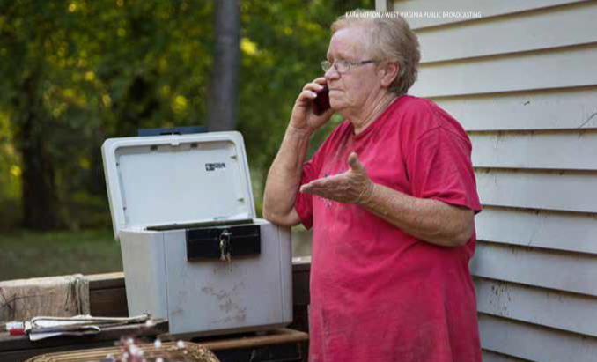

Monitoring Standards/Procedures
The complete West Virginia Monitoring Plan / Policies and Procedures (Monitoring Plan) were included in the Certification Documentation submitted to HUD. As demonstrated herein, WVDOC already possesses the necessary policies, systems and procedures which formally establish the critical monitoring strategies for all cross-cutting regulatory requirements. These well-established systems include HUD program rules and regulations, civil rights, environmental, labor standards, fair housing, Section 3, citizen participation, reporting and recordkeeping requirements. Not only do the systems exist, but they have proven to be successful approaches in the oversight of projects supported with CDBG and previously allocated CDBG-DR funds. The current CDBG-DR award will leverage these existing resources and adapt them to the requirements of Public Law 114-223/254 and any subsequent related guidance.
Monitoring functions will ensure funding recipients, developers, contract services providers, and all contracted agencies adhere to state and federal regulations and requirements when operating, facilitating, or developing WVDOC administered programs and activities. WVDOC utilizes a Monitoring Plan that details the reasons monitoring reviews occur, timelines, specific approach to monitoring, documentation required and corrective actions necessary to resolve issues or concerns discovered through a review. This plan details monitoring procedures, scheduling, and standards, to provide HUD-funded activity compliance and performance reviews for all funding recipients, including internal WVDOC program operations. WVDOC performs monitoring and compliance reviews based on risk assessments and predetermined scheduling, as well as monitoring related to an acute or chronic matter uncovered by an external audit or necessitated by the possibility of fraud, waste, or mismanagement. The monitoring process reviews consist of entrance meetings, analysis of documentation, interview, exit meetings, development and issuance of compliance review reports, corrective action plans, and if necessary, follow-up reviews and letters.

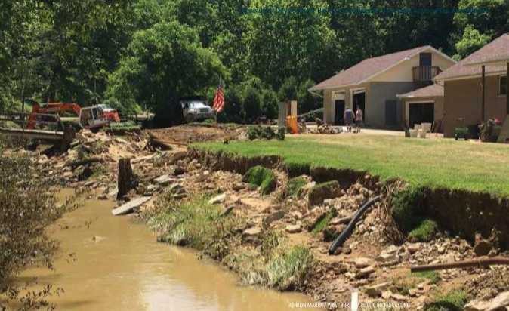
Image 25: An excavator, left, attempts to rebuild the piece of land where a private bridge used to sit. The bridge was washed away by flood waters.

Broadband Infrastructure
West Virginia will also ensure through its CDBG-DR Program that any new construction or substantial rehabilitation, as defined by 24 CFR 5.100, of a building with four or more rental units, will include installation of broadband infrastructure (as defined in 24 CFR 5.100), except where the grantee documents that: (i) The location of the new construction or substantial rehabilitation makes installation of broadband infrastructure infeasible; (ii) the cost of installing broadband infrastructure would result in a fundamental alteration in the nature of its program or activity or in an undue financial burden; or (iii) the structure of the housing to be substantially rehabilitated makes installation of broadband infrastructure infeasible.

Citizen Participation Plan
The State values citizen and stakeholder engagement. West Virginia has developed a Citizen Participation Plan (CPP) in compliance with 24 CFR 91.115, the requirements set forth under 81 FR 83254 for this allocation and other applicable HUD requirements. The State’s CPP is intended to maximize the opportunity for citizen involvement in the planning and development of the West Virginia CDBG-DR recovery program including but not limited to:
- The amount of assistance expected to be received by impacted communities;
- The range of eligible activities to be undertaken; and,
- Other Action Plan and program activities.
The goal of the CPP is to provide all West Virginia residents with an opportunity to participate in the planning and assessment of the State’s CDBG-DR recovery programs. In order to facilitate citizen involvement, West Virginia has laid out specific actions to encourage participation and allow equal access to information about the program by all citizens, especially those of low- and moderate- income, those living in slum and blighted areas and in areas identified for recovery through CDBG-DR, non-English speaking persons, and other vulnerable populations.
Action Plan
Citizen participation is an essential role in West Virginia’s recovery. The State’s goal is to provide every citizen, especially LMI citizens, an opportunity to participate in the planning, implementation and assessment of programs and projects. The participation of citizens is important given the impact of the CDBG-DR programs and projects on their communities. Thus, the State commits to provide citizens with reasonable and timely access to local meetings, public hearings and other information related to the use of the CDBG-DR funds.
The Action Plan defines how West Virginia will effectively use all available funding to support a data-driven recovery based on the calculation of unmet need across the state. The Action Plan describes the State’s proposed allocation by activity and lays out program design for each area of assistance, as well as identifying the beginning and end dates for each disaster recovery activity, and performance and expenditure schedules. Before West Virginia adopts the disaster recovery Action Plan, the State will make available for public input, information regarding program design including the amount of assistance West Virginia expects to receive, the range of activities that may be undertaken, and the estimated amount that will benefit persons of low-to-moderate income, and plans to mitigate displacement.
A summary of all comments received will be included in the final Action Plan submitted to HUD for approval. The final Action Plan approved by HUD will be posted to WVFloodRecovery.com.
Amendments to the Action Plan
Every amendment, substantial or not, shall be numbered sequentially and posted on the State’s Disaster Recovery website, not replacing, but in addition to all previous versions of the plan.
Substantial Amendments
West Virginia will engage citizens throughout the program lifecycle to maximize the opportunity for input on proposed program changes that result in a Substantial Amendment. Program changes result in a Substantial Amendment when there is:
- A change in program benefit or eligibility criteria;
- An addition or deletion of an activity;
- An allocation or re-allocation of more than $5 million per program; or,
- A change in planned beneficiaries.
The State will publish the availability of any draft Substantial Amendment and the dates of the fourteen (14) day public comment period. A copy of any Substantial Amendment will be available at Wvfloodrecovery.comwww.wvfloodrecovery.com.
Citizens will be provided with no less than fourteen days to review and provide comment on any proposed Substantial Amendment. A summary of all comments received will be included in the final Substantial Amendment submitted to HUD for approval. Final Substantial Amendments approved by HUD will be posted to the Disaster Recovery website located at www.wvfloodrecovery.com.
Non-substantial Amendments
In the event the State needs to make a plan amendment which is not substantial, it shall notify HUD but will not allow for public comment. HUD will be notified at least five (5) business days before the amendment becomes effective.
Public Meetings
West Virginia immediately began to seek the input from those communities impacted by the June 2016 floods along with stakeholders from across the State. Although a public hearing is not required given the citizen participation waivers provided by HUD for this CDBG-DR allocation, the State held two (2) public meetings to discuss the specific proposed use of the CDBG-DR funds with the public. The State sought input from the impacted communities and other stakeholders regarding the housing, infrastructure and economic revitalization unmet needs. Notice of public hearings was announced through the impacted communities Long-Term Recovery Committees, posting on the West Virginia Secretary of State website and postings on various social media. All notices were posted in advance of the event. Public hearings were held at a time and location convenient to potential and actual beneficiaries. West Virginia considered all comments or views of citizens received in writing or orally at the public hearings.
Individuals who require auxiliary aids or special assistance at public hearings should make a request at least forty-eight hours in advance of the event to the WVDOC by contacting Jennifer Ferrell at 304-957-2019 or the hearing impaired may call 304-558-1675, or 866-461-3578 (toll-free).
Public meetings were held to present the Substantial Amendment to the Action Plan and further allow the public’s input on Tuesday, April 4, 2017 and Wednesday, April 5, 2017 at 6:00 PM at the following locations, respectively:
Advent Christian Fellowship Hall
2nd Avenue & Spencer Rd. (Rt. 119)
Clendenin, WV 25045
WV School of Osteopathic Medicine – first year lecture hall
400 North Lee St.
Lewisburg, WV 24901
Public Notice and Comment Period
West Virginia considered all comments regarding the Action Plan or any Substantial Amendments thereto received in writing, via email, or expressed in-person at official public hearing events. Additionally, in an effort to permit public examination and public accountability, West Virginia will make the information available to citizens, VOADs, public agencies, and other interested parties upon request.
Notice of public comment period will be provided by publication on the WVDOC disaster recovery website and in any notices regarding publication of the Action Plan or a Substantial Amendment. West Virginia will provide notice and open the citizen comment period for the following time frames per action:
- Comment period for the original Action Plan will take place for fourteen (14) days after the publication of the Action Plan.
- Comment period for Substantial Amendments will take place for no less than fourteen (14) days after the publication
The Action Plan was posted on the Department of Commerce’s website Wvfloodrecovery.com WVFloodRecovery.com on April 3, 2017. The Action Plan was available for comment for a period of 14 days until April 18, 2017. The Amendment to the Action Plan was posted on the Department of Commerce’s website wvfloodrecovery.com WVFloodRecovery.com on October 19, 2017. The Amendment was available for public comment for a period of 14 days until November 2, 2017.

Outreach to Vulnerable Populations and those with Limited English Proficiency
West Virginia is mindful that after a disaster, vulnerable populations, including those with limited English proficiency, may be most in need of resources and most difficult to reach. Such populations could include elderly, disabled, low or moderate income or those with limited English proficiency.
West Virginia is committed to providing all citizens with equal access to information about the recovery program, including persons with disabilities and limited English proficiency (LEP). The State follows HUD regulation, 24 CFR Part 1, “Nondiscrimination in Federally Assisted Program of the Department of Housing and Urban Development – Effectuation of Title VI of the Civil Rights Act of 1964,” which requires all recipients of federal financial assistance from HUD to provide meaningful access to LEP persons.
Persons who do not speak English as their primary language and who have a limited ability to read, write, speak, or understand English can be LEP and may be entitled to language assistance with respect to a particular type of service, benefit, or encounter.
As a result of initial population analysis, West Virginia will post the Language Assistance Plan to the WVFloodRecovery Website to outline the services provided for LEP population in the State.
Citizen Complaint Procedures
The State of West Virginia will handle citizen complaints through a Constituent Services Team. All complaints received by the State, any contractor or vendor working on the CDBG-DR program or project, and/or other program sources, will be reviewed by the Constituent Services Team for:
1. Investigation as necessary;
2. Resolution; or
3. Follow-up actions.
It will remain the goal of the State to always attempt to resolve complaints in a manner that is both sensitive to the complainant’s concerns and that achieves a fair result.
The goal of the State and its Constituent Services Team is to provide an opportunity to resolve complaints in a timely manner. The State will provide a timely written response (either by letter or email as applicable) within 15 business days of the receipt of the complaint. If it is not practicable to provide a response within this time period, then the complainant shall be notified of the reason for the delay and the expected time period for a response. It shall be the right of any party filing a complaint to participate in the process and appeal a decision reached by the State.
Citizens may file a written complaint or appeal through the Department of Commerce email at DisasterRecovery@WV.gov or submit by postal main to the following address:
Attention: Constituent Services
West Virginia Development Office,
1900 Kanawha Blvd., East Capitol Complex,
Building 3, Suite 700
Charleston, WV 25305-0311

Certification
In accordance with the applicable statutes and regulations governing the CDBG-DR grant, including the Federal Register Notice published November 28, 2016 at 81 FR 83254 (the Prior Notice) as well as the Federal Register Notice published January 23, 2017 at 82 FR 5591 (the Notice), the State of West Virginia (the Grantee), certifies as follows:
- The Grantee certifies that it has in effect and is following a residential anti-displacement and relocation assistance plan in connection with any activity assisted with funding under the CDBG program.
- The Grantee certifies its compliance with restrictions on lobbying required by 24 CFR part 87, together with disclosure forms, if required by part 87.
- The Grantee certifies that the Action Plan for Disaster Recovery is authorized under State and local law (as applicable) and that the Grantee, and any entity or entities designated by the Grantee and any contractor, subrecipient, or designated public agency carrying out an activity with CDBG-DR funds, possess(es) the legal authority to carry out the program for which it is seeking funding, in accordance with applicable HUD regulations and the Notice. The Grantee certifies that activities to be undertaken with funds under the Notice are consistent with its Action Plan.
- The Grantee certifies that it will comply with the acquisition and relocation requirements of the URA, as amended, and implement regulations at 49 CFR part 24, except where waivers or alternative requirements are provided for in the Notice.
- The Grantee certifies that it will comply with Section 3 of the Housing and Urban Development Act of 1968 (12 U.S.C. 170u) and implementing regulations at 24 CFR part 135.
- The Grantee certifies that it is following a detailed citizen participation plan that satisfies the requirements of 24 CFR or 91.115 (except as provided for in notices providing waivers and alternative requirements for this grant). Also, each UGLG receiving assistance from a State grantee must follow a detailed citizen participation plan that satisfies the requirements of 24 CFR 570.486 (except as provided for in notices providing waivers and alternative requirements for this grant).
- The Grantee certifies that it has consulted with affected UGLGs in counties designated in covered major disaster declarations in the non-entitlement, entitlement, and tribal areas of the State in determining the uses of funds, including method of distribution of funding, or activities carried out directly by the State.
- The Grantee certifies that it is complying with each of the following criteria:
  - Funds will be used solely for necessary expenses related to disaster relief, long-term recovery, restoration of infrastructure and housing, and economic revitalization in the most impacted and distressed areas for which the President declared a major disaster in 2016 pursuant to the Robert T. Stafford Disaster Relief and emergency assistance act of 1974 (42 U.S.C. 5121 et seq.) but prior to September 29, 2016.
  - With respect to activities expected to be assisted with CDBG-DR funds, the Action Plan has been developed so as to give the maximum feasible priority to activities that will benefit low- and moderate- income families.
  - The aggregate use of CDBG-DR funds shall principally benefit low- and moderate-income families in a manner that ensures that at least 70 percent (or another percentage permitted by HUD in a waiver published in an applicable Federal Register) of the grant amount is expended for activities that benefit such persons.
  - The Grantee will not attempt to recover any capital costs of public improvements assisted with CDBG-DR grant funds, by assessing any amount against properties owned and occupied by persons of low- and moderate-income, including any fee charged or assessment made as a condition of obtaining access to such public improvements, unless: (a) disaster recovery grant funds are used to pay the proportion of such fee or assessment that relates to the capital costs of such public improvements that are financed from revenue sources other than under this title; or (b) for purposes of assessing any amount against properties owned and occupied by persons of moderate income, the Grantee certifies to the Security that it lacks sufficient CDBG funds (in any form) to comply with the requirements of clause (a).
- The Grantee certifies that it (and any subrecipient or recipient) will conduct and carry out the grant in conformity with Title VI of the Civil Rights Act of 1964 (42 U.S.C. 2000d).
- The grantee certifies that the grant will be conducted and administered in conformity with the Fair Housing Act (42 U.S.C. 3601-3619) and implementing regulations, and that it will affirmatively further fair housing, which means that it will take meaningful actions to further the goals identified in an AFH conducted in accordance with the requirements of 24 CFR 5.150 through 5.180, and that it will take no action that is materially inconsistent with its obligation to affirmatively further fair housing.
- The Grantee certifies that it has adopted and is enforcing the following policies, and, in addition, States receiving a direct award must certify that they will require UGLGs that receive grant funds to certify that they have adopted and are enforcing:
  - A policy prohibiting the use of excessive force by law enforcement agencies within its jurisdiction against any individuals engaged in nonviolent civil rights demonstrations; and
  - A policy enforcing applicable State and local laws against physically barring entrance to or exit from a facility or location that is the subject of such nonviolent civil rights demonstrations within its jurisdiction.
- The grantee certifies that it (and any subrecipient of administering entity) currently has or will develop and maintain the capacity to carry out disaster recovery activities in a timely manner and that the grantee has reviewed the requirements of this notice and requirements of the Appropriations Act applicable to funds allocated by this notice, and certifies to the accuracy of its certification documentation referenced at A.1.a. under section VI and its risk analysis document referenced at A.1.b. under section VI.
- The Grantee certifies that it will not use CDBG-DR funds for any activity in an area identified as flood prone for land use or hazard mitigation planning purposes by the State, local, or Tribal government or delineated as a Special Flood Hazard Area in FEMA’s most current flood advisory maps, unless it also ensures that the action is designed or modified to minimize harm to or within the floodplain, in accordance with Executive Order 11988 and 24 CFR part 55. The relevant data source for this provision is the State, local and Tribal government land use regulations and hazard mitigation plan and the latest issued FEMA data or guidance, which includes advisory data (such as Advisory Base Flood Elevations) or preliminary and final Flood Insurance Rate Maps.
- The Grantee certifies that its activities concerning lead-based paint will comply with the requirements of 24 CFR part 35, subparts A, B, J, K, and R.
- The Grantee certifies that it will comply with environmental requirements at 24 CFR Part 58.
- The Grantee certifies that it will comply with applicable laws.
Signature of Authorized Official:
Date:
Title:

Appendices

Appendix A: Summary of Public Comments and Responses
- Public Comments received through email address offered by WVDO during the public comment period: DisasterRecovery@WV.gov
Comment 1:
Response:
No comments were received over the 14-calendar day public comment period for this amendment per Federal Register Vol. 81, No.224.

Appendix B:
Table 23
Name | Address | County | Date Contacted | Damage Y/N
Agsten Manor | 715 Randolph St.  Charleston, WV 25302 | Kanawha | 2/6/2017 | No
Alderson Apartments | 200 Maple Ave.  Alderson, WV 24910 | Greenbrier | 2/16/2017 | No
Assaley Place Apartments | 1532 Jackson St.  Charleston, WV | Kanawha | 2/6/2017 | No
Brook Village | 348 Northridge Dr.  Lewisburg, WV 24901 | Greenbrier | Unable to Contact | N/A
Brooks Manor | 23 Brooks St.  Charleston, WV 25301 | Kanawha | 2/6/2017 | No
Carriage Hill Apartments | 101 Surrey Ter.  St. Albans, WV 25177 | Kanawha | Unable to contact | N/A
Charleston Arbors | 100 Washington St. E  Charleston, WV 25301 | Kanawha | 2/7/2017 | No
Charleston Replacement Housing | 700 Patrick St.  Charleston, WV 25301 | Kanawha | 3/1/2017 | No Response
Charleston/Kanawha Housing Authority | 1525 Washington St. W  Charleston, WV 25387 | Kanawha | 2/7/2017 | No
Chelyan Village Apartments | 205 Appalachian St.  Cabin Creek, WV 25035 | Kanawha | 2/7/2017 | No Response
Chesterfield Village | 5250 Chesterfield Ave.  Charleston, WV 25035 | Kanawha | 2/16/2017 | No Response
Community Housing, Inc. | 1573 Jackson St.  Charleston, WV 25311 | Kanawha | 2/6/2017 | No
Concord House I & II | 5511 Noyes Ave.  Charleston, WV 25304 | Kanawha | 2/6/2017 | No
CRH 1 Public Housing | 711 Patrick St.  Charleston, WV 25387 | Kanawha | Unable to contact | N/A
CRH 3 Washington Manor & Littlepage | 100 IDA Mae Way  Charleston, WV 25301 | Kanawha | 2/21/2017 | No Response
CRH 4 Orchard Elderly | 321 Copenhaver Dr.  Charleston, WV 25387 | Kanawha | Unable to contact | N/A
CRH 8 Legion Prezioso | 1727 Seventh Ave.  Charleston, WV 25387 | Kanawha | Unable to contact | N/A
Cross Lanes Unity Apts. | 101 Unity Ln.  Charleston, WV 25313 | Kanawha | 2/6/2017 | No
Dunbar Towers | 1000 Myers Ave.  Dunbar, WV 25064 | Kanawha | 2/6/2017 | No
EL – Elderly | 701 E Edgar Ave.  Ronceverte, WV 24970 | Greenbrier | 2/1/2017 | No Response
EL – Elderly | 1300 Third Ave. W  Montgomery, WV 25136 | Kanawha | 2/7/2017 | No
EL – Elderly | 303 Austin St.  Lewisburg, WV 24901 | Greenbrier | 2/7/2017 | No
EL – Elderly | 205 Appalachian St.  Cabin Creek, WV 25035 | Kanawha | 2/7/2017 | No Response
EL – Elderly | 41 Surber Rd.  White Sulphur Springs, WV 24986 | Greenbrier | 2/7/2017 | No Response
Elk Crossings Apartments | 1511 Frame Rd.  Elkview, WV 25071 | Kanawha | 2/28/2017 | No
Elk Valley I | 295 S Pinch Rd.  Elkview, WV 25071 | Kanawha | 2/16/2017 | No Response
Elk Valley II Apartments | 301 S Pinch Rd.  Elkview, WV | Kanawha | 2/16/2017 | No Response
Elk Valley II Apartments | 307 S Pinch Rd.  Elkview, WV 25071 | Kanawha | 3/1/2017 | Yes
Elle Bella Villa | 100 Everette Ln.  Dunbar, WV 25064 | Kanawha | 2/24/2017 | No
FA – Family | 1000 Blake Ave.  Ronceverte, WV 24970 | Greenbrier | 2/1/2017 | No Response
FA – Family | 601 Ferrell Rd.  St. Albans, WV 25177 | Kanawha | 2/6/2017 | No
FA – Family | 301 S Pinch Rd.  Elkview, WV 25071 | Kanawha | 2/7/2017 | No
FA – Family | 316 Amanita Dr.  S. Charleston, WV 25309 | Kanawha | 2/7/2017 | No
FA – Family | 5270 Dewitt Rd.  Cross Lanes, WV 25313 | Kanawha | 2/7/2017 | No Response
FA – Family | 2001 Teresa Ln.  Sissonville, WV 25302 | Kanawha | 2/7/2017 | No Response
Glenwood School Place | 810 Grant St.  Charleston, WV 25302 | Kanawha | 2/20/2017 | No
Greenbrier Senior Housing | 268 Greenbrier St.  Rupert, WV 25987 | Greenbrier | 2/20/2017 | No
Greystone & Legion Townhomes | 1904 Washington St. W  Charleston, WV 25387 | Kanawha | 3/1/2017 | No Response
Highview Unity Apartments | 701 Garvin Ave.  Charleston, WV 25302 | Kanawha | 2/6/2017 | No
Homes of Washington Manor (CRH 5) | 600 Clendenin St.  Charleston, WV | Kanawha | 3/1/2017 | No Response
Housing Authority of the City of Dunbar | 900 Dutch Hollow Rd.  Dunbar, WV 25064 | Kanawha | 2/20/2017 | No Response
Housing Authoring of the City of South Charleston | 520 Goshom St.  S. Charleston, WV 25309 | Kanawha | 2/7/2017 | No
Housing Authority of the City of St. Albans | 650 6th St.  St. Albans, WV 25177 | Kanawha | 2/20/2017 | No Response
Jacob Arbors | 521 Jacob St.  Charleston, WV 25301 | Kanawha | 2/7/2017 | No
Jenna Landing Apartments | 308 Jenna Way  Sissonville, WV 25320 | Kanawha | 2/24/2017 | No
Knollview Village Apartments | 571 Maccorkle Ave. SW  St. Albans, WV 25177 | Kanawha | 3/1/2017 | Yes
Lewis Terrace / Tabor Tower | 313 N Court St.  Lewisburg, WV 24901 | Greenbrier | 2/8/2017 | No
Lewisburg Manor | 344 N. Court St.  Lewisburg, WV 24901 | Greenbrier | 2/21/2017 | No
Lynnelle Landing Apartments | 408 Loretta Ln.  S. Charleston, WV 25309 | Kanawha | 2/24/2017 | No
Meg Village | 1 Meg Dr.  Sissonville, WV 25320 | Kanawha | 2/7/2017 | No Response
Mill Creek Landing Apartments | 1 Wise Acres Dr.  Charleston, WV 25311 | Kanawha | 2/24/2017 | No
MX – Mixed | 364 Pennsylvania Ave.  Rainelle, WV 25962 | Greenbrier | 2/7/2017 | No
Oakwood Terrace | 872 Westminister Way  Charleston, WV | Kanawha | 2/6/2017 | No
Pentecostal Holiness Church Housing Corp. | 101 Miracle Dr.  Saint Albans, Wv 25177 | Kanawha | 2/21/2017 | No Response
Perkins Parke Apartments | 100 Drexel Pl.  Cross Lanes, WV 25313 | Kanawha | 2/24/2017 | No
Pocatalico Village | 2005 Teresa Ln.  Sissonville, WV 25320 | Kanawha | 2/7/2017 | No Response
Rivermont Homes, Inc. | 800 4th Ave. Apt B  Montgomery, WV 25136 | Kanawha | 2/6/2017 | No
Riverview Towers | 1 Kanawha Ter.  Saint Albans, WV 25177 | Kanawha | 2/6/2017 | No
Robinson Estates (Dupont Ave.) | 118 E Dupont Ave.  Belle, WV 25015 | Kanawha | Unable to Contact | N/A
Robinson Estates (Gardner Ave.) | 109 E Gardner Ave.  Belle, WV 25015 | Kanawha | Unable to Contact | N/A
Sewell Landing Apartments | 706 Pennsylvania Ave.  Rainelle, WV 25962 | Greenbrier | 2/27/2017 | Yes
South Charleston Unity Apartments | 4718 Kanawha Ave. SW  S. Charleston, WV 25309 | Kanawha | 2/6/2017 | No
Southmoor Hills Apartments | 5019 Kingswood Dr.  S. Charleston, WV 25309 | Kanawha | 2/20/2017 | No
Southmoor Hills Apartments | 4992 Richland Dr. Apt C  S. Charleston, WV 25309 | Kanawha | 2/6/2017 | No
Spruce Cove Apartments | 2010 Quarrier St.  Charleston, WV 25311 | Kanawha | Unable to Contact | N/A
The Village on Park | 1600 Park Ave.  Nitro, WV 25143 | Kanawha | 2/16/2017 | No
Thomas Patrick Maroney Unity Apartments, Inc. | 1004 Lewis St.  Charleston, WV 25301 | Kanawha | 2/6/2017 | No
Tyler Heights Apartments | 100 Tyler Ridge Rd.  Cross Lanes, WV 25313 | Kanawha | 2/24/2017 | No
Upper Falls Landing Apartment | 1300 Third Ave. W  Montgomery, WV 25136 | Kanawha | 2/24/2017 | No
Vandalia Terrace Apartments | 1507 Dorchester Rd.  Charleston, WV 25303 | Kanawha | 2/6/2017 | No
Vickers Parke Apartments | 316 Amanita Dr.  S. Charleston, WV 25309 | Kanawha | 2/24/2017 | No
Vista View Apartments | 1300 Renaissance Cir.  Charleston, WV 25311 | Kanawha | 2/16/2017 | No Response
Vista View Apartments | 1300 Renaissance Cir.  Charleston, WV 25311 | Kanawha | 3/1/2017 | No
Wilshere Landing Apartments | 719 Northridge Dr.  Lewisburg, WV 24901 | Greenbrier | Unable to Contact | N/A

Appendix C: Index of Tables and Figures

Tables
Table 1: Program Budget 9
Table 2: Unmet Needs 10
Table 3: CDBG-DR Funded Activities 11
Table 4: U.S. Census Comparison 28
Table 5: FEMA Applicants by County 38
Table 6: Homeless Services provided 42
Table 7: Damage to Public Parks 45
Table 8: Damage to Wildlife Management Areas 48
Table 9: Verified Loss of FEMA Applicants Referred to SBA 56
Table 10: Verified Loss of FEMA Applicants that did not apply for SBA 56
Table 11: Estimated Verified Loss of Rental Properties 57
Table 12: Total West Virginia Unmet Housing Need 57
Table 13: Socioeconomic Variables 58
Table 14: High SoVI® 60
Table 15: Medium SoVI ® 60
Table 16: Housing Units without a Mortgage by State 67
Table 17: Infrastructure 70
Table 18: Unemployment Claims 74
Table 19: Remaining Economic Unmet Need 76
Table 20: Program Budget 84
Table 21: Allocation of CDBG-DR funds by category 90
Table 22: West Virginia Recovery Agencies 113
Figures
Figure 1: U.S. Billion-Dollar Weather and Climate Disaster 21
Figure 2: Elderly Population 22
Figure 3: Social Vulnerability percentages for under age 5 and over age 65 23
Figure 4: Disabled Populations 24
Figure 5: U.S. Black Lung Claims 24
Figure 6: Social Vulnerability percentage living below poverty 25
Figure 7: Unemployment Rates 26
Figure 8: A snapshot of WVCEH’s performance during the 2014 Point in Time Count 29
Figure 9: West Virginia Disaster Declaration 32
Figure 10: FEMA applicants and impact assessment 36
Figure 11: Repair funds to recipient ration map 37
Figure 12: Snapshot of HUD Resource Locator 40
Figure 13: Capital Expenditures 43
Figure 14: Map of impacted cities and towns 46
Figure 15: Unemployment by County 49
Figure 16: FEMA Disaster Declared Counties 51
Figure 17: Sum of FEMA Real Property Verified Loss by County 53
Figure 18: FEMA verified losses 59
Figure 19: Unmet Housing Need 61
Figure 20: Unmet Housing Need 62
Figure 21: Unmet Housing Need 63
Figure 22: Unmet Housing Need 64
Figure 23: Unmet Housing Need 65
Figure 24: Median Household Value 66
Figure 25: West Virginia Labor Force 72
Figure 26: West Virginia Employment 72
Figure 27: Annual Coal Production 73
Figure 28: Coal Production Forecast 73
Figure 29: Program Allocation 82
Images
Image 1: An excavator rebuilds where a private bridge once stood
while containers from a flooded kitchen are laid out to dry 7
Image 2: Aftermath from Flooding in Clendenin 7
Image 3: A woman stands outside her home in Clendenin where water levels
reached the top of the home’s roof 13
Image 4: Members of the West Virginia National Guard travel by way of ATV’s
to do health and wellness checks for residents of Clendenin and other areas in
northern Kanawha County 14
Image 5: Cars inundated with mud sit outside a damaged home in Clendenin 17
Image 6: An elderly man lost all of his possessions in his house where he’s lived
since the 50’s 22
Image 7: Flooded homes along the Elk River 30
Image 8: A collapsed Dairy Queen as a result of flood damage 31
Image 9: A battered trailer and ice chest sit beside the river in Richwood 33
Image 10: A home destroyed by flood damage 34
Image 11: Home in Rainelle 35
Image 12: The Elk River 39
Image 13: A flooded mobile home along the Elk River 41
Image 14: The back of Nicholas County Nursing Home several days after
the flood 42
Image 15: Route 4 near Kanawha and Clay County lines washed away during flooding 44
Image 16: Musical instruments litter the floor of the band classroom at Herbert
Hoover High School where seven feet of water fled the room during the floods 46
Image 17: Flooded businesses in Elkview 48
Image 18: Damaged home in Clendenin 55
Image 19: Flood debris being removed off I-79’s Clendenin Exit 69
Image 20: Collapsed bridge at the Crossing Mall in Elkview 75
Image 21: Home destroyed by flood waters 93
Image 22: After their house was destroyed by rushing flood waters, a family of
5 is living in this camper; the left-hand side of the photo shows where their
home once stood 103
Image 23: Cleaning up flood damage in Richwood 104
Image 24: A Clendenin citizen forced to abandon her home with 50 years of
belongings by her side 120
Image 25: An excavator, left, attempts to rebuild the piece of land where a
private bridge used to sit. The bridge was washed away by flood waters 122

